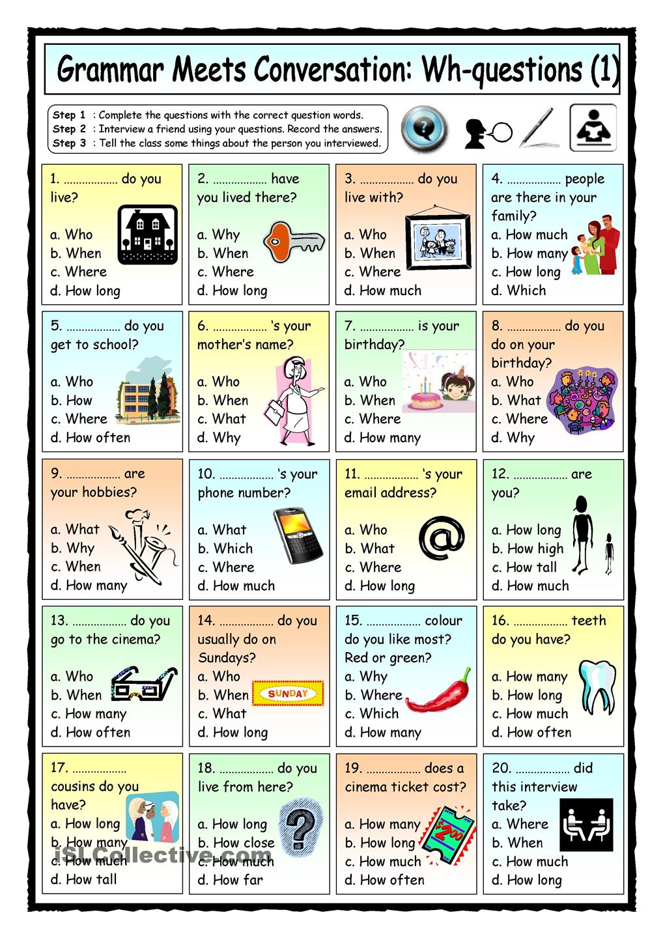
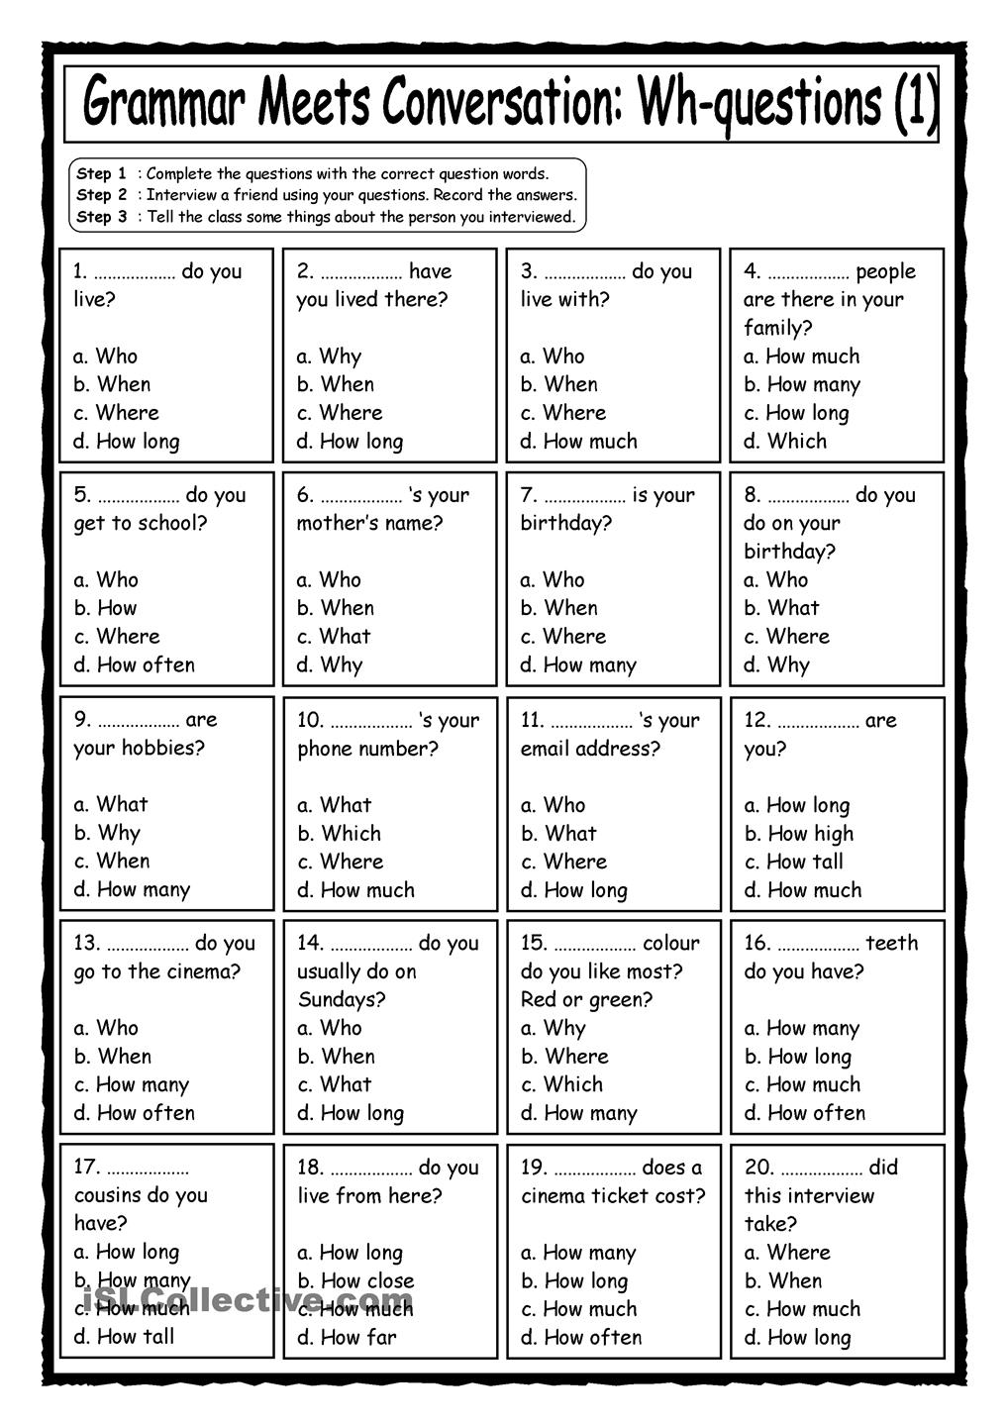
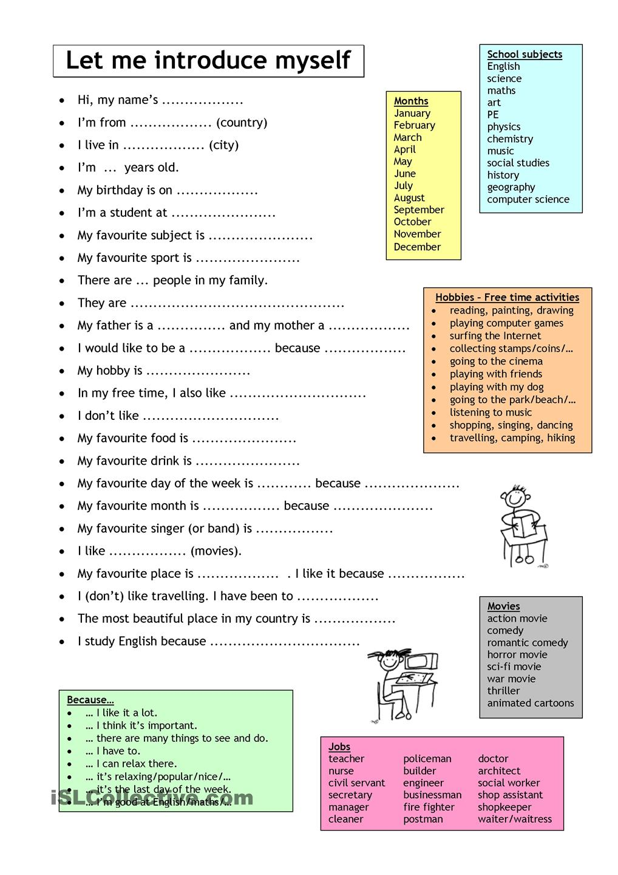

Fill in the blanks with the right subject / personal pronouns (I, you, he, she, it, we, they):
- Angelina Jolie is American. ___________ isn't French.
- Brad Pitt is American, too. ________ isn't German.
- Brad and Angelina aren't French. ________ are American.
- My friend and I are high school students. _______ aren't primary school students.
- The Statue of Liberty is in New York. ________ isn't in Washington.

Fill in the blanks with the right form of to be ( am, are or is):
- _______ you the new student?
- Yes, I ______ .
- Leila and Nancy _______ students.
- Nancy _______ Australian .
- My sister and I ______ students.
- The girls _______ tired.
- These women _______ beautiful.
- The tea _______ delicious.
- Nadia and Leila ______ friends.
- The newspaper _________ cheap.

Choose the correct answer (negative or affirmative form of to be):
- Is Julia Robert French? No, she ______________ French.
- What about Robert de Nero? Is he an American actor? Yes, he _____________ .
- Are New York and Los Angeles Spanish Cities? No, they _________ Spanish cities.
- Is Big Ben in Paris? No, it __________ in Paris.
- Is Mount Everest in Africa? No, it ___________ in Africa. It is in Asia.

