Unit 7

Objectives

To talk about customs.

To review conditional sentences.

Conditional sentences

Use: to express that the action in the main clause, can only take place if a certain condition is fulfilled.

zero conditional

Use: it’s used to make statements about the real world, and often refers to general truths, such as scientific facts.

IF + SIMPLE PRESENT SIMPLE PRESENT

If clause (condition) Main clause (result)

Examples
If it rains, the grass gets wet.
The grass gets wet if it rains.
When it rains, the grass gets wet.
The grass gets wet when it rains.
If you freeze water, it becomes solid.
Plants die if they don't get enough water.
- The zero conditional is also often used to give instructions, using the imperative in the main clause.

Examples
If Bill phones, tell him to meet me at the cinema.
Ask Peter if you're not sure what to do.
If you want to come, call me before 5:00.
If you come for breakfast, tell me.

First conditional

It's used to talk about things which might happen in the future. Of course, we can't know what will happen in the future, but this describes possible things, which could easily come true.

IF + SIMPLE PRESENT will/won’t + base form

If clause (condition) Main clause (result)
If it rains, I won't go to the park.
If you don’t pay the electricity bill, EEH will cut it.
She'll be late if the train is delayed.
She'll miss the bus if she doesn't leave soon.
If I see her, I'll tell her. Will you tell her if you see her?
Second conditional (present unreal)
Use: refers to an unlikely or hypothetical condition and its probable result. These sentences are not based on the actual situation.

IF + SIMPLE PAST WOULD/COULD/MIGHT + BASE FORM

If clause (condition) Main clause (result)
If the weather (weren’t)wasn't so bad, we would go to the park.
If I was/were the Queen of England, I would give everyone a chicken.
If I knew where she lived, I would go and see her.
We might buy a larger house if we had money.
What would/could you do if you were a butterfly? If I were a butterfly I’d fly ….
If I won the lottery, I’d travel around the world.
If there were no Covid 19, I wouldn’t wear a mask.

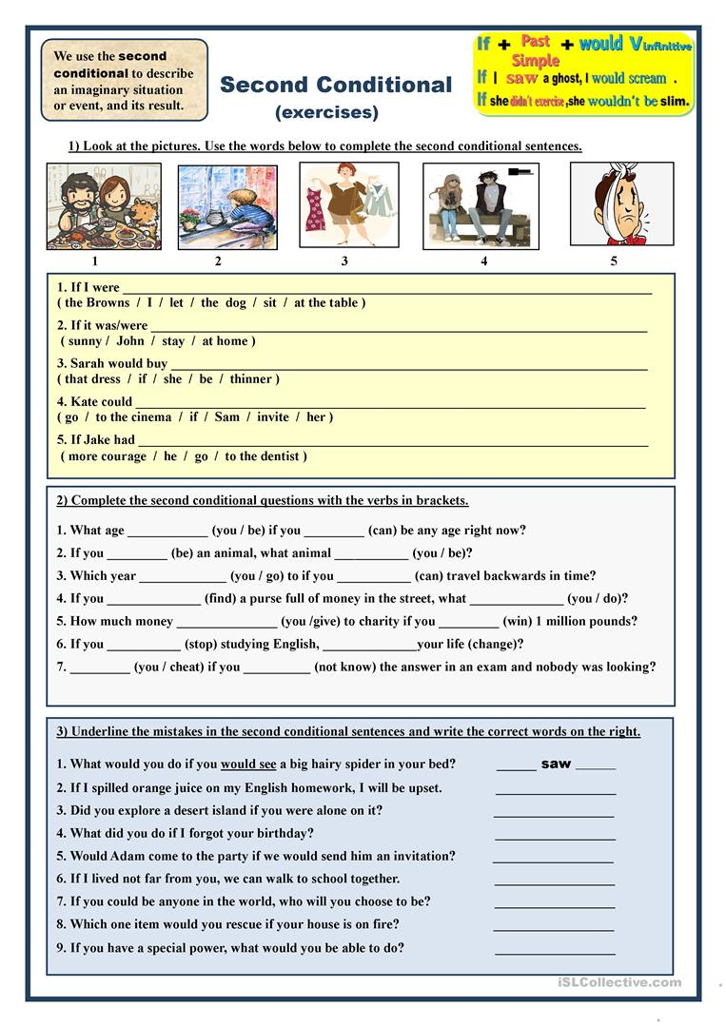
Third conditional (past unreal)

IF + PAST PERFECT WOULD/COULD/MIGHT + HAVE+ PP

If clause (condition) Main clause (result)

Use: to talk about imagined past situation that didn’t happen and speculate on a possible result of this situation.

If Panchito had had the money, he would have bought a Ferrari.

If she hadn’t eaten so much, she wouldn’t have felt sick.
I would have believed you if you hadn't lied to me before.
If you hadn't lied to me before, I would have believed you.
If I had studied harder, I could have passed the test.
Exercise
Which conditional should I use?
- In my experiments, the liquid is cooled to 32 degrees. It always freezes.
  - If you cool the liquid to 32 degrees, it freezes.
  - If you cool the liquid to 32 degrees, it will freeze.
  - If you had cooled the liquid to 32 degrees, it would have frozen.
  - If you cooled the liquid to 32 degrees, it would freeze.
- He stepped on the mine, and it exploded.
  - If he doesn't step on the mine, it won't explode.
  - If he didn't step on the mine, it wouldn't explode.
  - If he hadn't stepped on the mine, it wouldn't have exploded.
  - If he doesn't step on the mine, it doesn't explode.

- You ignored my advice, so you got into trouble!
  - If you don't ignore my advice, you don't get into trouble.
  - If you don't ignore my advice, you won't get into trouble.
  - If you hadn't ignored my advice, you wouldn't have gotten into trouble.
  - If you didn't ignore my advice, you wouldn't get into trouble.

- Unfortunately, I don't know Philosophy, so I can't answer your question.
  - If I know Philosophy, I can answer your question.
  - If I know Philosophy, I will be able to answer your question.
  - If I knew Philosophy, I would be able to answer your question.
  - If I had known Philosophy, I would have been able to answer your question.
- It may rain this afternoon. I hope it doesn't because I don't want the match to be cancelled.
  - If it rains, the match will be cancelled.
  - If it rains, the match is cancelled.
  - If it had rained, the match would have been cancelled.
  - If it rained, the match would be cancelled.
- I want to buy a Porsche, but I don't have enough money.
  - If I have enough money, I buy a Porsche.
  - If I had enough money, I would buy a Porsche.
  - If I have enough money, I will buy a Porsche.
  - If I had had enough money, I would have bought a Porsche.

Unless can mean”except if”// “if not”//
My leg's broken. I can't stand up unless you help me. (I can't stand up if you don't help me.)
The club is for members only. You can't go in unless you are a member (=except if you are a member)
As long as means “on condition that”
As long as you clean the house, you can have a party here.
you can stay here as long as you keep quiet.
You can borrow my car as long as you promise not to drive too fast.
Even if means “it doesn’t matter whether/if”
Even if we leave right now, we still won't catch the train.
I wouldn't go into the water even if I could swim.
Even if we had booked our flight earlier, it wouldn't have been cheaper.

HABITS

“usually” "used to" , "be used to" , "get used to"
- Usually to express present habit.

We usually go shopping on weekends.

They usually join the class late.

You usually drink a cup of coffee in the morning.

She usually eats beans for breakfast.

I don’t usually take a shower in the morning.

- used to + base form to express past habit or situation.
when I was a teenager, I used to live in San Pedro Sula. (state)
(+) I used to/ (would) walk to school.
(-) I didn't use to walk to school.
(?) Did you use to walk to school?

- Would + base form to express past habit. (Actions or situations that were repeated //not a state)

When I was a teenager I would go/ used to go shopping on weekends.

Panchito would play football every Saturday when he was at school.

- Be used to + noun to express that we are(were)
accustomed to smth.
be used to + v-ing (we are familiar with..)
I am used to exercising every day.
I am not used to exercising every day.
Are you used to exercising every day?
She is used to her new cellphone now.
Are you used to living in the US? Yes. I am
Anacleta is used to her computer .

- (Be )+get(ting) used to + noun to express that we are

(Be) +get(ting) used to + v-ing becoming accustomed to

Smth.
I am (was) getting used to waking up early.
I am not getting used to waking up early.
Are you getting used to waking up early?
I’m getting used to my new neighborhood.
I have to get used to my new lifestyle.

NOTE:
"be used to" and "get used to" are used with the gerund (the -ing form of the verb) while "used to" is used with the infinitive (the basic form of the verb).
I used to walk.
I am used to walking.
I get used to walking.

Practice: Select the sentence that has a similar meaning.

1. She cleaned the house regularly in the past.
She used to clean the house.
She got used to cleaning the house.
She is used to cleaning the house.

2. He became accustomed to waking up early.
He used to wake up early.
He is used to waking up early.
He got used to waking up early.

3. Pablo is accustomed to going late.
Pablo is used to going late.
Pablo used to go late.
Pablo is getting used to going late.

4. I am accustomed to cooking in the morning.
I am getting used to cooking in the morning.
I am used to cooking in the morning.
I used to cook in the morning.

5. Maria regularly drove the car in the past.
Maria used to drive the car.
Maria got used to driving the car.
Maria is used to driving the car.

6. She is becoming accustomed to working at that company.
She is getting used to working at that company.
She used to work at that company.
She is used to working at that company.

7. I didn't read many books in the past.
I didn't use to read many books.
I am used to reading many books.
I got used to reading many books.

8. Are you accustomed to the climate?
Are you used to the climate?
Did you get used to the climate?
