UNIT 6 –book 3
INFINITIVES (to + verb)
The infinitive is used:
- After certain verbs
Verb + (not) infinitive
They hope to reach the party on time.
Verb + infinitive
I want to try the new ice-cream flavor.
(-) She agreed not to speak before the game.
(-) I dislike not to cook chicken.
I decided to have one child.
I decided not to have a child.
I intend not to travel next week.
She agreed to do my homework.
She agreed not to do my homework.
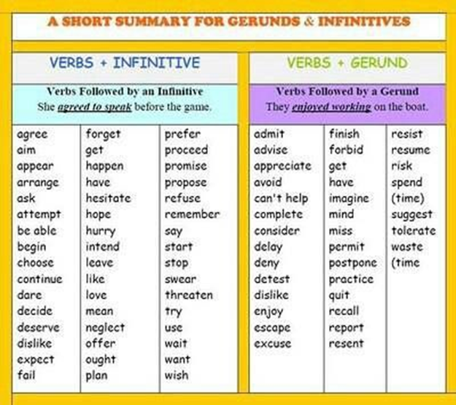
- After adjectives
Adjective + infinitive
I´m happy to hear you’re well.
She’s delighted to see him.
It’s wonderful to have good friends.
I’m ready to start the new class.
I’m sad to leave this place.
I’m surprised to receive this gift.
She’s pleased to learn a little bit more of this.
- After a noun
Noun + infinitive
I’ve got some homework to do.
Can I ask you to help me?
I’ve got some books to read.
I have a lot of tests to check.
I have a little water to drink.
I have a lot of reports to send.
I have a few apples to eat.

- Infinitive of purpose (to + verb)
Use: to indicate the purpose of an action.
He bought some flowers to give to his wife.
I’ll lock the door to prevent theft.
Why do wear shoes? To protect my feet.
Why do you comb your hair?
To look beautiful.
Why do you work?
To earn money. To pay my bills.
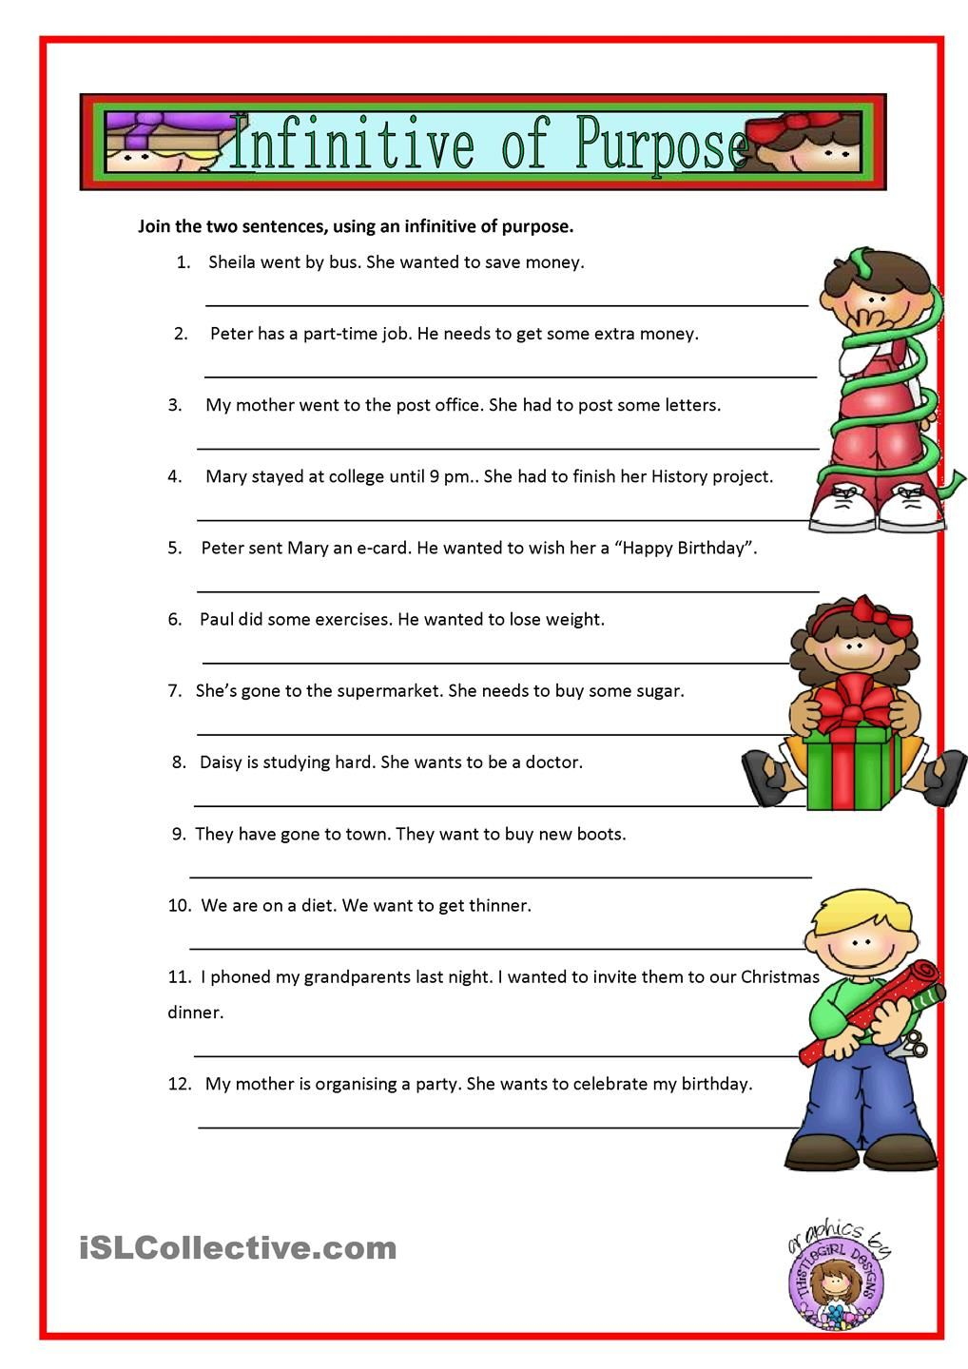

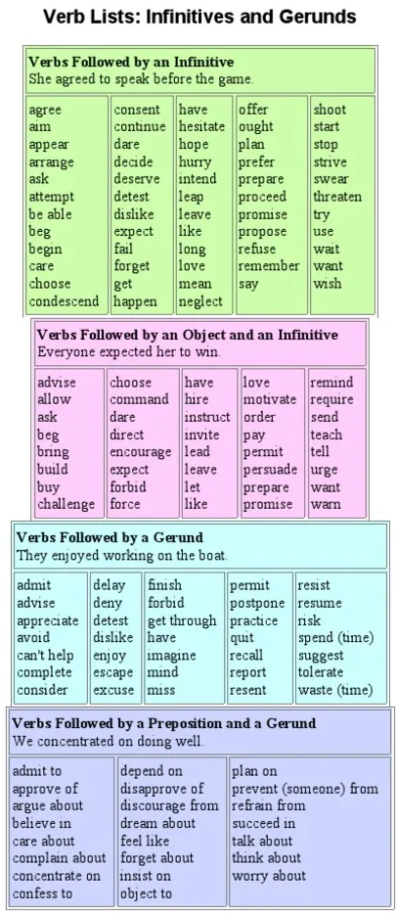
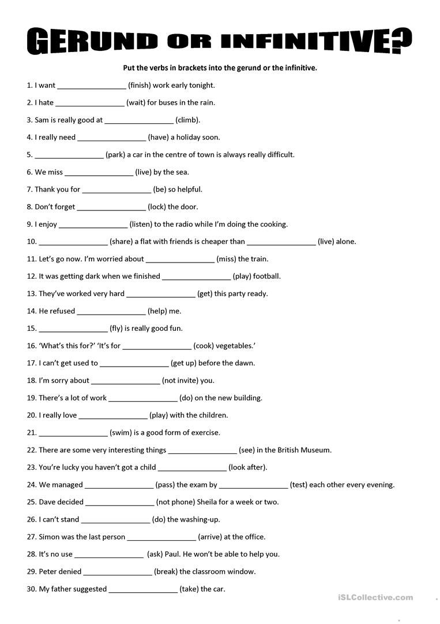
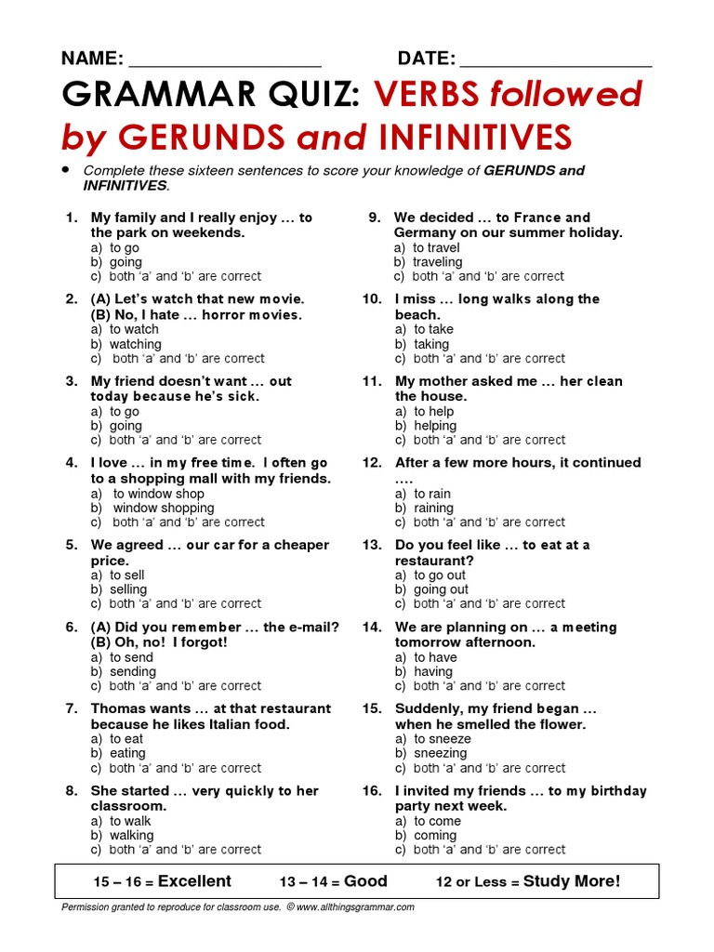

FUTURE FORMS
- Simple present.
1. timetable
2. scheduled events
The plane takes off at 11:40 tomorrow.
What time does the plane take off tomorrow?
We leave to Juticalpa at 7:00 next week.
- Present continous (Be (am, is, are) + v-ing)
1. arrangments ( a plan that you have decided and organized with another person).
2. plan (near future)
I’m working on a new project tomorrow afternoon.
I’m buying a new house next month.
I’m meeting my friends at 7.
- Will/ won’t (will not)
1. predictions
2. promise
3. voluntary action
4. spontaneous decisions
5. threat if you tell anyone about it, I’ll kill you.
6. forecast
7. offer
I’ll visit her on the weekend.//
I’ll take you on a great trip.//
Don’t worry, I’ll take the test for you.//
I think it’ll rain today.//
I won’t visit her on the weekend.
I’m hungry! I’ll make a sandwich.
Will you have something to drink?
- Be + going to + base form (gonna)
1. plan (previously made) (future intention)
2. Predictions based on strong evidence.. (look!, listen!, watch out!)
I’m going to (gonna) make pizza tomorrow.
Next month, I´m going to travel to Bay Islands. (future intention)
Next month, I’m traveling to Bay islands.(arrangment)
Look at the sky! It’s going to rain in a few minutes. (prediction)
