
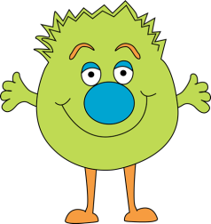

No Change
Most verbs add “ing”
- eat - eating
- speak - speaking
- cook - cooking
- start - starting
- do - doing
- stay - staying
- fix - fixing

Most verbs ending in “y” add ING

buy + ing = buying
enjoy + ing = enjoying
play + ing = playing
say + ing = saying
try + ing = trying
talk + ing = talking
sing + ing = singing

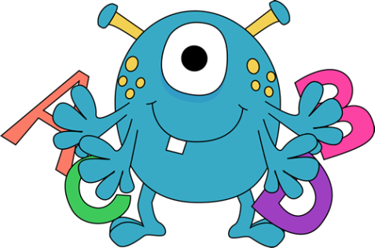


Change
Verbs ending in “e” drop the final “e”

- hope - hoping
- ride - riding
- make - making
- write – writing
- believe- believing
- drive- driving
- dance-dancing

Verbs ending with -ie
Change the -ie to -y and add -ING
- die - dying
- tie - tying
- lie - lying

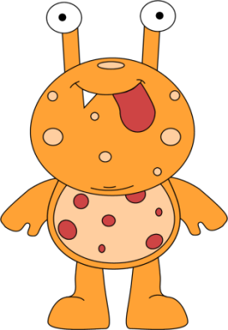
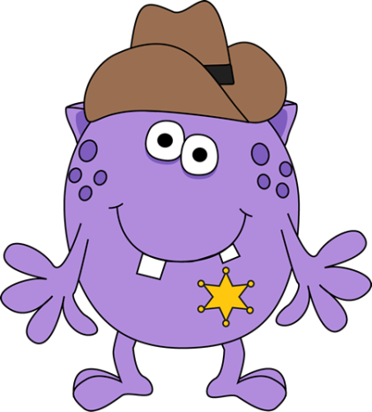

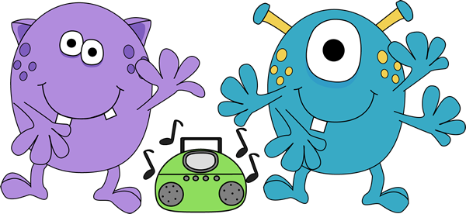

Verbs ending with one vowel and one consonant

For one syllable verbs
double the consonant and add -ING
- jog - jogging
- sit - sitting
- run - running
- stop – stopping
- swim-swimming

If the 2nd syllable is stressed , double the consonant and add ING
- admit - admitting
- prefer - preferring
- begin - beginning

Double letters

