PRONOUNS (SUBJECT, OBJECT, POSSESSIVE) NAME:___________________________

- Substitute the underlined words with the correct pronoun.
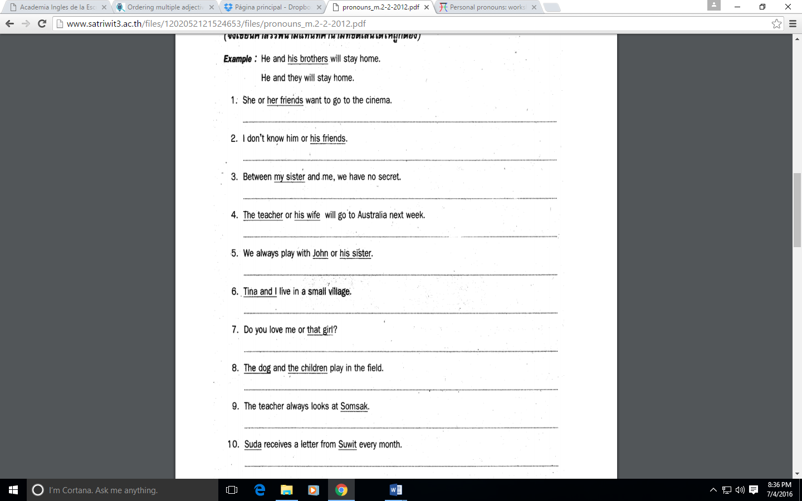

- Fill in the blanks with the correct form of pronoun.
1. This girl is Mona. ____________ is a good student.
2. The dog is growling. ____________ is jumping to the cat.
3. I want some milk. Give ____________ to ____________, please.
4. Frank puts the books on the desk. ____________ are heavy.
5. My brother wants a kite. My father gives ____________one kite.
6. I have many puppets. Do you want ____________?
7. Who is that woman? Why are you looking at _________?
8. I can't find my pencil. Can you give one to _________?
9. I want to see your test. Please show_________ to _________.
10. We don't know your phone number. Please give _________ to _________.
11. These flowers are a present for mother. Please, give _________ to _________.
12. I cannot help _________, Betty. I have other work to do.
13. My friend Susan lives in London. This is a postcard from _________.
14. The children are thirsty. Give _________ a glass of water.
15. I often clean ____________ bike.
16. The dogs eat ____________ food.
17. The movie was great. We really enjoyed _________________ very much.
18. My bike was not working, I repaired _____________ this morning.
19. The windows are dirty. Why don’t you clean _________________?
20. Sally is great, Jack and I met _________________ at the party five years ago.
21. At Christmas, my friends often give presents to ______________ , and also I to ______________.
22. The information is on the board, did you write ______________?
23. Susan cannot find ____________ pen.
24. Our uncle and aunt like ____________ new house.
25. The rabbit is white. ____________ cage is in the garden.

