UNIT 6
INFINITIVES (to + verb)
The infinitive is used:
- After certain verbs
Verb + (not) infinitive
They hope to reach the party on time.
I want to try the new ice-cream flavor.
She agreed not to speak before the game.
I dislike not to cook chicken.
- After adjectives
Adjective + infinitive
I´m happy to hear you’re well.
She’s delighted to see him.
It’s wonderful to have good friends.
I’m ready to start the new class.
- After a noun
Noun + infinitive
I’ve got some homework to do.
Can I ask you to help me?
- Infinitive of purpose
Use: to indicate the purpose of an action.
He bought some flowers to give to his wife.
I’ll lock the door to prevent theft.

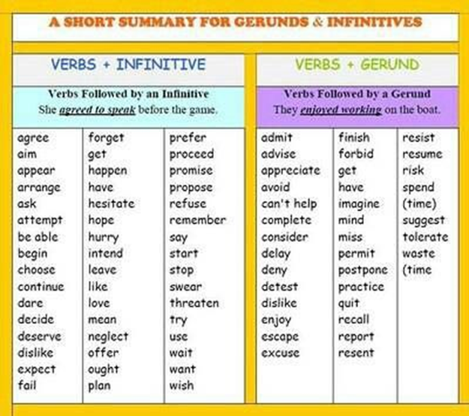

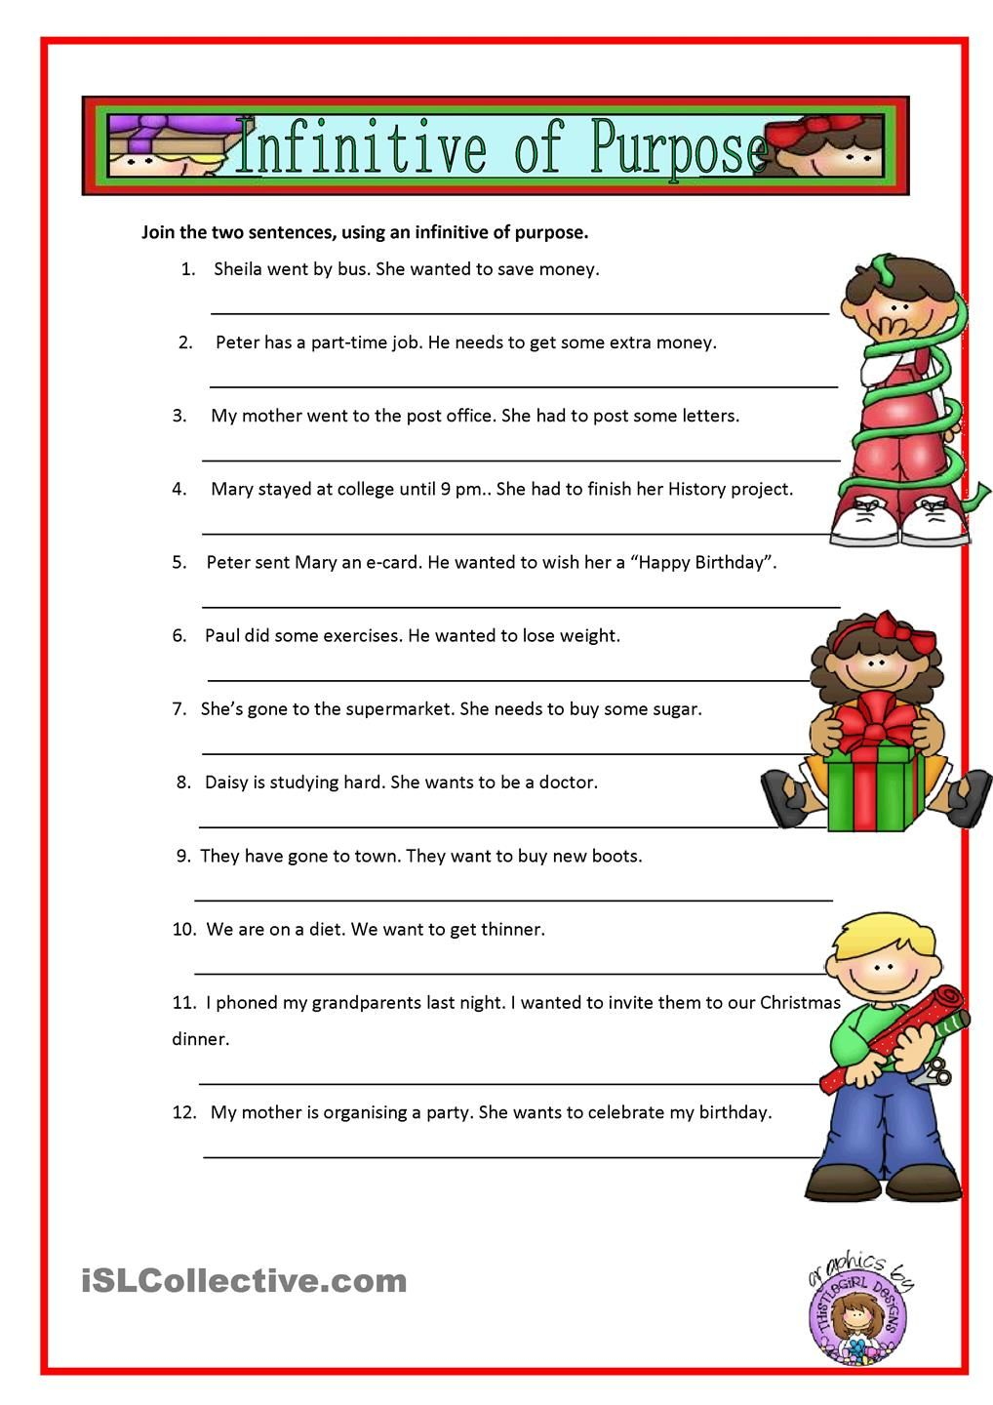

FUTURE FORMS
- Simple present.
1. timetable
2. scheduled events
The plane takes off at 11:40 tomorrow.
We leave to Juticalpa at 7:00.
- Present continous (Be + v-ing)
1. arrangments
2. plan (near future)
I’m working on a new project tomorrow afternoon.
I’m buying a new house next month.
I’m meeting my friends at 7.
- Will/ won’t
1. predictions
2. promise
3. voluntary action
4. spontaneous decisions
5. threat
6. forecast
7. offer
I’ll visit her on the weekend.
I’ll take you on a great trip.
Don’t worry, I’ll take the test for you.
I think it’ll rain today.
I won’t visit her on the weekend.
I’m hungry! I’ll make a sandwich.
Will you have something to drink?
- Be + going to + base form (gonna)
1. plan (previously made) (future intention)
2. Predictions based on strong evidence.. (look!, listen!, watch out!)
I’m gonna make pizza tomorrow.
Next month, i´m gonna travel to Bay islands.
Look at the sky! It’s going to rain in a few minutes.

