LEVEL 2
FUTURE FORMS
NAME:____________________________________________________ DATE:______________________
- Circle the best future form to complete these sentences.
1. Don't worry about your driving test! I'm sure you’ll pass / you're passing .
2. I won’t come / ’m not coming on Friday, sorry. I have a doctor's appointment.
3. Are you hot? OK, I’m going to / I’ll open the window.
4. Don't leave your bike there! Someone ’s stealing it / ’ll steal it .
5. Good morning and welcome to our school. In this talk I’ll / I’m going to tell you about ...
6. Look at the traffic! We're going to be / We're arriving late for school.
7. Oops, I forgot your drink! I'm going to go / I’ll go and get it now.
8. I don't think he'll / think he won't go to the party.
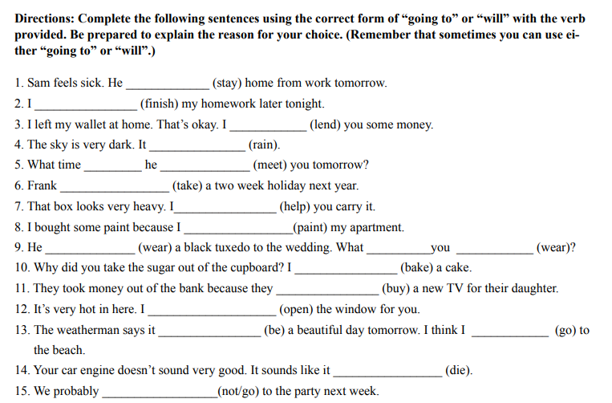

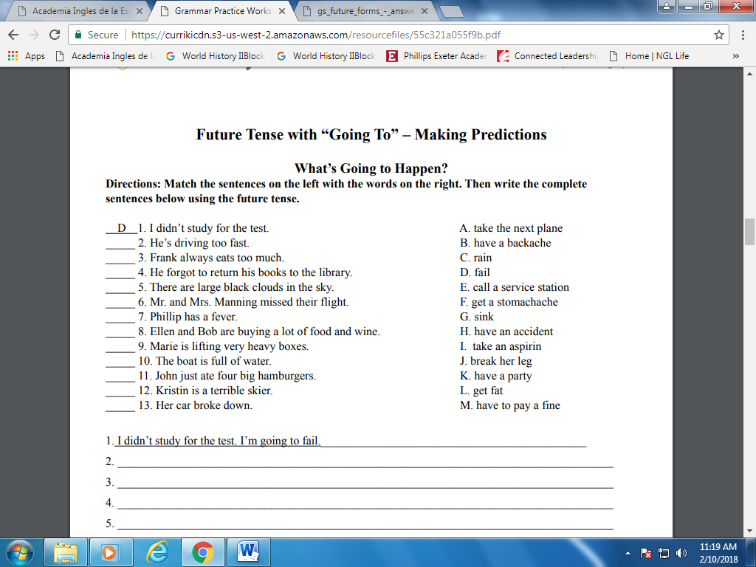
I’m going to fail the test.
- ___________________________________________________________________________
- ___________________________________________________________________________
- ___________________________________________________________________________
- ___________________________________________________________________________
- ___________________________________________________________________________
- ___________________________________________________________________________
- ___________________________________________________________________________
- ___________________________________________________________________________
- ___________________________________________________________________________
- ___________________________________________________________________________
- ___________________________________________________________________________
- ___________________________________________________________________________
- ___________________________________________________________________________

