Compare the difficulty of the three problems

____________________________________________________________________________________________________________________________________________________________________________________________________________________________________________________________________________________________________________________________________________________
Compare the ages of the children
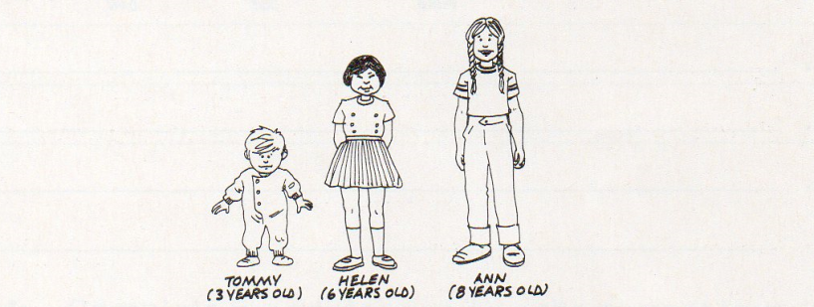
____________________________________________________________________________________________________________________________________________________________________________________________________________________________________________________________________________________________________________________________________________________
Compare the height of the three women



