WAS / WERE NAME:___________________________
MIXED EXERCISE DATE:___________________________
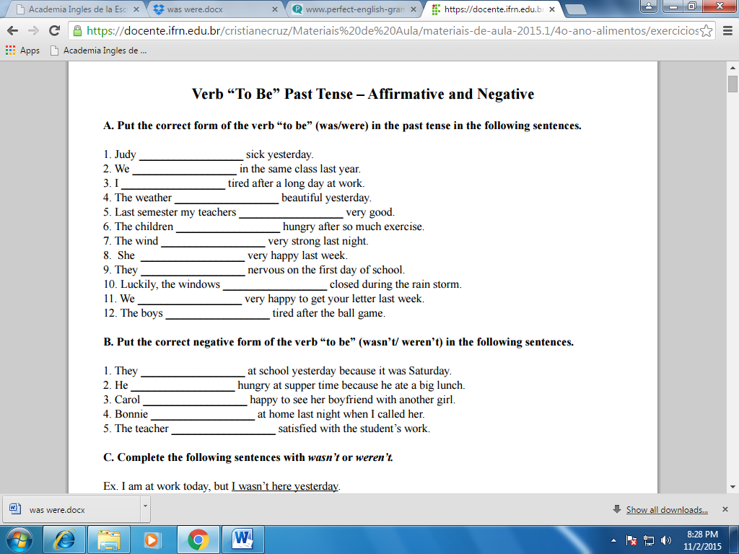
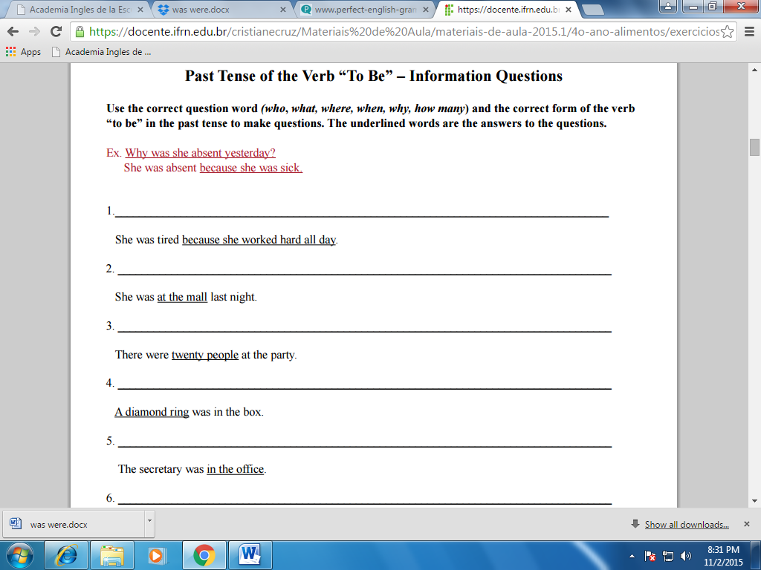

B. Make the past simple (use positive / negative or question):
1. (I / be / at the cinema last night.)
__________________________________________________________________
2. (the children / be / naughty?)
__________________________________________________________________
3. (we / be / in a cafe when you called.)
__________________________________________________________________
4. (I / be / late?)
__________________________________________________________________
5. (she / be / a teacher when she was young.)
__________________________________________________________________
6. (where / we / be?)
__________________________________________________________________
7. (you / be / okay?)
__________________________________________________________________
8. (we / be / too tired?)
__________________________________________________________________
9. (how / the party / be?)
__________________________________________________________________
10. (they / be / late for the interview.)
__________________________________________________________________

