Unit 9 book 4
Objectives
- To talk about the best shopping centers in the world.
- Shopping trends
- Worse markets in the world
- To review quantifiers and passive voice.

Passive voice
Structure: subject + be + past participle of the verb + complement + (by + agent)
Use: When we don’t know or don’t want to express who performed the action.
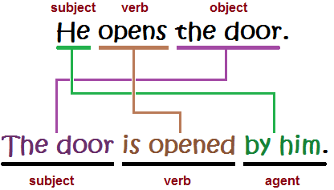
Simple present am/is/are + pp
Panchito cleans Astrid’s house. (active voice)
Astrid’s house is cleaned by Panchito. (passive voice)
Mary takes care of children. (active voice)
Children are taken care by Mary. (passive voice)
Present continuous am/is/are + being + pp
Panchito is cleaning houses. (active)
Houses are being cleaned by Panchito. (passive)

Simple past was/were + pp
Anacleta built a beautiful house. (active voice)
A beautiful house was built by Anacleta. (passive)
Past continuous was/were + being + pp
Anacleta was building a beautiful house. (active)
A beautiful house was being built by Anacleta. (passive)
Present perfect have/has+ been + pp
Anacleta has built a beautiful house. (active)
A beautiful house has been built by Anacleta. (passive)
Future will + be + pp
Anacleta will build a house. (active)
A house will be built by Anacleta. (passive)
- Is/am/are + going to + be + pp
Anacleta is going to build a house (active)
A house is going to be built by Anacleta. (passice)
Modal modal + be+ pp
Panchito should make a cake. (active)
A cake should be made by Panchito.

Carlos will drive a new car this year.
A new car will be driven by Carlos this year.

https://www.youtube.com/watch?v=7FBr-G0ur9I
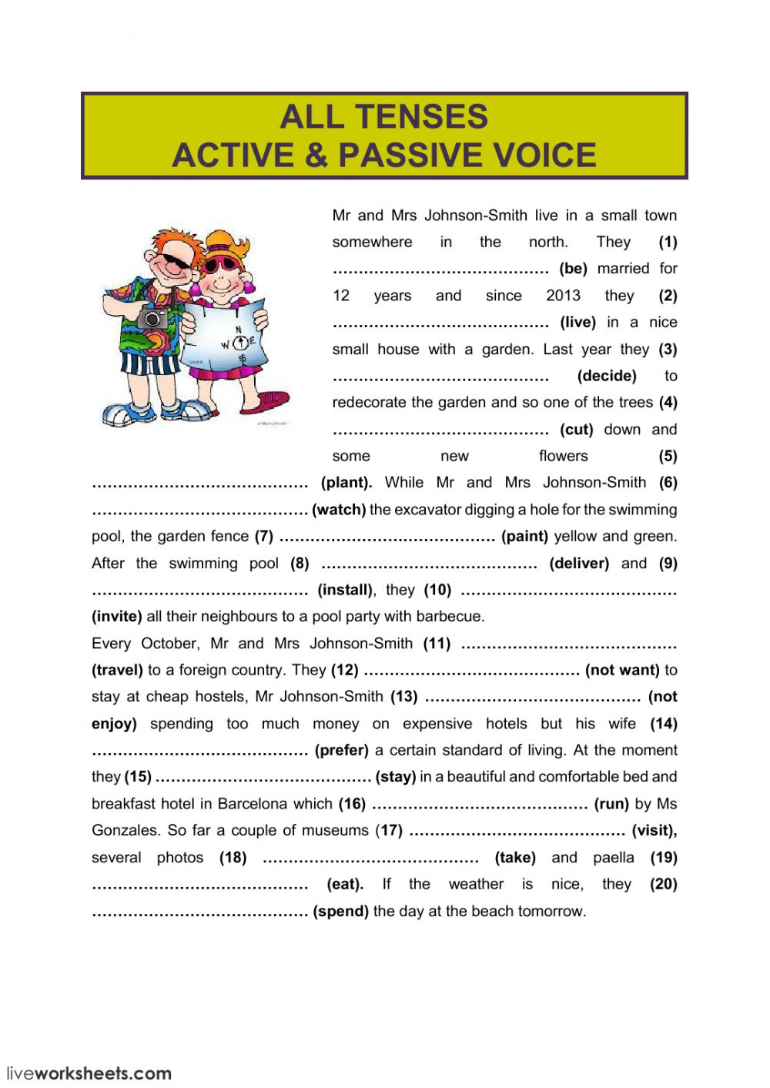
Quantifiers
- Several a number of (but not many) (countable nouns)
- A little / little a small amount of
I have a little money in my pocket// I have little money in my pocket.
- Lots of an informal way of saying a lot of
She has a lot of friends. // she has lots of friends.
- Plenty of a large or enough amount or quantity (more than enough) Countable and uncountable nouns.
- A couple of two (things) or a few (things)
- Some ( positive sentences, countable and uncountable nouns..)
- Any (negative sentences, questions ( countable and uncountable)
- Enough
- A few /few
I have a few apples// I have few apples.
- (too)Much
- (too) Many

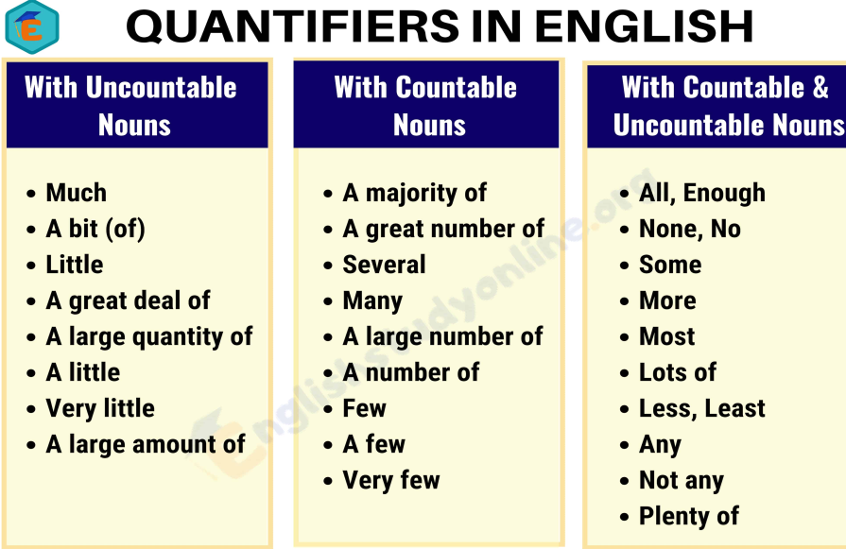
There’s only a little cake left. Would you like it?

I’ll be ready in a couple of minutes.

We have plenty of potatoes/ time. Please take as many as you like!

There are several movies that I’d like to see.

Hurry up! We don’t have much time before the train leaves!

Articles
a/an
uses:
- First mention
I saw an old woman and a dog in the park.
- Jobs
Panchito is a teacher and Anacleta is an engineer.
- Decriptions
Choluteca is a hot city in Honduras.
The
Uses:
- Second mention
I saw a woman and a dog. The woman was old.
- Specific things
The children are in the park.
- Only one thing
The moon looks beautiful today.
- Common places
We’re going to the church.
- Superlatives
Panchito is the best student in the class.
- Musical instruments
Anacleta plays the piano.

Zero article
Uses:
- General meaning
She doesn’t like children. ( children in general)
- Meal
What time do you have dinner?
- Years, months, days
2018 was a great year.
- Tv
There’s a good film on TV.
- Languages, school subjects
Panchito doesn’t speak French. He loves maths.
- Next, last + year, week, month.
I went to the theater last year.

