Unit 9
TO TALK ABOUT SHOPPING TRENDS.
OBJECTIVE

Grammar : passive voice
The passive emphasizes the action. The receiver of the action is the subject.
Structure: be + past participle of the verb.
Use : when we don’t want to say who does the action, or it’s unimportant or obvious.
PASSIVE VOICE DIFFERENT TENSES.
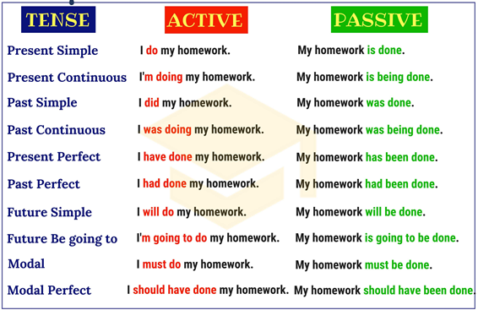
PRESENT IS/AM/ARE + PAST PARTICIPLE
PRESENT CONTINUOUS AM/IS/ARE + BEING + PAST PARTICIPLE
PRESENT PERFECT HAVE/HAS + BEEN + PAST PARTICIPLE
PAST WAS/WERE + PAST PARTICIPLE
PAST CONTINUOUS WAS/WERE + BEING + PAST PARTICIPLE
PAST PERFECT HAD + BEEN + PAST PARTICIPLE
FUTURE BE GOING TO AM/IS/ARE + GOING TO + BE + PAST PARTICIPLE
FUTURE WITH WILL WILL + BE + PAST PARTICIPLE
MODALS MUST + BE + PAST PARTICIPLE
SHOULD

Passive Voice
Write down the passive form of the verbs. Use the tense in brackets.
1. Paul ___________________ (send) to prison. (Future tense)
2. My brother ____________________ (just beat) in the race. (Present perfect)
3. He _________________ (tell) to wait outside. (Past tense)
4. I __________________ (not pay) for the work. (Past tense)
5. Policemen _____________________ (often ask) the way. (Present tense)
6. Their lawn ____________________ (cut) once a week. (Present tense)
7. We __________________ (ask) by the police. (Future tense)
8. The towels ____________________ (not use). (Past tense)
9. The jewels ____________________ (not sell) so far. (Present perfect)
10. They ___________________ (teach) French. (Present tense)
11. The fire brigade ______________ (phone) soon after the fire had broken out. (Past tense)
12. You __________________ (laugh) at if you talk such nonsense. (Future tense)
13. All the fruits ______________________ (eat up) by the guests. (Past tense)
14. The email_________________________ (answer) tomorrow. (Future tense)
15. The best cookies____________________ (sell) here. (Present tense)

The Statue of Liberty
Complete the sentences (Active or Passive Voice). You must either use Simple Present or Simple Past.
- The Statue of Liberty (give) _______________ to the United States by France.
- It (be) _______________ a present on the 100th anniversary of the United States.
- The Statue of Liberty (design) ______________ by Frederic August Bartholdi.
- It (complete) _________________ in France in July 1884.
- In 350 pieces, the statue then (ship) ________________ to New York, where it (arrive) __________________ on 17 June 1885.
- The pieces (put) _______________ together and the opening ceremony (take) _______________ place on 28 October 1886.
- The Statue of Liberty (be) ________ 46 m high (93 m including the base).
- The statue (represent) _______________ the goddess of liberty.
- She (hold) __________________ a torch in her right hand and a tablet in her left hand.
- On the tablet you (see / can) ______________ the date of the Declaration of Independence (July 4, 1776).
- Every year, the Statue of Liberty (visit) _____________ by many people from all over the world.

QUANTIFIERS
USE: TO TELL US HOW MUCH OR HOW MANY OF SOMETHING THERE IS.

- A LOT OF / LOTS OF UNCOUNTABLE NOUNS
- PLENTY OF (MORE THAN ENOUGH) PLURAL COUNTABLE NOUNS

(TOO)MANY PLURAL COUNT NOUNS
- (TOO) MUCH NON COUNTABLE NOUNS

- SOME PLURAL COUNTABLE NOUNS
UNCOUNTABLE NOUNS

SEVERAL
ONE, TWO PLURAL NOUNS
A COUPLE OF
A FEW, FEW

A LITTLE, LITTLE UNCOUNTABLE NOUNS

