Unit 8 book 4
Objectives
To talk about nature.
To talk about vacations and memories.
To review gerunds and infinitives
Verb patterns –ing form and infinitive (to + verb).
- Gerunds v-ing
Use:
- After certain verbs
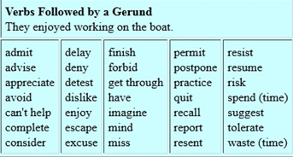
I enjoy hanging out with my friends.
She enjoyed going shopping.
She enjoyed not going shopping.
He didn’t mind cleaning my house.
They avoid eating fish.
I can’t help eating pasta.
- As a subject of a sentence
Reading on your cellphone is not very good for your eyes.
Cooking is my favorite hobby.
Dancing can be fun.
Running a marathon is very tiring.
Climbing can be dangerous.

- After preposistions
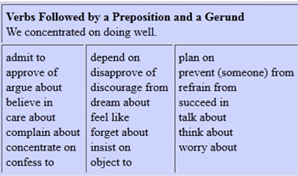
It depends on writing the report on time.
She was worried about eating at night.
They talked about wearing shoes.
Panchito always complains about studying math.
He cares about doing exercise.

- After go + activity
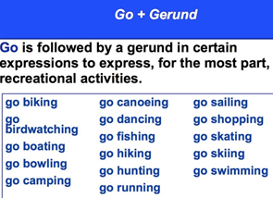
He went shopping yesterday.
I’ll go swimming next weekend.
We’ll go dancing.
She has gone camping to La Campa.
They went birdwatching to Meambar yesterday.
I have gone shopping twice this week.

- Infinitive to + verb
Use:
- After certain verbs
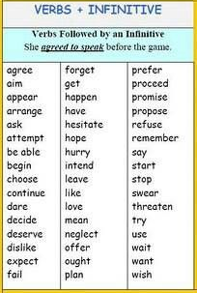
I agreed (not) to work late.
She is asking them to be quiet.
I have planned to study tomorrow.
She seems to be tired.
She seems not to be tired.

- After adjectives
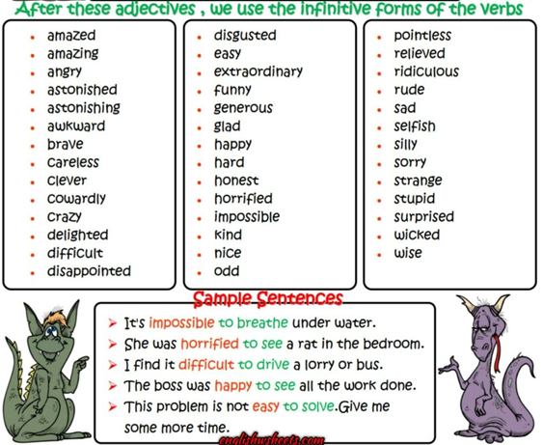

I’m happy to see you here.
It’s amazing to travel to Europe.
It’s important to speak English in class.
It’s important to participate in class.
It’s hard to work at night.
It’s difficult to understand when you’re eating.

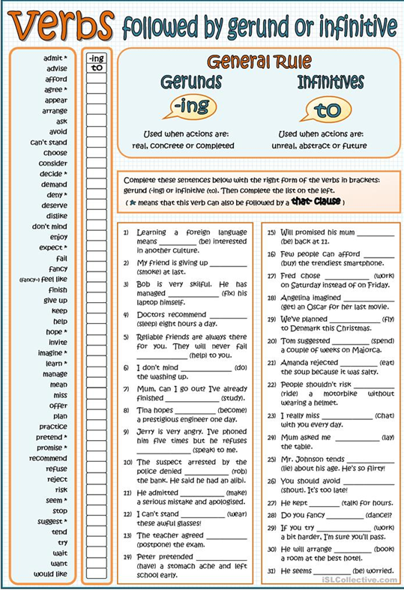

PRESENT PERFECT AND PRESENTE PERFECT CONTINUOUS
- Present perfect simple subject + have/has + past participle of the verb+ complement
(completion and result)
____________x__________x__________x___________
past now

Use: The action is completed (in the past but we don’t say when) and the result is that the speaker has these experiences now, in the present.
Time expressions: so far, since, for, already, yet, recently, before, still, lately, up to now, ever, never, several times.

I have traveled out of the country several times.
I havent traveled out of the ……….
I have lived in this house for a long time.
She hasn’t eaten fish since last month.
I have already done my homework. / I havent done my homework yet.
Have you done your homework yet?
They haven’t received their bonus yet.
I have to travel out of the country.
I don’t have to travel out of the country.

- Present perfect continuous subject+ have/has+ been+ v-ing+ complement
(duration or repetition)
_______________________________________________
Past now

Use: The activity has duration and happened in the recent past (it may or may not be completed)
I’ve been working here for 11 years. (duration)
We have been studying for 2 hours.
We’ve been listening to the teacher since 5 pm.
How long have you been waiting for me?
I’ve been waiting for you for 3 hours.

Repeated actitivties that started in the past and continue to now.
I’ve been going to the church a lot. (repeated)
They’ve been learning English recently.
I’ve been working a lot.
I’ve been eating a lot these weeks.

Note: we don’t usually use stative verbs in the continuous tense. (ex. Be, like, know, have (possession) )

