Assessment Unit 8
(Make a Copy and share with me)

Exercise 1 ( in pairs)(breakout rooms)

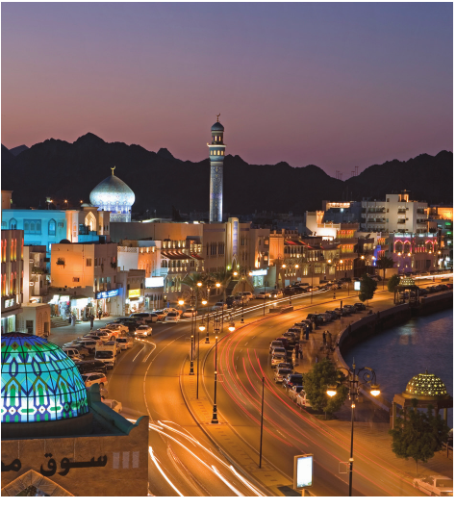
Look at the photo. You are on Vacation in Oman. Look at the sentences 1-5 and choose from the options. Then create a telephone conversation.

- I’m in Oman.
- It’s hot/cold.
- I’m o.k./ happy.
- The beach is nice / beautiful.
- My hotel is nice / o.k.

Exercise 2

Complete the sentences with the correct form of verbs in the parenthesis.(s / es; does / doesn’t)

- Jack___________in the hospital. (work)

- Ryan__________cusomers in a cafe.(serve)

- The bus__________________near my house.(not / stop)

- This button___________the door. (open)

- Kristen ___________________to work every day. (not / walk)

Exercise 3

Complete the paragraph with the correct form of the verbs.(s / es)

Buy get go have sell

Use watch work play not work

Alain Bofill 1._____________in the city. He 2. __________a computer all day. He 3.

___________ and 4.____________money dollars. He 5.____________home on the

subway. He 6. _____________home at nine o’clock in the evening. He 7.

__________dinner and he 8. ____________T.V. He 9. ______________on Saturdays,

he 10.____________golf with his friends.

Exercise 4

Fill in the sentences with the correct frequency adverb. (sometimes, never, usually, often).

- I ______________ have coffee with friends.

- My brother ___________ works late.

- My friend ___________studies at my home.

- Our teacher ___________ gives us homework.

- My colleague travels __________ in her job.

Exercise 5

Read the sentences, then write questions with the words in Parenthesis.

- Carl doesn’t finish work at eight o’clock. ( nine o’clock? )
1.

- John doesn’t work in an office. (Where?)
2.
- Julia doesn’t go to bed late. (early?)
3.

- My brother doesn’t read Novels. (What?)
4.

- My sister doesn’t like tea. ( coffee?)
5.

