Unit 7- book 4
Objectives
To talk about amazing buildings.
To talk about past habits.
Past habits
- Used to + base form to talk about past states and habits.
(+) I used to wake up early but now I sleep late.
(-) I didn’t use to wake up early.
(?) Did you use to wake up early? Yes, I did.
She used to live in El chichicaste when she was a child.(state)
Panchito used to eat meat // Panchito would eat meat.
- Would + base to talk habits but NOT past states.
I would go to the gym in the morning.
My mom would read me nice stories every night.
They would walk back home after school.
Anacleta went to Paris in 2019. ( it happened only once)
He used to go swimming every Saturday.
He would go swimming every Saturday.
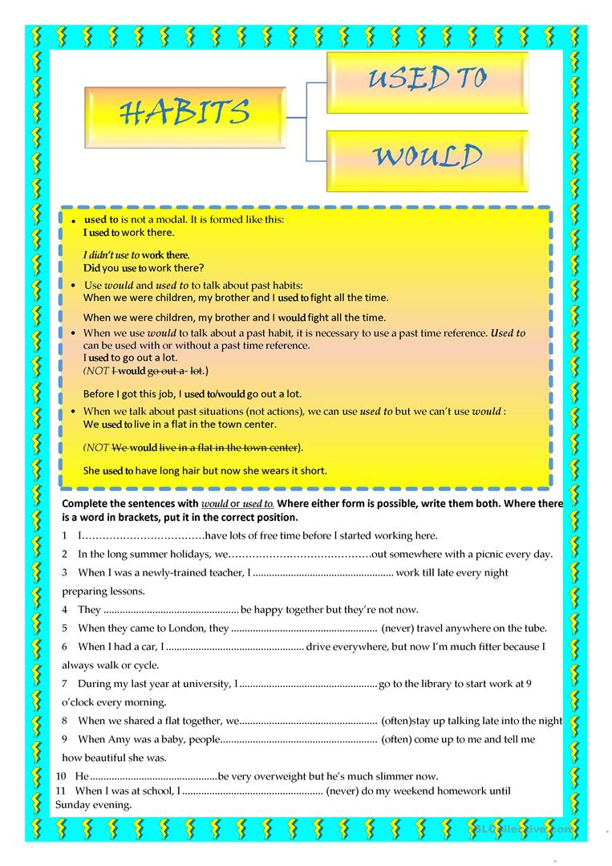
COMPARATIVE ADVERBS
Adverb Comparative form
Carefully ………………….. more/less carefully
Sadly ……………………….. more/less sadly
Happily …………………… more/ less happily
Quickly …………………… more/less quickly
Slowly …………………….. more/less slowly
IRREGULAR
Badly ………………… worse
Early ………………… earlier
Much ……………… more
Far ………………… further/farther
Little …………….. less
Well …………….. better
Trains go more slowly than planes.
Planes go faster than trains.
Panchito spends less money than Anacleta.
- verb +As + adverb (adjective) + as to say 2 things are equal.
She drives as carefully as her sister.
My mother cooks as delicious as my grandma.
Martina can run as fast as Silvia.
(not) as + adverb/adjective + as to say 2 things are not equal.
My mother doesn’t cook as delicious as my grandma.
The bus doesn’t go as fast as the motorcycle.
Intensifiers much, a lot , far(big difference), a bit, a little(small difference)
Panchito spends much more money than Anacleta.
Anacleta drives far more carefully than Anastasia.
Martica can run a lot faster than Silvia.

Comparative Patterns
- Describing two related things (one thing depends on another)
The more you write, the smarter you feel.
Comparative + subject + verb, comparative + subject + verb
The more you eat, the fatter you become.
The sooner I leave, the earlier I get home.
The faster you drive, the more dangerous it is.
- Describing change (how something or someone changes)
The balloon got bigger and bigger.
Everything is getting more and more expensive.
More and more people are getting the vaccine.
Less and less people are getting the vaccine.
English is becoming more and more difficult.

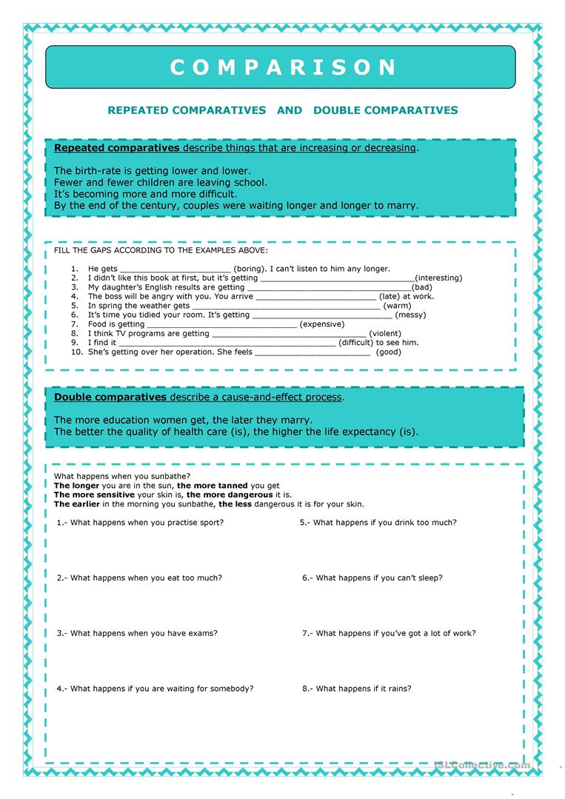
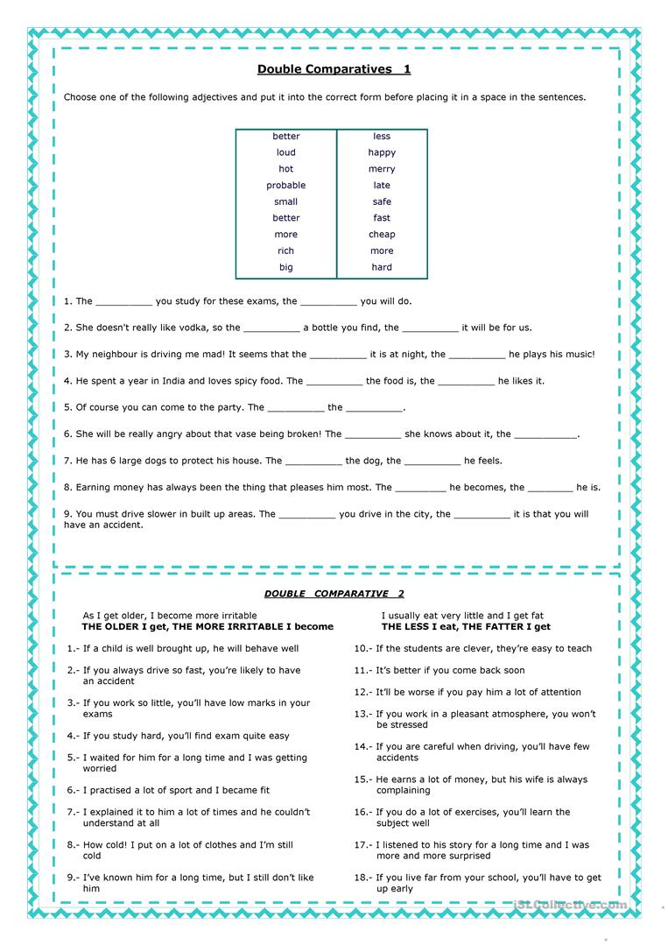
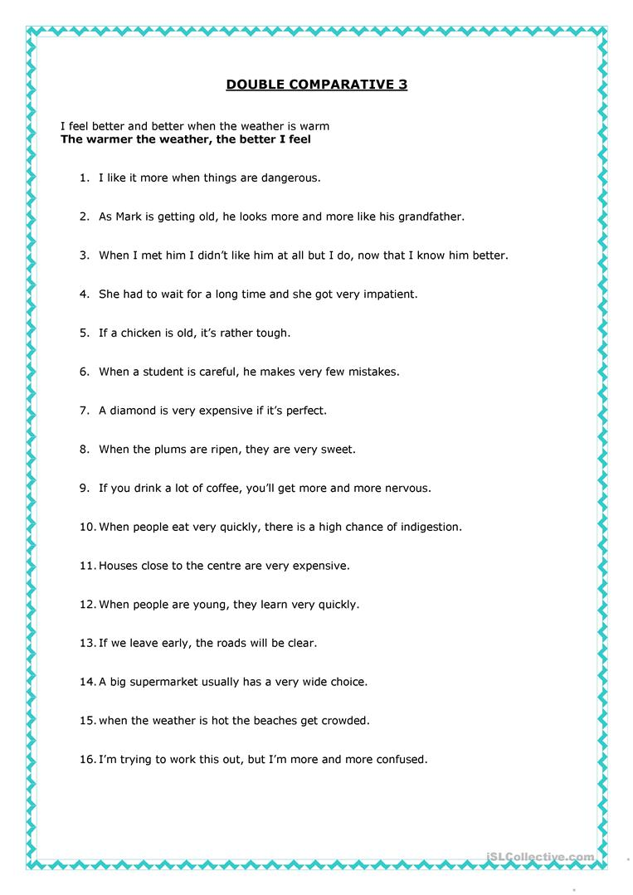
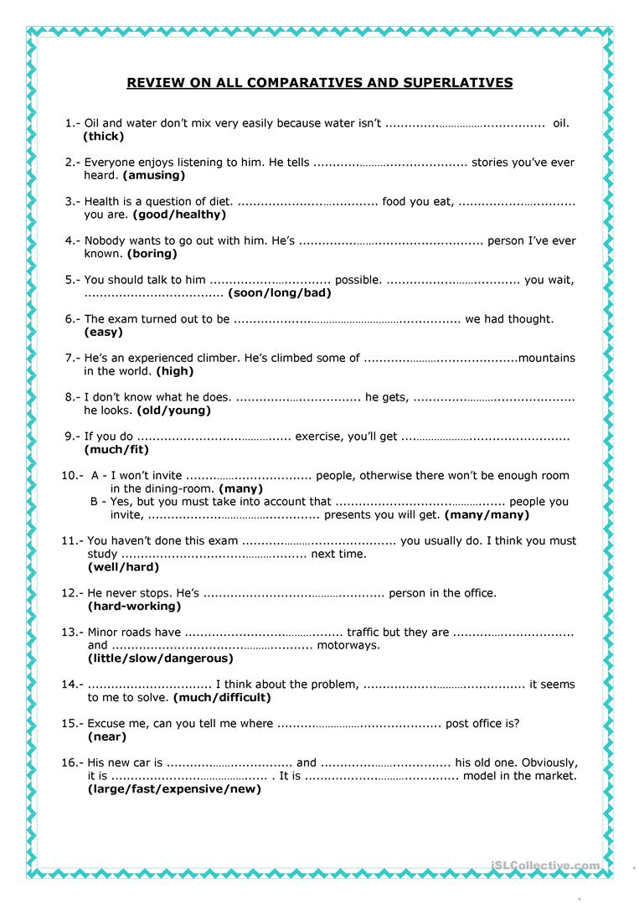

- As / like
As comparing
In the same way
Having a job role.
When, while
Because
Like similar to
For example
As if

