Unit 6 – book 2
Objectives
- To talk about your last vacations.
- To talk about famous biographies.
- To talk about your childhood.
GRAMMAR: Simple past
Simple past of verb to be.
Present past
Am, is was (wasn’t)
Are were (weren’t)
(+) I am happy today. I was happy yesterday.
(-) I’m not happy today. I wasn’t happy yesterday.
(?) Are you happy today? Were you happy yesterday?
Yes, I am Yes, I was.
(?) Why are you happy today? Why were you happy yesterday?
Because my family is here. Because my family was here.
She is at the airport she was at the airport.
They are really hungry they were really hungry.
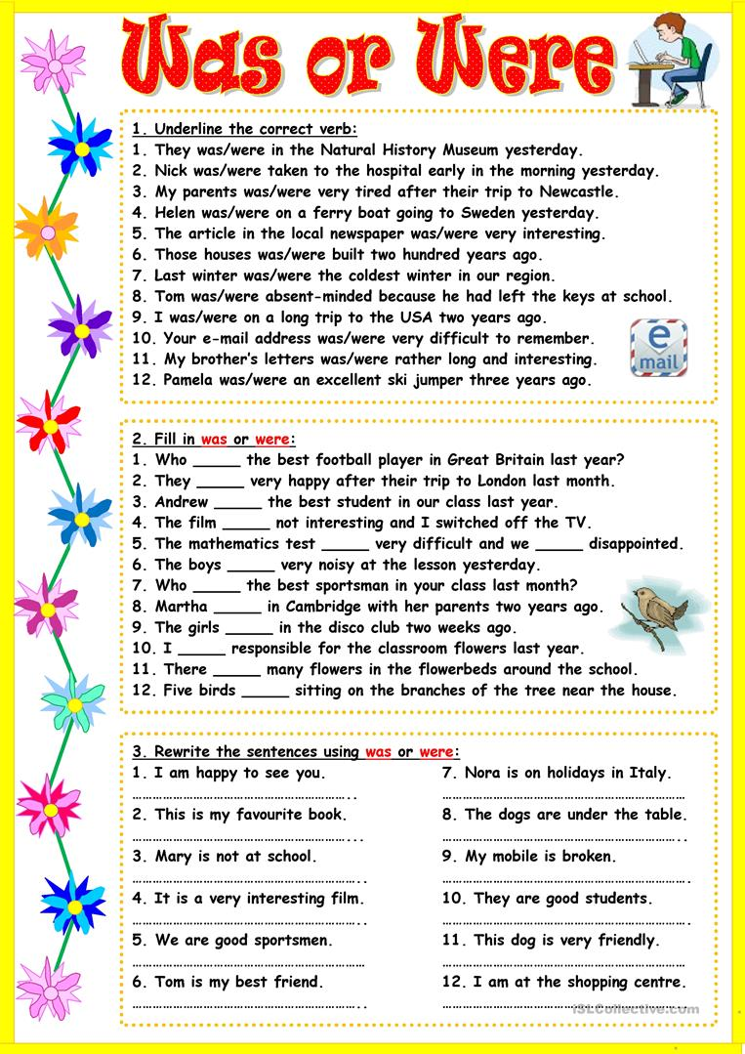

- Simple past
Use: to talk about completed actions, events, or situations in the past.
- To talk about a dead person.
Auxiliary: did questions
Didn’t negative
Past time expression:
ago : 5 minutes ago , a long time ago, many years ago, a little while ago, etc
last: last night, last week, last month, last year, last(Monday)
yesterday: yesterday morning, yesterday evening, the day before yesterday.
- Simple past irregular verbs
(+) Panchito went to Paris with his girlfriend Anacleta last month.
(-) Panchito didn’t go to Paris with his girlfriend Anacleta last month.
(+) She ate nacatamales for breakfast yesterday.
(-) she didn’t eat nacatamales for breakfast yesterday.
YES/NO QUESTIONS
Structure : auxiliary + subject + verb + complemente?
(?) Did Panchito go to Paris with his girlfriend Anacleta last month?
Yes, he did// No, he didn’t.
(?) Did you sleep well yesterday? (+)You slept well yesterday.
(-) You didn’t sleep well yesterday.
INFORMATION QUESTIONS
Structure: wh + auxiliary + subject + verb + complement ? (Object question)
Q: When did Panchito go to Paris with his girlfriend?
A: Last month.
Q: Where did Panchito and Anacleta go to?
A: To Paris
Q: Who did Panchito go to Paris with?
A: With his girlfriend.
Structure: wh + verb in past + complement ? (subject question)
Q: Who went to Paris with Anacleta last month?
A: Panchito
Jarvin went to El chichicaste with Panchito.
Subj. object.
Q: Who did Jarvin go to El Chichicaste with? (object question)
A: With Panchito
Q: Who went to El chichicaste with Panchito? (subject question)
A: Jarvin

Anacleta ate at that restaurant.
Q: Who ate at that restaurant?
A: Anacleta
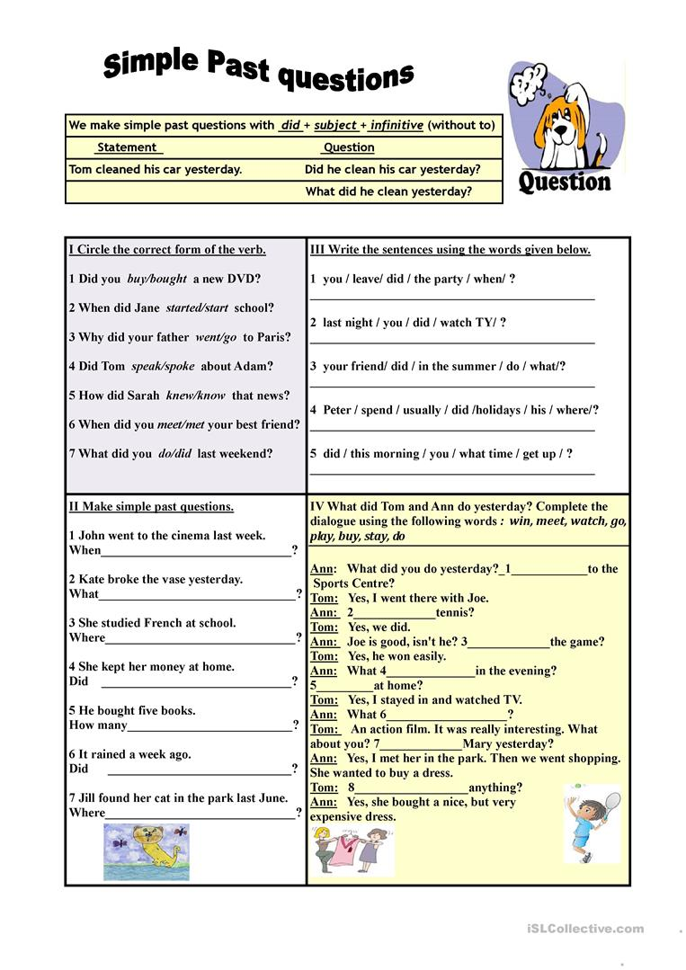
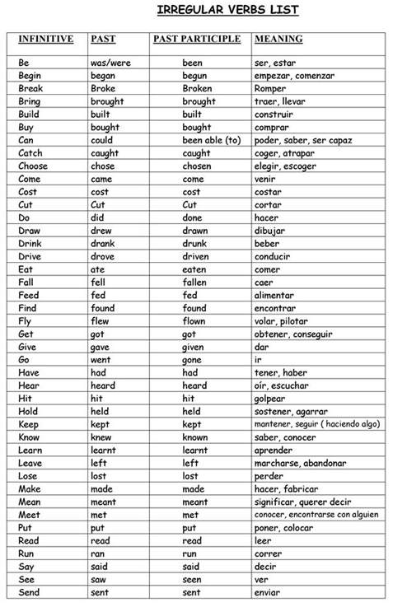
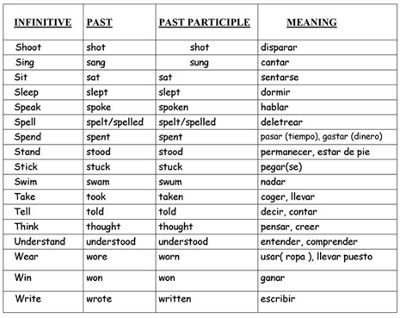
Simple past regular verbs
Add "ed" to most verbs:
- jump jumped
- paint painted
- open opened
- enter entered
- swallow swallowed

If a verb of one syllable ends consonant-vowel-consonant, double the final consonant and add "ed":
- chat chatted
- stop stopped

If the final consonant is "w," "x," or "y," don't double it:
- sew sewed
- play played
- fix fixed

If the last syllable of a longer verb is stressed and ends consonant-vowel-consonant, double the last consonant and add "ed":
- incur incurred
- prefer preferred

If the verb ends "e," just add "d":
- thrive thrived
- guzzle guzzled

If the verb ends consonant + "y", change the "y" to an "i" and add "ed":
- cry cried
- fry fried
- study studied
- try tried

Pronunciation of ED

1. The /id/ sound
If the last letter of the word is spelled with D or T, the ED is pronounced as a separate syllable with an /id/ sound
- want wanted (sounds like "want-id")
- wait waited
- need needed (nidid )
- fold folded

2. The /t/ sound
If the last consonant of the word is voiceless p, k, f,gh, sh, ch, ss, c, x , then the ED is pronounced as a T.
- Talk talked (sounds like "tokt")
- Kiss kissed (sound like "kisst")
- Park parked (parkt)
- Help helped (helpt)
- Fix fixed

3. The /d/ sound
If the last letter of the words ends in a voiced consonant (or sound) l, n, g, r, v, s, z, b, m, then the ED is pronounced like a D
- Play played (sounds like "playd")
- Close closed (sound like "clozd")
- Open opened
- Live lived (livd)

