Unit 5
Objective
To talk about food.
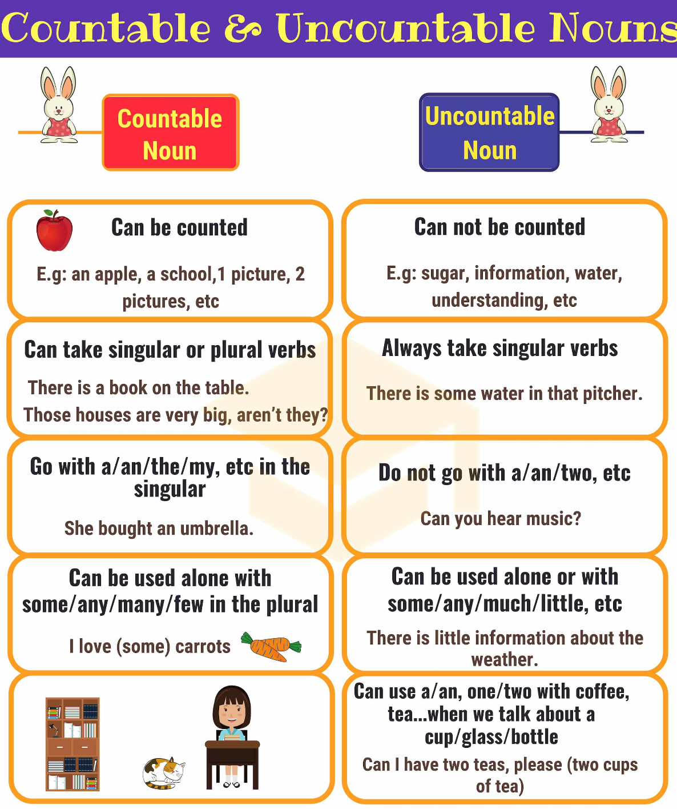
A / AN before singular countable noun
A before consonant sound.
AN before vowel sound.
____ hour ____ house _____ apples _____ university
____ unicorn ____ umbrella _____ banana _____ orange
There is a pencil in my bag. There is an orange in the basket.
There isn’t a pencil in my bag. There isn’t an orange in the basket.
Is there a pencil in your bag? Is there an orange in the basket?
Any plural countable nouns Some plural countable nouns
Uncountable nouns uncountable nouns
Negative sentences positive sentences
Questions questions (offer something)
There aren’t any apples in the bag. There are some apples in the bag.
Are there any apples in the bag? Do you want some apples?
There isn’t any coffee in the coffee pot. There is some coffee left.
Is there any coffee in the coffee pot? Would you like some coffee?

A lot of/ lots of plural countable nouns
Affirmative sentences
Uncountable nouns
Panchito eats a lot of junk food.
Anacleta has a lot of friends.

Many negative sentences much negative sentences
Questions questions
Plural countable nouns uncountable nouns
There aren’t many students today. There isn’t much milk in the fridge.
How many friends do you have? How much money do you have ?

A few plural countable nouns a little uncountable nouns
She has a few friends. He has a little money.

