Unit 11 – book 3
Objectives
- To report news.

REPORT SPEECH
USE: TO SAY WHAT SOMEONE SAID.
Backshift
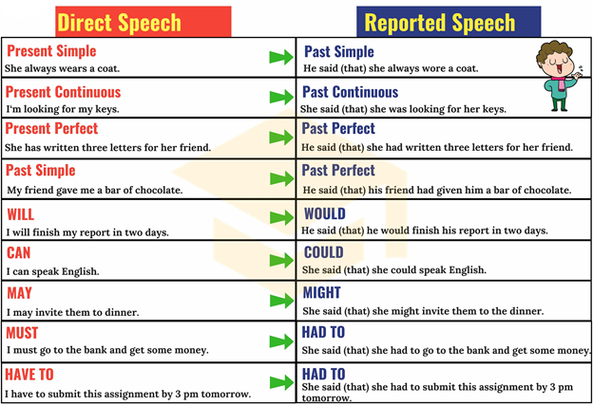

“I’m very tired” She said (that) she was very tired.
“They are happy” He said (that) they were happy.
“ He is writing a report” She said (that) he was writing a report.
“Karol is eating” She said (that) she was eating.
“I wash my car on weekends” He said (that) he washed his car on weekends.
“ They write letters.” they said (that) they wrote letters.
“He breaks the rules.” He said (that) he broke the rules.
“She paints houses” She said (that) she painted houses.
“They worked very hard.” They said (that) they had worked very hard.
“She has written 10 letters.” She said (that) she had written 10 letters.
“He wrote 10 letters.” She said (that) he had written 10 letters.
“They are traveling tomorrow.” They said (that) they were going to travel the next day.

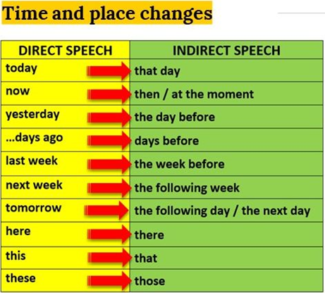

REPORTING QUESTIONS
Yes/No questions
Direct speech Reported speech
Do you want some more cake? She asked him if he wanted some more cake.
Are you coming to the cinema He asked if/whether she was going to the cinema
with me? with him.

Wh – questions
Where did he go on holiday? She asked me where he had gone on holiday.
How often do you play soccer? He asked him how often he played soccer.

“Are you hungry?” He asked me if I was hungry.
“ Did you study for the test?” He asked me if I had studied for the test.
“Is it blue?” She asked me if it was blue.
“ Where is the cafeteria?” He asked me where the cafeteria was.
“ Who is she?” He asked me who she was.
“Does she clean her house?”
“ Is she taking her English class?”
“ Where does she live?”
“What time is it?”
“Who’s your mother?”
“Why were you happy?” he asked me why I had been happy.
“How old are you?”

Say/said (to me)
Tell/told me
Ask/ asked me
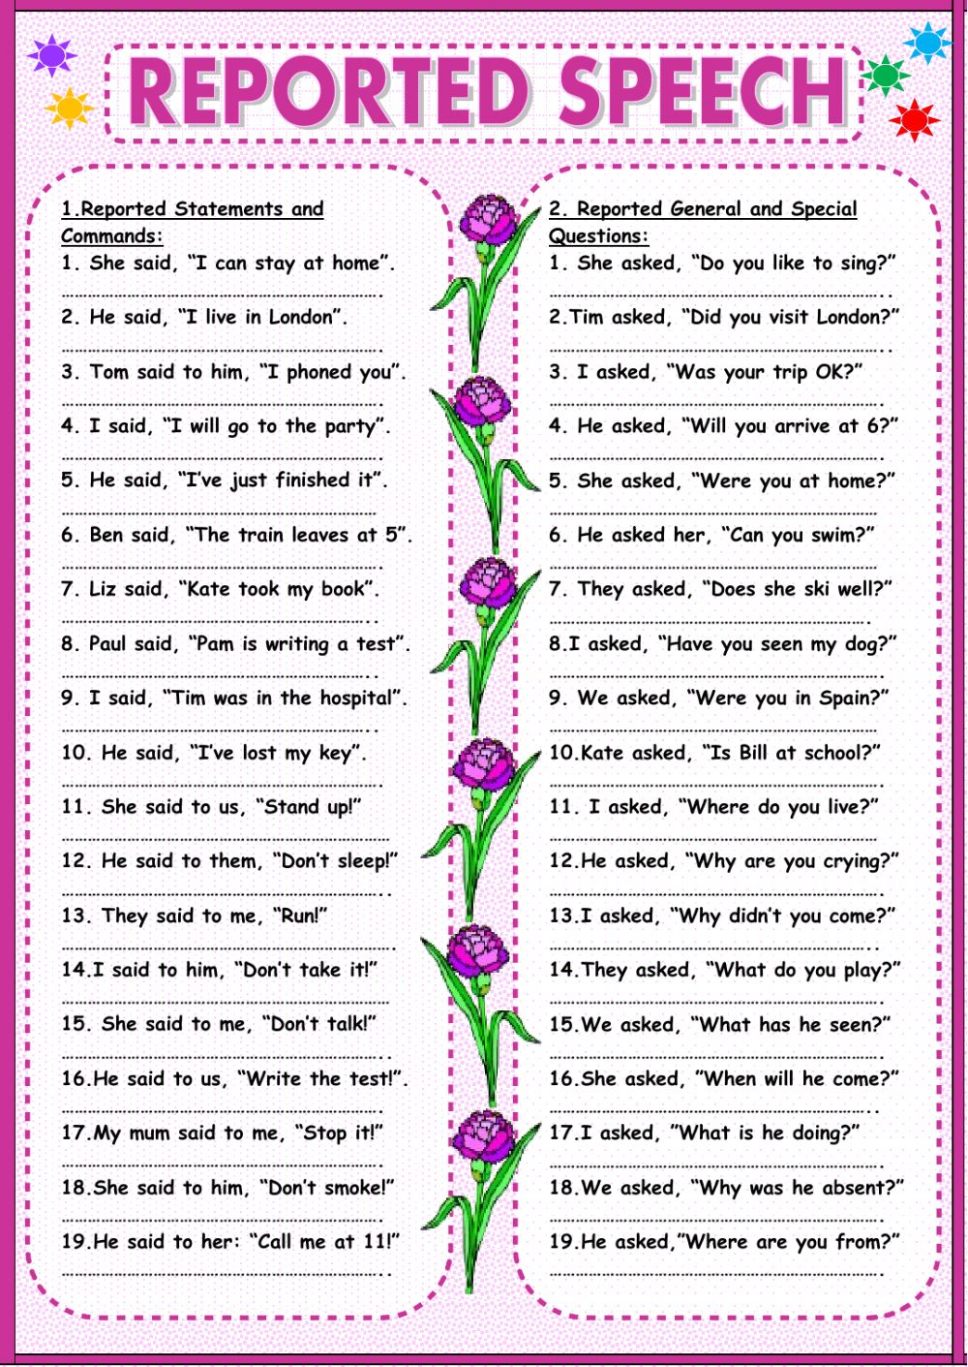}
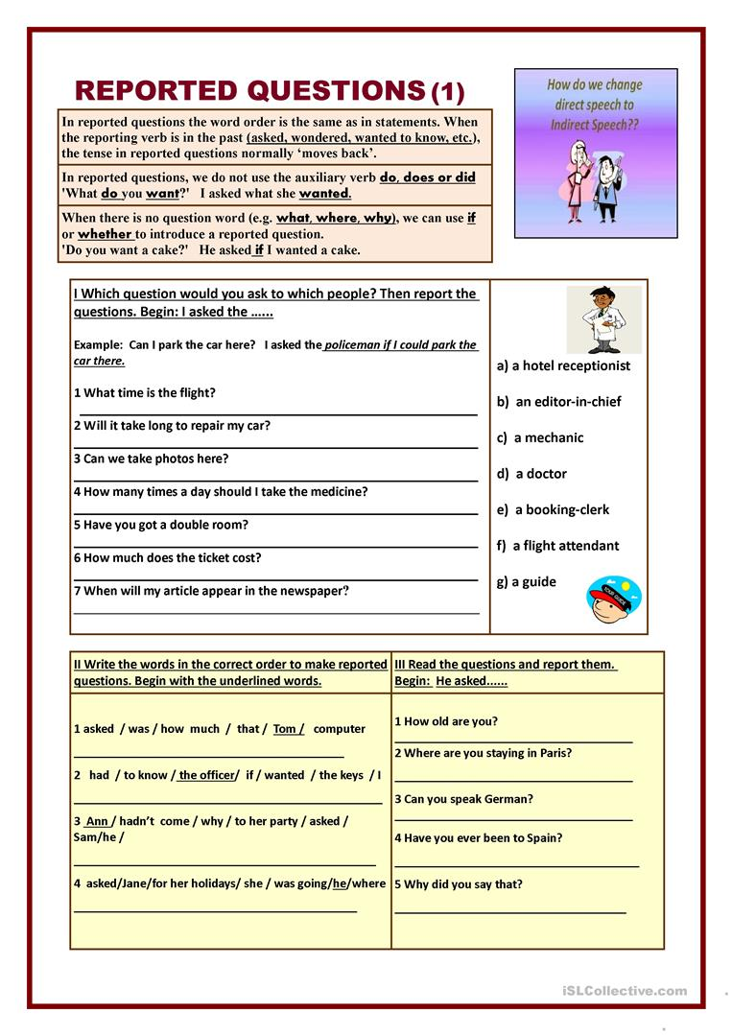
REPORTING VERBS
PATTERNS
- SAY -------
SHE SAID THAT HER BOYFRIEND HAD LEFT HER.

- ASK, TELL, REMIND, INVITE+ OBJECT + (NOT) + INFINITIVE
SHE TOLD ME NOT TO WRITE THE LETTER.

- PROMISE, OFFER + (NOT) INFINITIVE
SHE OFFERED TO CLEAN THE ROOM.

- PROMISE + THAT + CLAUSE
SHE PROMISED THAT SHE WOULDN’T DO IT AGAIN.

TO REPORT TOUGHTS:
- REALIZE, THINK, KNOW + THAT + SUBJECT + VERB
SHE KNEW THAT SHE HAD LEFT HER WALLET AT HOME.

- WONDER + IF/WHETHER
SHE WONDERED IF HER SON HAD DONE HIS HOMEWORK.

