Unit 10/12
0bjectives
- To talk about “start a new life”

CONDITIONAL SENTENCES
Second conditional (present unreal)
Use: To talk about imagine present of future situations that are impossible or improbable to happen. (hypothetical situation)
Structure: simple past , would/could/may/might + base form
If clause main clause (result)
Ex. If I won the lotto, I would buy a huge house.
I would buy a huge house if I won the lotto.
What would you do if you were a butterfly?
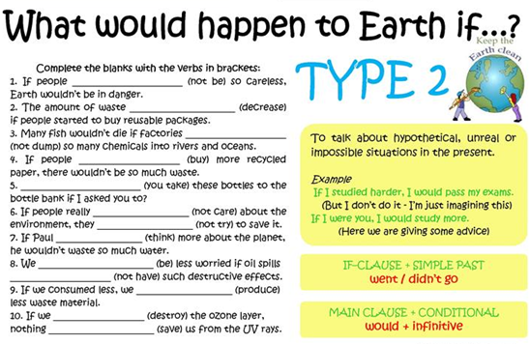
Third conditional (past unreal)
Use: it refers to an impossible condition in the past and its probable result in the past.
Structure: past perfect, would/could/may/might + have+ pp
If clause main clause (result)
Past perfect: had + past participle.
If I had studied, I would have gotten a better grade.
I would have gotten a better grade If I had studied.
Exercise
1. The phone was broken so I didn’t call you.
________________________________________________________
2. They laughed. Jim didn’t know how to reboot the pc.
________________________________________________________
3. I felt so ashamed since I didn’t speak his language.
_________________________________________________________
4. She didn’t take an umbrella with her and got wet.
_________________________________________________________
5. I wasn’t careful enough and so I hurt myself.
_________________________________________________________
6. I made up a silly excuse because I was late.
_________________________________________________________
7. He proposed to her and they got married.
_________________________________________________________
8. We didn’t go out. Tom was watching the game.
__________________________________________________________
9. He didn’t show up. I had dinner alone.
__________________________________________________________
10. I felt asleep because the lesson was so boring.
___________________________________________________________

Which conditional should I use?
- In my experiments, the liquid is cooled to 32 degrees. It always freezes.
  - If you cool the liquid to 32 degrees, it freezes.
  - If you cool the liquid to 32 degrees, it will freeze.
  - If you had cooled the liquid to 32 degrees, it would have frozen.
  - If you cooled the liquid to 32 degrees, it would freeze.
- He stepped on the mine, and it exploded.
  - If he doesn't step on the mine, it won't explode.
  - If he didn't step on the mine, it wouldn't explode.
  - If he hadn't stepped on the mine, it wouldn't have exploded.
  - If he doesn't step on the mine, it doesn't explode.
- You ignored my advice, so you got into trouble!
  - If you don't ignore my advice, you don't get into trouble.
  - If you don't ignore my advice, you won't get into trouble.
  - If you hadn't ignored my advice, you wouldn't have gotten into trouble.
  - If you didn't ignore my advice, you wouldn't get into trouble.
- Unfortunately, I don't know Philosophy, so I can't answer your question.
  - If I know Philosophy, I can answer your question.
  - If I know Philosophy, I will be able to answer your question.
  - If I knew Philosophy, I would be able to answer your question.
  - If I had known Philosophy, I would have been able to answer your question.
- It may rain this afternoon. I hope it doesn't because I don't want the match to be cancelled.
  - If it rains, the match will be cancelled.
  - If it rains, the match is cancelled.
  - If it had rained, the match would have been cancelled.
  - If it rained, the match would be cancelled.
- I want to buy a Porsche, but I don't have enough money.
  - If I have enough money, I buy a Porsche.
  - If I had enough money, I would buy a Porsche.
  - If I have enough money, I will buy a Porsche.
  - If I had had enough money, I would have bought a Porsche.
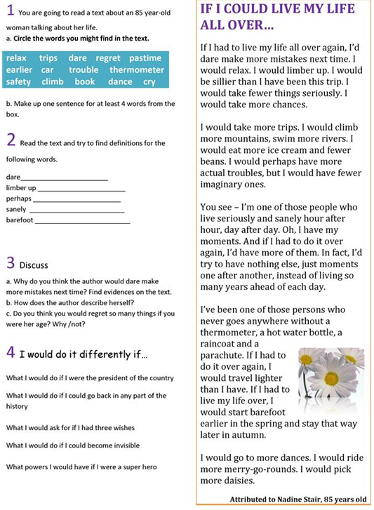

DEFINING RELATIVE CLAUSES
USE: Defining relative clauses give us essential information about something.
Relative Pronouns
Who people Why reason
Where place whose possessive
That people/thing whom people
Which thing
When time
- The man lives next door. He is very friendly.
The man who lives next door is very friendly.
She's the woman who cuts my hair.
He's the man that I met at the conference.
We know a lot of people. They live in El Chichicaste.
_________________________________________________
Where are the eggs? They were in the fridge.
___________________________________________________
Panchito is a good guy. His mother is a nurse.
_____________________________________________________
The window has now been repaired. It was broken.
_____________________________________________________

