English Course
Unit 1 Assessment
- Write I’m or you’re.
- Hello, ________ Jack.
- Hi, _________ Susana.
- _________ in my class.
- Good, ________ my teacher. Great, _______ my student.

- Write he’s, she’s or it’s.
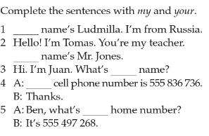
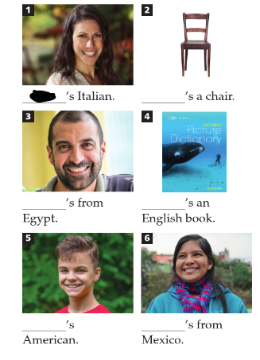
3.

- Write am, are, and is.

- Hi! I______ Elena.
- Paul_____ a doctor.
- He_____ from Hong Kong.
- It_____ in China.
- You______ American.

- Put the words in order to make sentences. Use contractions if possible.

- am / a / I / student / Honduras / from /
I’m a student from Honduras.
- is / the United States / it / from It’s from the United States.
- Mexico / is / Elisabeth / from
- Spanish / is / the teacher
- is / Brazilian / he
- in / New York / am /

- Write the numbers:

- Four _____
- Ten_____
- Fifteen _____
- Eight ______
- Three _____

- Write good morning, good afternoon, good evening and good night:

- 3:30 pm. _____________________
- 8:10 am. _____________________
- 11:50 pm. ____________________
- 7:00pm. _____________________

