USED TO
NAME:_____________________________________________ DATE:______________________

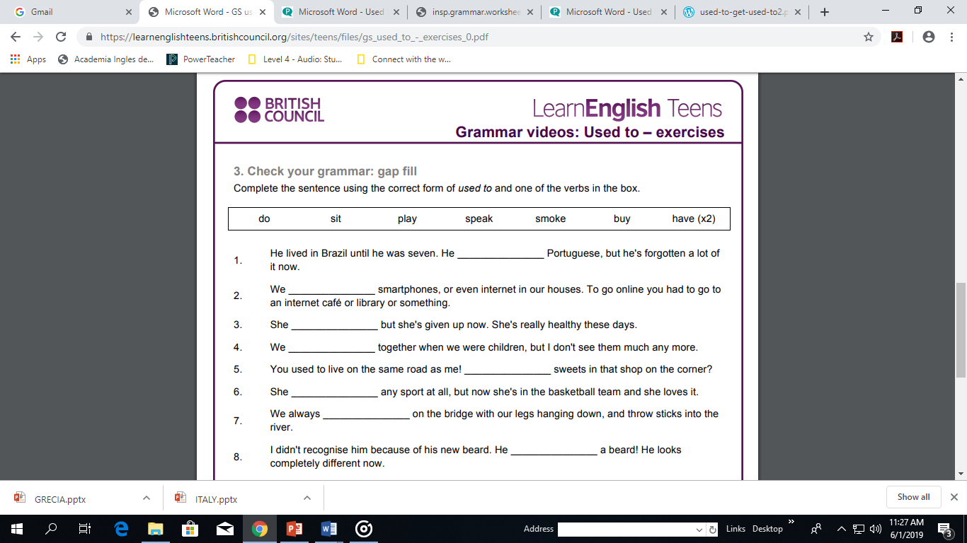

- Choose the correct words to complete each sentence.
200 years ago …
1 … people used to / didn’t use to make their own clothes.
2 … people used to / didn’t use to have mobile phones.
3 … people used to / didn’t use to read books.
4 … people used to / didn’t use to watch TV.
5 … people used to / didn’t use to drive cars.
6 … people used to / didn’t use to walk everywhere.

- Choose the correct words to complete each sentence.
1 Why did people _______________ mend their clothes?
a) used to b) use to c) didn’t use to
2 I _______________ like watching football, but now I do.
a) used to b) use to c) didn’t use to
3 What did you _______________ like doing when you were young?
a) used to b) use to c) didn’t use to
4 John _______________ like Mary, but he doesn’t now.
a) used to b) use to c) didn’t use to
5 People _______________ produce as much rubbish as we do nowadays.
a) used to b) use to c) didn’t use to
6 Did you _______________ collect anything when you were young?
a) used to b) use to c) didn’t use to

- Complete these sentences with used to or didn’t use to.
1 I _______________ play the guitar, but I do now.
2 I _______________ ride a bike, but I don’t any more.
3 I _______________ collect stamps, but I don’t any more.
4 I _______________ enjoy getting up early, but I do now.
5 I _______________ be worried about the environment, but I am now.
6 I _______________ be afraid of flying, but I’m not anymore.
7 I _______________ know how to use a computer, but I do now.

