UNIT 8/12
Objectives
- To talk about technology
- To talk about conditions

CONDITIONAL SENTENCES
Zero conditional
Use: for facts that are generally true and do not change.
It refers to a general situation that always happens if a condition is met.
Structure: simple present , simple present
If clause (condition) main clause (result)
Ex. If you leave ice in the sun, it melts.
Ice melts if you leave it in the sun.
If it rains, the trees get wet.
The trees get wet if it rains.
If you freeze water, it turns into ice.
Water turns into ice if you freeze it.
What happens if you don’t take breakfast?
If I don’t take breakfast, I’m hungry at 8:00 am.
I’m hungry at 8:00 am If I don’t take breakfast.

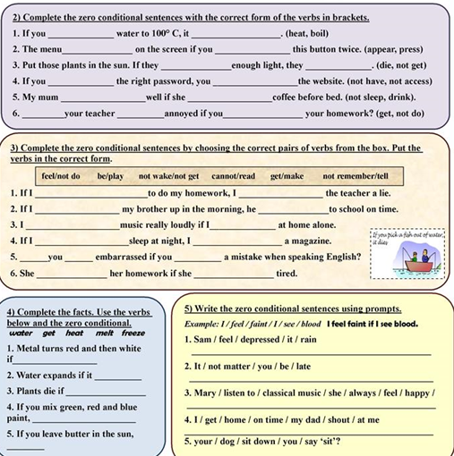
First conditional
Use: We use it to talk about a possible future event(result)
Structure: simple present , future +will/won’t
If clause main clause (result)
Ex. If you come tomorrow, we will go to the park.
We’ll go to the park if you come tomorrow.
If I have enough money, I’ll buy a new car.
I’ll buy a new car if I have enough money.
If I see him, I’ll tell him you miss him a lot.
We’ll go to the park if my mom comes early.
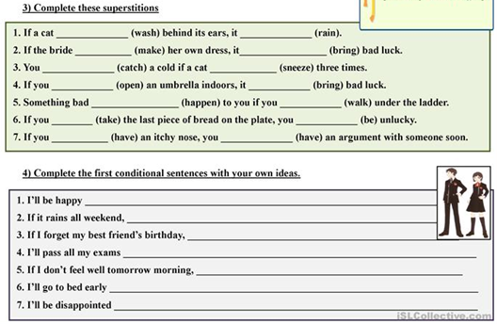

Second conditional (present unreal)
Use: To talk about imagine present of future situations that are impossible or improbable to happen. (hypothetical situation)
Structure: simple past , would/could/may/might + base form
If clause main clause (result)
Ex. If I won the lotto, I would buy a huge house.
I would buy a huge house if I won the lotto.
What would you do if you were a butterfly?
I could fly if I was/were a butterfly.
I could clean my house if I had time.
I could play all day long if I had a day off.
I would play all day long if I didn’t have to work.
If I were/was you, I would review the conditional sentences.
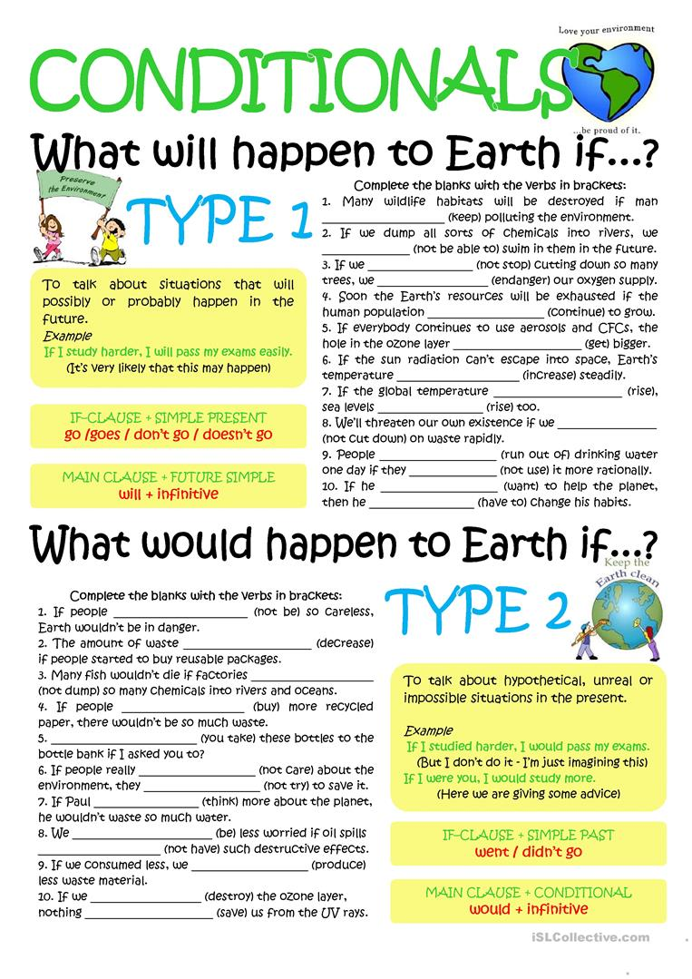
Third conditional (past unreal)
Use: it refers to an impossible condition in the past and its probable result in the past.
Structure: past perfect, would/could/may/might + have+ pp
If clause main clause (result)
Past perfect: had + past participle.
If I had studied, I would have gotten a better grade.
I would have gotten a better grade If I had studied.
If I had gone to the party, I could have had fun.
If I hadn’t gone to the party, I wouldn’t have gotten the virus.
If I had visited my mom, she might have made lunch for us.
What would you have done if you had known about the pandemic?
If I had known about the pandemic, I would have traveled to USA.

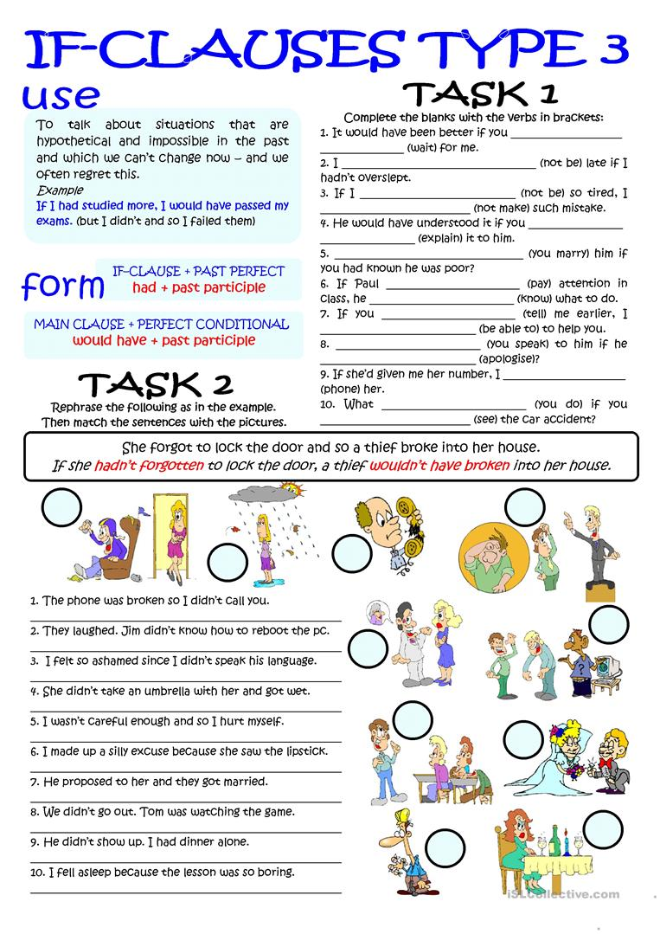
Which conditional should I use?
- In my experiments, the liquid is cooled to 32 degrees. It always freezes.
  - If you cool the liquid to 32 degrees, it freezes.
  - If you cool the liquid to 32 degrees, it will freeze.
  - If you had cooled the liquid to 32 degrees, it would have frozen.
  - If you cooled the liquid to 32 degrees, it would freeze.
- He stepped on the mine, and it exploded.
  - If he doesn't step on the mine, it won't explode.
  - If he didn't step on the mine, it wouldn't explode.
  - If he hadn't stepped on the mine, it wouldn't have exploded.
  - If he doesn't step on the mine, it doesn't explode.
- You ignored my advice, so you got into trouble!
  - If you don't ignore my advice, you don't get into trouble.
  - If you don't ignore my advice, you won't get into trouble.
  - If you hadn't ignored my advice, you wouldn't have gotten into trouble.
  - If you didn't ignore my advice, you wouldn't get into trouble.
- Unfortunately, I don't know Philosophy, so I can't answer your question.
  - If I know Philosophy, I can answer your question.
  - If I know Philosophy, I will be able to answer your question.
  - If I knew Philosophy, I would be able to answer your question.
  - If I had known Philosophy, I would have been able to answer your question.
- It may rain this afternoon. I hope it doesn't because I don't want the match to be cancelled.
  - If it rains, the match will be cancelled.
  - If it rains, the match is cancelled.
  - If it had rained, the match would have been cancelled.
  - If it rained, the match would be cancelled.
- I want to buy a Porsche, but I don't have enough money.
  - If I have enough money, I buy a Porsche.
  - If I had enough money, I would buy a Porsche.
  - If I have enough money, I will buy a Porsche.
  - If I had had enough money, I would have bought a Porsche.

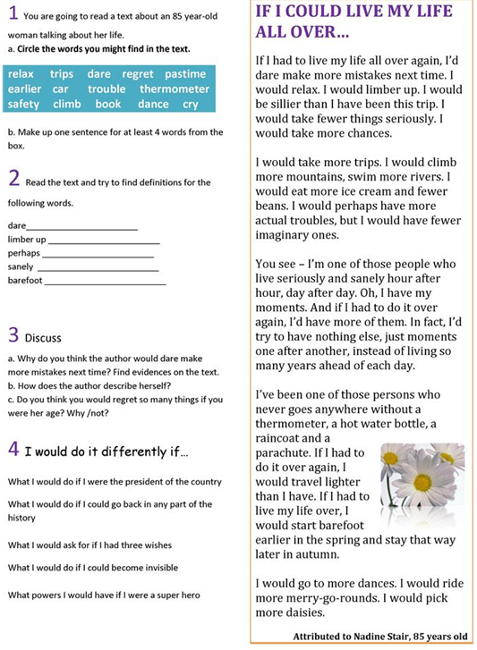

DEFINING RELATIVE CLAUSES
USE: Defining relative clauses give us essential information – information that tells us who or what we are talking about.
Relative Pronouns
Who people Why reason
Where place whose possessive
That people/thing whom people
Which thing
When time
- The man lives next door. He is very friendly.
The man who lives next door is very friendly.
She's the woman who cuts my hair.
He's the man that I met at the conference.
We know a lot of people. They live in El Chichicaste.
_________________________________________________
Where are the eggs? They were in the fridge.
___________________________________________________
Panchito is a good guy. His mother is a nurse.
_____________________________________________________
The window has now been repaired. It was broken.
_____________________________________________________
