unit 8

objective

to talk about unique places in the world.

MIXED CONDITIONAL sentences
It is possible for the two parts of a conditional sentence to refer to different times, and the resulting sentence is a "mixed conditional" sentence. There are two types of mixed conditional sentence.
1. mixed second and third conditional. These mixed conditional sentences refer to an unreal present situation and its probable (but unreal) past result.
If + Simple past would + have + past participle
If clause main clause
Unreal present probable but unreal
Situation. Past result.
- If I wasn't afraid of spiders, I would have picked it up.
- I would have picked it up if I wasn't afraid of spiders.
- If I wasn’t taking my English class, I would have gone with my parents.
- If I were a man, They would have given me the job.
- If I didn’t love my pets, I wouldn’t have taken them to the vet.
- If I had that amount of money, I’d have bought that mansion.

2. MIXED THIRD AND SECOND CONDITIONAL.
This type of mixed conditional refers to an unreal past condition and its imagined result in the present. These sentences express a situation which is contrary to reality.
If + Past Perfect would/could/might + base form
If clause main clause
Unreal past probable result in
situation. the present.
- If I had studied, I would have my driving license. (but I didn't study and now I don't have my license)
- I would be a millionaire now if I had taken that job. (but I didn't take the job and I'm not a millionaire)
- If you had spent all your money, you wouldn't buy this jacket. (but you didn't spend all your money and now you can buy this jacket)
- If I hadn’t had an accident, I would be in The Air Force.
- If I had been born in USA, I would speak English.
- If I hadn’t crashed, I would have my car.

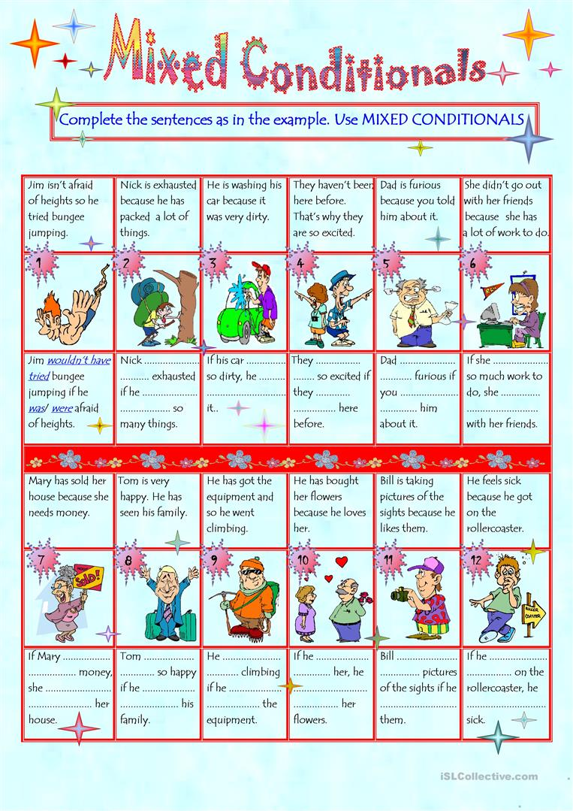
WISH, WOULD RATHER, IF ONLY
Wish/ if only ( to express a strong wish that things could be different)
Use: to talk about regrets and to describe an imaginary situation which is the opposite of the real situation.
- Wish/ if only + simple past present regrets
I wish you didn’t live so far. ( I want the situation to be different)
I wish I knew what to do.
- Wish /if only + past perfect (had + pp) past regrets ( past situations)
I wish I hadn’t eaten all that chocolate. I feel sick.
If only I had known you were coming…
- Wish/ if only + noun/pronoun + would + base form
Use: to express a wish for someone to do something differently in the present or future. (things we can’t change)

She wishes it would rain, the plants really need some water.
If only you wouldn’t borrow my car without asking.
I wish people would stop doing that.

USING WOULD RATHER
- Would rather + base form same subject
Use: to talk about preferences

I’d rather go for dinner.
I´d rather not fly. I hate planes.
She’d rather listen to music than watch tv.
Would you rather meet me at the restaurant?

- Would rather + object + simple past different subject
She would rather (that) you came another time.
She’d rather (that) Panchito didn’t stay so late at the office.

1. Panchito would rather his son ________ (play)tennis this year but he prefers to play soccer.

2. Shall we order pizza? I’d rather ________ (have) chicken.

3. Can I have pizza tonight? I’d rather you ______ (do/not) It’s not healthy.

4. Are you going to call Panchito or would you rather I _____ (do)

5. He called and said he’d rather _______ (visit) us after dinner.

6. My boss would rather we ________ (wait) before signing the contract.

7. If you could choose, would you rather _______ (visit) London or Paris?

8. Mum would rather you _____ (do) your homework.

Prefer + infinitive
Prefer + gerund

