UNIT 8

2ND CONDITIONAL (PRESENT UNREAL)
USE: TO TALK ABOUT HYPOTHETICAL SITUATIONS IN THE PRESENT OR FUTURE.
(UNREAL OR IMAGINARY SITUATIONS)
STRUCTURE: SIMPLE PAST WOULD/COULD/MIGHT/ + BASE FORM
IF CLAUSE RESULT CLAUSE
IF I WON THE LOTTO, I’D BUY A BIG HOUSE.
SHE WOULD TRAVEL ALL OVER THE WORLD IF SHE WERE RICH.
IF I WERE YOU, I WOULDN’T TRUST HIM.
IF SHE WERE MY DAUGHTER, I WOULDN’T LET HER DROP OUT OF SCHOOL.
WHAT WOULD YOU DO IF YOU WERE A BUTTERFLY?

3RD CONDITIONAL (PAST UNREAL)
USE: TO TALK ABOUT IMAGINED PAST SITUATION THAT DIDN’T HAPPEN AND SPECULATE ON A POSSIBLE RESULT OF THIS SITUATION.
STRUCTURE: PAST PERFECT WOULD/COULD/MIGHT/+HAVE+PAST PARTICIPLE
IF CLAUSE RESULT CLAUSE
IF SHE HAD STUDIED, SHE WOULD HAVE PASSED THE TEST.
I WOULDN’T HAVE FELT SICK IF I HADN’T EATEN SO MUCH.

Conditionals.
- In my experiments, the liquid is cooled to 32 degrees. It always freezes.
  - If you had cooled the liquid to 32 degrees, it would have frozen.
  - If you cooled the liquid to 32 degrees, it would freeze.
  - If you cool the liquid to 32 degrees, it freezes.
  - If you cool the liquid to 32 degrees, it will freeze.

- He stepped on the mine, and it exploded.
  - If he doesn't step on the mine, it doesn't explode.
  - If he doesn't step on the mine, it won't explode.
  - If he didn't step on the mine, it wouldn't explode.
  - If he hadn't stepped on the mine, it wouldn't have exploded.
- It may rain this afternoon. I hope it doesn't because I don't want the match to be cancelled.
  - If it rains, the match is cancelled.
  - If it rains, the match will be cancelled.
  - If it had rained, the match would have been cancelled.
  - If it rained, the match would be cancelled.
- Unfortunately, I don't know Philosophy, so I can't answer your question.
  - If I knew Philosophy, I would be able to answer your question.
  - If I know Philosophy, I can answer your question.
  - If I know Philosophy, I will be able to answer your question.
  - If I had known Philosophy, I would have been able to answer your question.

- I want to buy a Porsche, but I don't have enough money.
  - If I had had enough money, I would have bought a Porsche.
  - If I have enough money, I will buy a Porsche.
  - If I had enough money, I would buy a Porsche.
  - If I have enough money, I buy a Porsche.
- You ignored my advice, so you got into trouble!
  - If you didn't ignore my advice, you wouldn't get into trouble.
  - If you don't ignore my advice, you don't get into trouble.
  - If you hadn't ignored my advice, you wouldn't have gotten into trouble.
  - If you don't ignore my advice, you won't get into trouble.

MIXED CONDITIONAL SENTENCES
USE: TO TALK ABOUT UNREAL SITUATIONS WHEN THE IF CLAUSE AND THE MAIN CLAUSE (RESULT) DOESN’T REFER TO THE SAME TIME.
- MIXED SECOND AND THIRD CONDITIONALS

(UNREAL PRESENT SITUATION) (PROBABLE (BUT UNREAL) PAST RESULT SIMPLE PAST WOULD HAVE + PAST PARTICIPLE
IF CLAUSE MAIN (RESULT) CLAUSE

USE: TO TALK ABOUT AN IMAGINED SITUATION IN THE PRESENT OR FUTURE WITH THE HYPOTHETICAL PAST RESULT OR CONSEQUENCE. (WHAT WOULD HAVE HAPPENED IN THE PAST.)

IF I WERE RICH, I WOULD HAVE BOUGHT THE CAR I SAW YESTERDAY.
IF I WASN’T AFRAID OF SPIDERS, I WOULD HAVE PICKED IT UP.
SHE WOULDN’T HAVE TRAVELED BY BOAT IF SHE WASN’T AFRAID OF FLYING.

- MIXED THIRD AND SECOND CONDITIONALS
(UNREAL PAST CONDITION ) (PROBABLE RESULT IN THE PRESENT)
PAST PERFECT WOULD/COULD/MIGHT + BASE FORM
IF CLAUSE MAIN (RESULT) CLAUSE
USE: TO TALK ABOUT AN IMAGINED SITUATION OR ACTION IN THE PAST WITH THE IMAGINED CONSEQUENCE IN THE PRESENT OR FUTURE.
IF I HAD WORKED HARDER, I WOULD HAVE A BETTER JOB NOW.
WE WOULDN’T BE LOST IF WE HAD USED THE GPS.
IF YOU HAD CAUGHT THAT PLANE, YOU’D BE DEAD NOW.
IF HE HAD CRASHED HIS FATHER’S CAR, HE……….
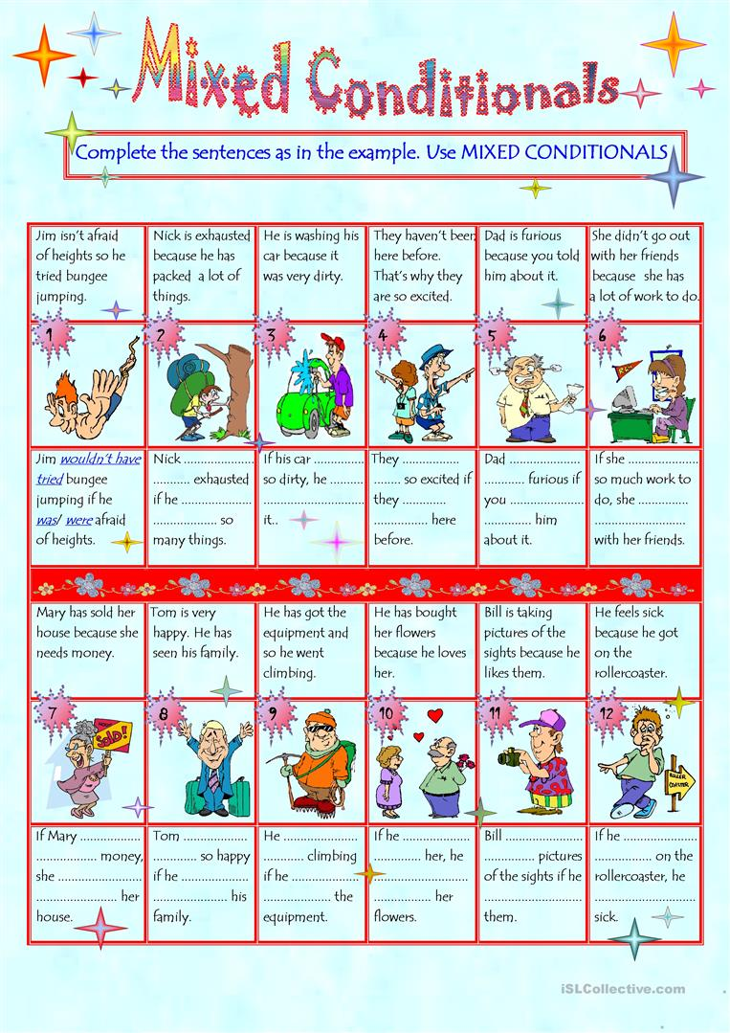
WISH, WOULD RATHER, IF ONLY
WISH/IF ONLY
USE: TO TALK ABOUT REGRETS AND TO DESCRIBE AN IMAGINARY SITUATION WHICH IS THE OPPOSITE OF THE REAL SITUATION.
- WISH/IF ONLY + SIMPLE PAST ( PRESENT REGRET)
I WISH YOU DIDN’T LIVE SO FAR AWAY.
I WISH I KNEW WHAT TO DO.
- WISH/IF ONLY + PAST PERFECT (PAST REGRET)
I WISH I HADNT EATEN ALL THAT CHOCOLATE. I FEEL SICK.
IF ONLY I HAD KNOWN YOU WERE COMING.
- WISH/IF ONLY + NOUN/PRONOUN + WOULD+ BASE FORM : TO EXPRESS A WISH FOR SOMEONE TO DO SOMETHING DIFFERENTLY IN THE PRESENT OR FUTURE. (THINGS WE CAN’T CHANGE)

SHE WISHES IT WOULD RAIN. THE GARDEN REALLY NEEDS SOME WATER.
IF ONLY SHE WOULDN’T BORROW MY CLOTHES WITHOUT ASKING.
I WISH YOU’D GIVE UP SMOKING. IT’S REALLY BAD FOR YOU.

WOULD RATHER + BASE FORM / PREFER + INFINITIVE ( NOUN/GERUND)
WOULD RATHER + BASE FORM (SAME SUBJECT)
USE: TO TALK ABOUT PREFERENCES.

I’D RATHER LISTEN TO MUSIC./ I PREFER _____________________________
WOULD YOU RATHER DRINK BEER OR WINE WITH THE FOOD?
I’D RATHER NOT ANSWER THAT QUESTION.
I’D RATHER LISTEN TO MUSIC THAN WATCH TV.

WOULD RATHER + OBJECT + SIMPLE PAST (DIFFERENT SUBJECT)
USE: TO SAY WHAT WE WOULD PREFER SOMEONE ELSE TO DO.

SHE WOULD RATHER (THAT) HE WEREN’T SO ANGRY.
I’D RATHER (THAT) YOU CAME ANOTHER TIME.
SHE’D RATHER (THAT) PANCHITO DIDN’T PHONE AFTER 10 PM .

I’D RATHER COOK THE MEAL TONIGHT.
I’D RATHER YOU COOKED THE MEAL TONIGHT.

- PANCHITO WOULD RATHER HIS SON ______________ (PLAY) TENNIS THIS YEAR BUT HE’D PREFER TO PLAY SOCCER.
- A: SHALL WE ORDER PIZZA?
B: I’D RATHER ____________ (HAVE) CHICKEN.
- A: CAN I HAVE BEANS TONIGHT?
B: I RATHER YOU _________ (NOT). IT’S NOT HEALTHY.
- ARE YOU GOING TO CALL ANA OR WOULD YOU RATHER I _________ (DO) IT?
- HE CALLED AND SAID HE’D RATHER ___________ (VISIT) US AFTER DINNER.
- MY BOSS WOULD RATHER WE __________ (WAIT) BEFORE BOOKING THE ROOMS.
- IF YOU COULD CHOOSE, WOULD YOU RATHER __________ (VISIT) LONDON OR PARIS?
- MARIA WOULD RATHER YOU __________ (DO) YOUR HOMEWORK BEFORE WATCHING TV.

