UNIT 6

OBJECTIVES
- TO TALK ABOUT STAYCATIONS
- UNUSUAL PLACES TO STAY.

GRAMMAR: NOT
The position of “not” with verbs is as follows:
- After the verb to be
It isn’t a nice place to visit.
They weren’t with us.
She isn’t a good person.
- After an auxiliary (has/have, did, do/does, will)
She hasn’t booked yet.
Actually, they didn’t go to Spain.
We don’t like camping in winter, it’s too cold.
He doesn’t like to eat nacatamales.
- After modal verbs (must, can, could, should, would, may, might)
You must not eat junk food.
He can’t explain it.
I couldn’t have said it better myself.
He shouldn’t help his sister.
- Negative infinitive (to+verb)
Use: to give advice or order about what not to do.
It’s cheaper not to go abroad.
We decided not to go to “El Chichicaste”
I agreed not to pay the bill.
- (do/does/did)Not + Want // would + not + like
Use: to talk about a wish not to do something in the future.
I don’t want to do homework but I have to.
I wouldn’t like to travel during the pandemic.
She wouldn’t like to eat Korean food.
He doesn’t want to wash the car.

- Must + not to say that it’s important not to do something.
(auxiliary)Not + have to to show that something isn’t important or essential.
She mustn’t go out at midnight as It’s very dangerous.
They don’t have to clean the whole room if they don’t want to.
She mustn’t run carrying the scissors.
- Hope // think
Subject + hope + subject + auxiliary verb + not
I hope he isn’t late again.
She hopes her mom hasn’t had an accident.
They hope he isn’t in bad physical condition.
Subject + not + think
I don’t think he should go there in the middle of the night.
She doesn’t think (that) that’s a good idea.
- Let’s + not to make a negative suggestion
Let’s not sleep ‘cause we have to study.
Let’s not go out tonight, because I have homework to do.
Let’s not work under the rain.

TAG QUESTIONS
Use: to ask for confirmation. (it´s that right? / do you agree?) tag questions come at the end of a sentence.
a) positive sentence, negative tag (expects a yes answer)
Gissel is hungry, isn´t she?
They ate fish for lunch, didn’t they?
He can play the guitar, can’t he?
They’ll go to bed late, won’t they?
I’m next, aren’t I ?
b) negative sentence, positive tag (expects a no answer)
it hasn’t rained yet, has it?
That’s not easy, is it?
My brother didn’t listen to Reggaeton, did he?
Panchito can’t drive well, can he?
I’m not tall, am I?
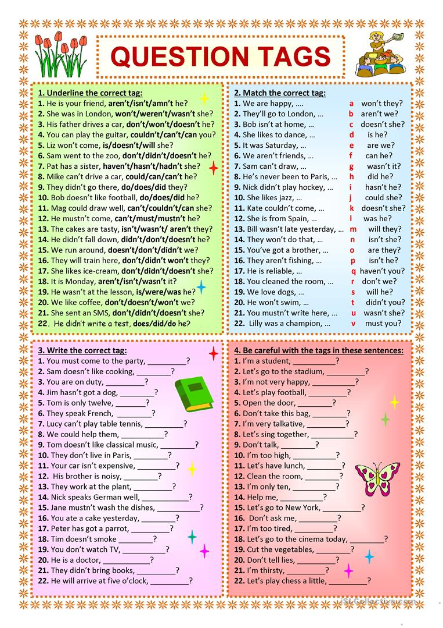

Negative questions
Use:
- To check information that’s probably true.
- To show surprise.
- To make a suggestion.
- To request something, especially when we expect a negative answer.
Wouldn’t it be nice to paint that wall green? (suggestion, opinion)
Hasn’t the mail come yet!? (surprise)
Why don’t you come and spend the evening with us? (polite request)
Can’t you do anything right? ( criticism)
Isn’t it a lovely day?

Indirect questions
Use: to be more polite or tentative.
Wh + subject + verb
Do you know where the bathroom is?
Can you tell me where the gate is?
Could you tell me where I can take the bus?
I was wondering what your favorite food is.
What flavor is this drink? ( direct question)
Can you tell me what flavor this drink is?
Why isn’t Sarah here yet? (direct question)
Do you know why Sarah isn’t here yet?
I would like to know where my dog is.
I wonder what your favorite kind of music is.
I’m not sure where you live.
I can’t remember when your bday is.
Do you happen to know ______________________________
Can I ask you ______________________________________
I would like to know_________________________________
I need to know _____________________________________

Does this bus go downtown? (direct y/n question)
Could you tell me if this bus goes downtown?
What is her favorite subject?
Could I know what her favorite subject is?
Do you have any hobbies?
I can’t remember if you have hobbies.

Do you like vegetables?
I need to know if you like vegetables.

Have you finished your homework?
_______________________________________________

Is she interested in a new job?
_______________________________________________

Negative imperative
Don’t + verb
Don’t go to sleep when you just have dinner.
Don’t Take your brother with you.
Don’t Close the door.
Don’t Clean your room.

Negative words : neither, none, no
Neither: in short answers to agree with a negative statement
I don’t like beans.
Me neither
Neither do I

None: can be used as pronoun followed by of + noun
None of the students are here.

No: determiner (before a noun or gerund)
No students are allowed in.
No smoking is permitted in the school.

