UNIT 5 – book 3
GRAMMAR: QUANTIFIERS
COUNTABLE NOUNS UNCOUNTABLE NOUNS
ex. orange(s), student(s) ex. water, information,homework…
A/AN *singular CN ============ X
SOME *Plural CN ============= SOME * positive sentences
*Positive sentences * questions
*Questions
Would you like some apples? Would you like some water?(offer)
I have some messages. She has some homework.
ANY *negative sentences ====== ANY *negative
*Questions *questions
*Plural CN
Do you have any questions? Is there any money left?
She doesn’t have any friends. I haven’t got any flour for my recipe.
A FEW/ FEW *plural ========= A LITTLE/LITTLE
A few not many but enough A little not much but enough
Few not enough Little not enough
I have a few friends. I have a little money.
I have few friends. I have little money.
A LOT OF/LOTS OF *plural ====== A LOT OF/ LOTS OF
I have a lot of dishes to wash. She has a lot of work for today.
I have lots of dishes to wash. She has lots of work for today.
I have lots of dishes to wash. I drunk lots of milk this morning.

ENOUGH *plural ============= ENOUGH
We have enough friends . We don´t have enough water.
We don’t have enough friends. We have enough water.
Do we(you) have enoght friends? Do you have enough water?
MANY *negative ============= MUCH *negative
*Questions *questions
*Plural
We didn´t buy many potatoes. She hasn’t bought much oil.
How many students do you have? How much water do you drink?

How many good friends do you have ?
I have a good friend.
I have some good friends.
I don’t have any good friends.
I have a few good friends.
I have lots of good friends.
I have enough good friends.
I don’t have many good friends.

How much money do you save every month?
I save a little every month.
Do you have a lot of friends?
Yes, I do.

(+) Panchito has an apple in his bag.
(-) Panchito doesn’t have an apple in his bag.
(?) Does Panchito have an apple in his bag? Yes, he does.

(+) Panchito has some apples in his bag.
(-) Panchito doesn’t have any apples in his bag?
(?) Does Panchito have any apples in his bag? Yes, he does.
Panchito doesn’t have any apples in his bag.
Panchito doesn’t have many apples in his bag.

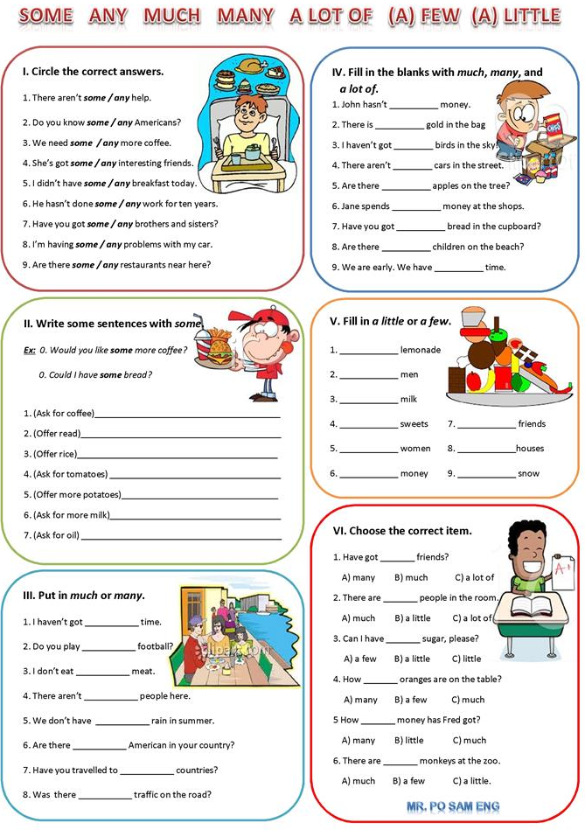
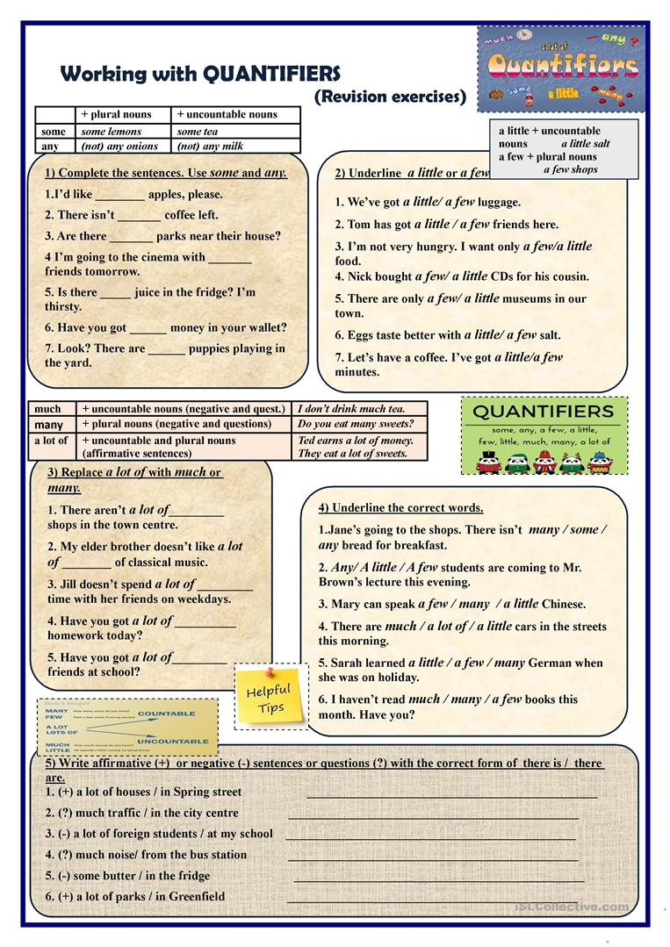
Articles a/an, The
A/an *singular countable noun
*To talk about one person or thing in general.
*When we first mention something.
The
(da)the book
(di)The eyes
*To talk about specific person/people or thing(s)
*When we refer back to a person/people or thing(s) already mention.
*Before a superlative form of adjectives.

______ hour _____ university ______ house _____ unicorn
______ horses

