UNIT 5 –BOOK 4
Objectives
To talk about food benefits.
To talk about unusual kinds of food.
Review Modal verbs and conditional sentences.

Grammar Modal Verbs
- Have to/has to+ base form….., must + base form obligation
I have to do my homework today.
She has to cook dinner tonight.
Does she have to cook dinner tonight? Yes, she does.
Do you have to cook dinner tonight? Yes, I do.
I must work late this week.
He must work late this week.

- Don’t have to/doesn’t have to no obligation (not necessary)
We don’t have to answer to Yolany.
Panchito doesn’t have to work today.

- Must not prohibition
You must not touch the paintings.
She must not smoke here.

- Can (colloquial),…… is /are allowed to permission
You can go to the party.// you’re allowed to go to the party.
She is allowed to drive my car. // She can drive my car.
He can drive my car tomorrow.

- Can’t,………. Is not/are not allowed to no permission
You can’t stay here. // you’re not allowed to stay here.
The students can’t use my computer.
She can’t take money.

- Should/ should not (shouldn’t) + base form recommendation /advice
You should go to the doctors.
She should clean her house.
She shouldn’t cook, her food isn’t healthy.
We should study a little bit more.
Should I go to the dentist?
No, you shouldn’t.

Grammar CONDITIONAL SENTENCES
You can use these words instead of if
Unless= if not/ except if
Before= at an earlier time
Until = at that time
As soon as = immediately after

First conditional

It's used to talk about things which might happen in the future. Of course, we can't know what will happen in the future, but this describes possible things, which could easily come true. (it can be also used to give warnings)

IF + SIMPLE PRESENT will/won’t + base form

If clause (condition) Main clause (result)
If it rains, I won't go to the park.
If she doesn’t study, she won’t pass the test.
She won’t pass the test if she doesn’t study.
Unless she studies, she won’t pass the test.
What will happen if it rains?
I won’t go to the park.
If you study hard, you will learn a lot.
You will learn a lot if you study hard.
If you don’t understand, you will be lost the rest of the class.
If I go to the gym, I’ll be healthy.
If it rains, I won’t wash the clothes.
Second conditional (present unreal) (unit 10)
Use: refers to an unlikely or hypothetical (improbable or impossible) situation and its probable result. These sentences are not based on the actual situation.

IF + SIMPLE PAST WOULD/COULD/MIGHT + BASE FORM

If clause (condition) Main clause (result)
If the weather (weren’t)wasn't so bad, we would go to the park. (But the weather is bad so we can't go.)
If I was/were the Queen of England, I would give everyone a house. (But I am not the Queen.)
If I were/was in Roatan, I would be resting in a nice room.
What could you do if you were a butterfly?
If I was a butterfly, I could fly over the trees.
Where would you go if you had a million dollars?
I would travel around world.
If it was raining, I wouldn’t go to visit my family.
If I were a boy, I would do better.
I would do better if I were a boy.
Would you do better if you were a boy?
Yes, I would.
If I won the lotto, I’d have a lot of money.
If I knew the answers, I’d get 100%.
If I didn’t have money, I wouldn’t travel to Brazil.
If I spoke French, I could go out with him.

Third conditional (past unreal) (unit 12)

IF + PAST PERFECT WOULD/COULD/MIGHT + HAVE+ PP

If clause (condition) Main clause (result)

Use: to talk about imagined past situation that didn’t happen and speculate on a possible result of this situation.

If Panchito had had the money, he would have bought a Ferrari.

If she hadn’t eaten so much, she wouldn’t have felt sick.

If I had studied, I would have gotten a better grade.

If I hadn’t gone to the party, I wouldn’t have gotten a bad grade.

If I had traveled yesterday, I’d have come on time.

Exercise
Which conditional should I use?
- In my experiments, the liquid is cooled to 32 degrees. It always freezes.
  - If you cool the liquid to 32 degrees, it freezes.
  - If you cool the liquid to 32 degrees, it will freeze.
  - If you had cooled the liquid to 32 degrees, it would have frozen.
  - If you cooled the liquid to 32 degrees, it would freeze.
- He stepped on the mine, and it exploded.
  - If he doesn't step on the mine, it won't explode.
  - If he didn't step on the mine, it wouldn't explode.
  - If he hadn't stepped on the mine, it wouldn't have exploded.
  - If he doesn't step on the mine, it doesn't explode.

- You ignored my advice, so you got into trouble!
  - If you don't ignore my advice, you don't get into trouble.
  - If you don't ignore my advice, you won't get into trouble.
  - If you hadn't ignored my advice, you wouldn't have gotten into trouble.
  - If you didn't ignore my advice, you wouldn't get into trouble.

- Unfortunately, I don't know Philosophy, so I can't answer your question.
  - If I know Philosophy, I can answer your question.
  - If I know Philosophy, I will be able to answer your question.
  - If I knew Philosophy, I would be able to answer your question.
  - If I had known Philosophy, I would have been able to answer your question.
- It may rain this afternoon. I hope it doesn't because I don't want the match to be cancelled.
  - If it rains, the match will be cancelled.
  - If it rains, the match is cancelled.
  - If it had rained, the match would have been cancelled.
  - If it rained, the match would be cancelled.
- I want to buy a Porsche, but I don't have enough money.
  - If I have enough money, I buy a Porsche.
  - If I had enough money, I would buy a Porsche.
  - If I have enough money, I will buy a Porsche.
  - If I had had enough money, I would have bought a Porsche.

First conditional: If+ simple present, will/wont+ base form. (future result)
Second conditional: if + simple past, would/could/might + base form. ( present situation) unreal
Third conditional: If + past perfect (had+ past participle), would/could/might+ have + past participle. ( refers to past situations)

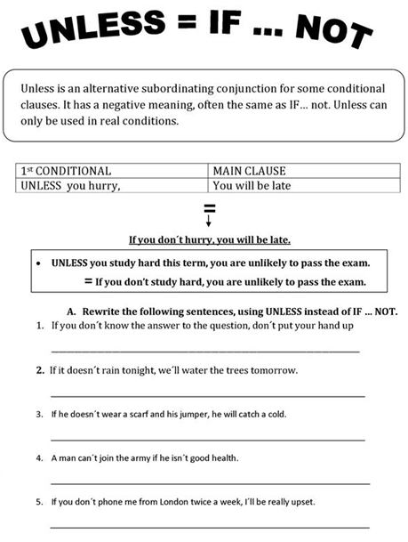
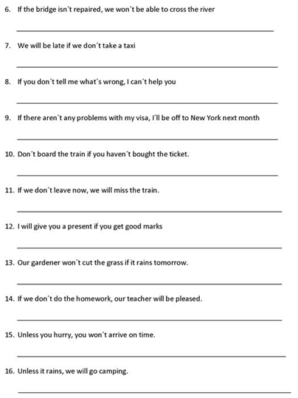
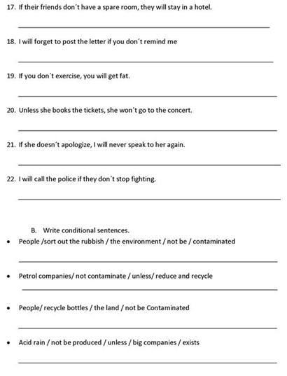
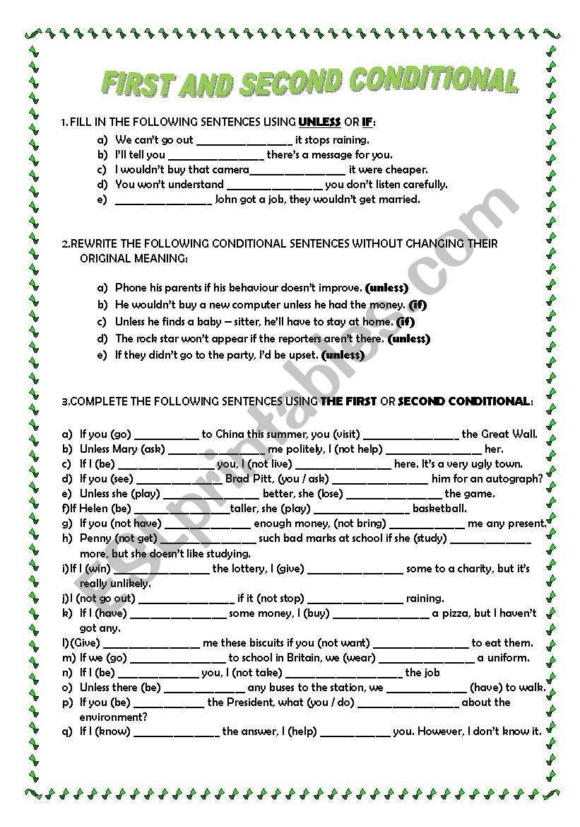
IF, WHEN, AS SOON AS, UNTIL, BEFORE, AFTER, UNLESS
Fill in the gaps with the most appropriate word. In some cases, there may be more than one correct option.
1. Please call me ____________ you get home.
2. ________ you leave the house, be sure to turn off the TV.
3. I won’t lend you any more books ________ you return the ones I lent you 2 months ago.
4. Please send me the price list ________ you finish it. It’s very urgent.
5. Mary ate breakfast at 7 o’clock and _______ doing that she went to work.
6. You can keep those DVDs __________ you are done watching all of them.
7. Panchito usually likes to go jogging _______ after work.
8. ________ she apologizes, I have no intention of ever speaking to her again.
9. _______ you work hard, I’m sure they will eventually ptomote you.
10. “Panchito, Anacleta asked you to call her _________ you finish work.”
11. I turned the car around ______ I realized that I had forgotten my bag.
12. The bank told me that they wouldn’t let me take out a loan _______ I prove that I have a steady income.
13. ________ you don’t want him to yell at you, you’d better not interrup him now, he’s very busy.
14. Remember that you have to call Panchito ______ you prepare that offer, because he’s the only one who knows all the data.
15.You really shouldn’t wait _____ the wedding to discuss the most important issues. It’s important to know certain things early on.

