UNIT 4 – BOOK 3
Objectives
- To tell stories.
- To talk about childhood.

GRAMMAR: Simple past and Past continuous.
- Simple past
Use: finished actions, events, or situations in the past.
- To talk about a dead person.
Auxiliary: did questions
Didn’t negative
Past time expression:
ago : 5 minutes ago , a long time ago, many years ago, a little while ago, etc
last: last night, last week, last month, last year, last(Monday)
yesterday: yesterday morning, yesterday evening, the day before yesterday.

(+) Panchito went to Paris with his girlfriend Anacleta last month.
(-) Panchito didn’t go to Paris with his girlfriend Anacleta last month.
YES/NO QUESTIONS
Structure : auxiliary + subject + verb + complemente?
(?) Did Panchito go to Paris with his girlfriend Anacleta last month?
Yes, he did// No, he didn’t.
Did you eat at Mcdonald yesterday? Yes, I did.
You ate at Mcdonald yesterday.
You didn’t eat at …………
Did she meet the President? No, she didn’t.
She met the president. She didn’t meet the president.

INFORMATION QUESTIONS
Structure: wh + auxiliary + subject + verb + complement ? (Object question)
Panchito went to Paris with his girlfriend Anacleta last month.
Q: When did Panchito go to Paris with his girlfriend Anacleta?
A: Last month.
Q: Where did Panchito go with his girlfriend last month?
A: To Paris
Q: Who did Panchito go to Paris last month?
A: With his girlfriend.
Q: Who went to Paris with Anacleta last month? (subject question)
A: Panchito

Erika ate rice and beans for breakfast the day before yesterday.
Q: What did Erika eat for breakfast the day before yesterday?
A: Rice and beans
Q: When did Erika eat rice and beans for breakfast?
A: The day before yesterday.
Q: Who ate rice and beans for breakfast the day before yesterday?
A: Erika

Regular verbs
Walk walked

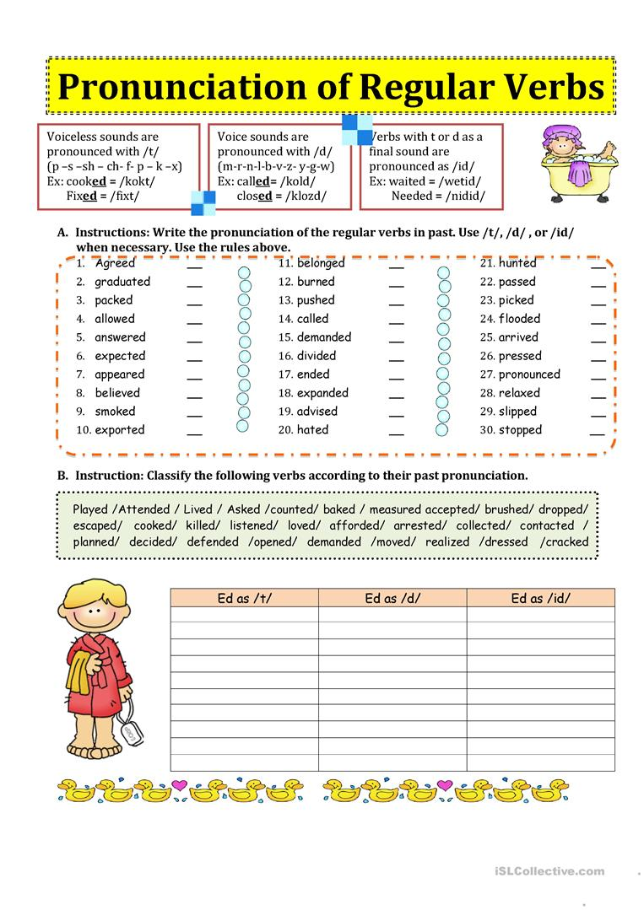
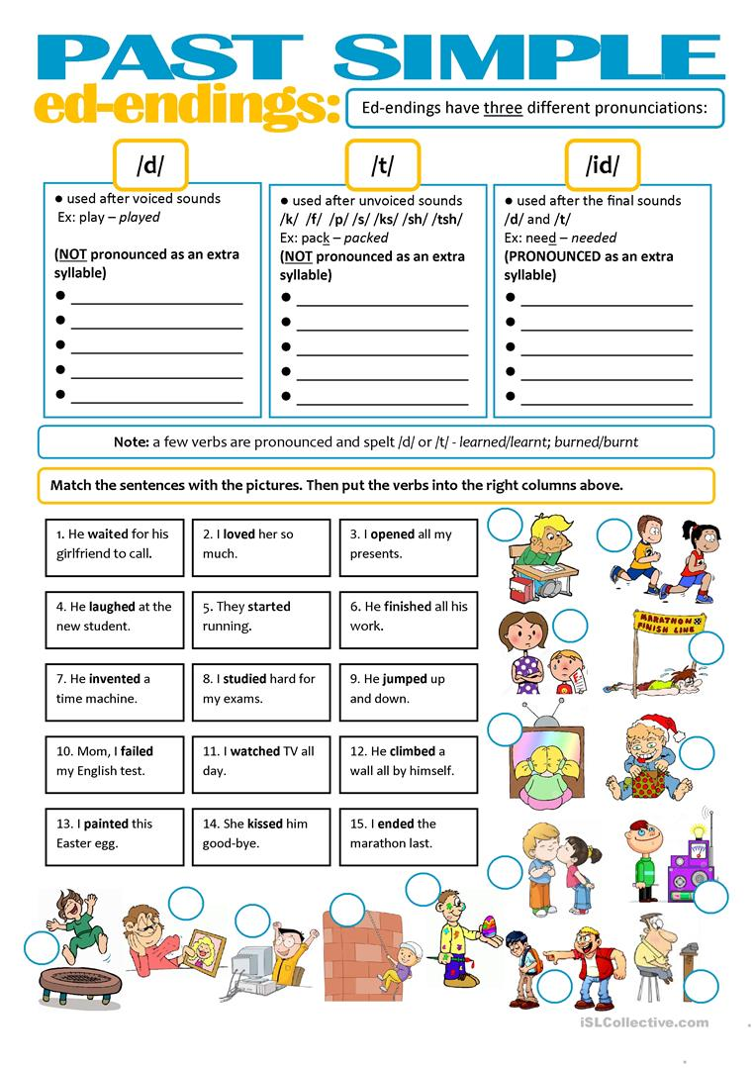
- Past continuous
Structure:
- affirmative:was/ were + v-ing
- Negative: wasn’t/weren’t +v-ing
- Questions: wh +was/were + subject + v-ing + complement
Was/ wasn’t I, she, he, it
Were/ weren’t you, they, we
Use:
1. Two actions taking place at the same time.
While I was taking the test, my mother was cooking dinner.
My mother was cooking while I was taking the test.
While I was taking a shower, my cat was eating.
While they were playing soccer, I was working.
I was taking notes while the teacher was explaining.
While I was taking the class, my dogs were playing in the garden.
He was watching TV while I was eating dinner.
I was cleaning the house while I was listening to music.

2. To describe what someone was doing at a particular point in the time.
What were you doing yesterday at 3pm?
I was working in the garden at that hour.
I was listening to my boss in a meeting.
I was working in the hospital.
What were you doing yesterday at 4 pm?
I was taking a nap.
What were you doing yesterday at this time?
I was taking a exam.
Panchito was cleaning his room yesterday at this time.
3. To express interrupted actions in the past.
I was driving to work when someone crashed my car.
While she was cooking dinner, someone called her.
Someone called her while she was cooking dinner.
When someone called her , she was cooking dinner.
When + simple past, past continuous
While + past continuous, simple past
While ________________________, __________________________
____________________________ while _______________________
When ______________________ , ____________________________
___________________________ when _________________________
4. To describe repetition and irritation. (annoying)
He was always complaining in class.
He was always snoring while he was sleeping.
5. Story background
The birds were singing and the sun was shining.

What did you do yesterday? I went to the supermarket then I worked on my project………..
What were you doing yesterday at 10 am? I was taking a nap.

