UNIT 4 – book 2
Objective
To talk about sports.
To talk about preferences.
Grammar: love/ like/ hate + noun or v-ing
I like taking long walks in the afternoon.
I don’t like cooking.// I hate cooking.
I love listening to music while I’m taking a bath.
I hate doing the dishes.
She loves dancing in the rain.
They like running in the morning.
We don’t like playing soccer on the weekends.
I love listening to music.
She loves listening to music.
I hate studying with my classmates.
Do you like running in the morning?
Yes, I do.
She likes baleadas.
He doesn’t like dogs. (Wil)

ADVERBS OF FREQUENCY.
Use: to tell how frequent we do something.
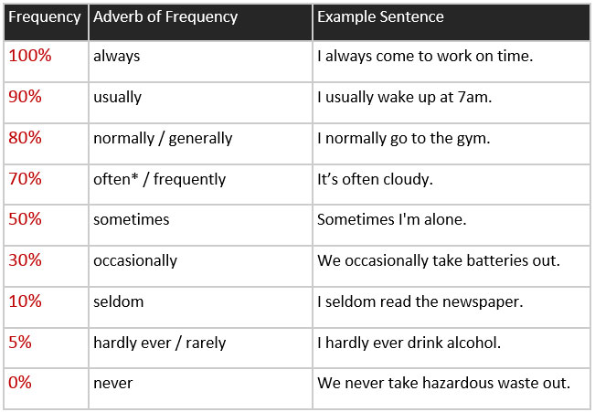
1. subject + be + adverb
I’m always happy.
She’s never late to class.
They’re usually in the park.
We aren’t usually upset.
Are you always cranky?
No, I’m not.
Are you always hungry?
Yes, I am.
2. subject + adverb + verb
She never comes to my house.
They always complain about it.
We don’t usually clean our house.
She sometimes meets with her boyfriend.
I usually start work at 7:20 am.
She never studies for the exam.
She doesn’t usually take breakfast.
She rarely walks her dogs.
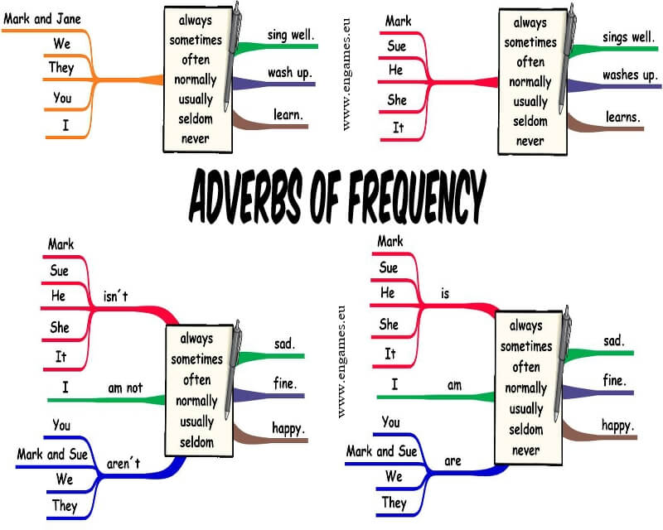
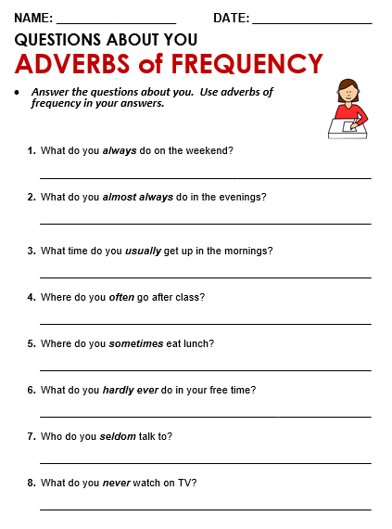
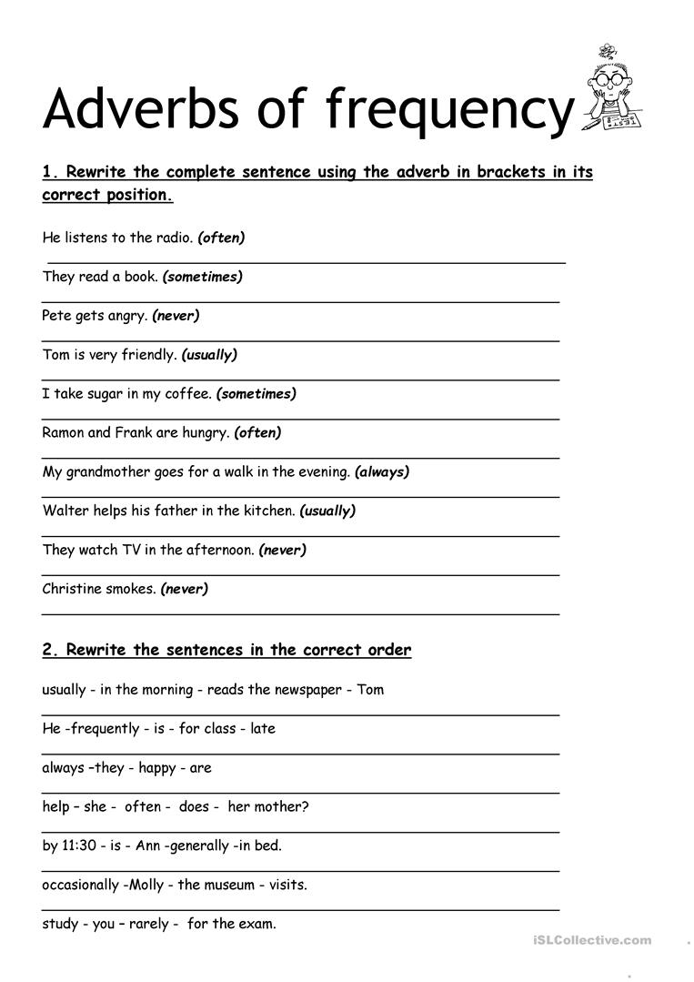
EXPRESSIONS OF FREQUENCY
These expressions of frequency go at the end of a sentence.
(one time) Once a day / a month /a year / a week
I go to the gym once a week.
(two times) Twice a day / a week / a year /a month
she goes to the dentist twice a year
(3) times a day / a week/ a month/ a year
I take a meal three times a day.
Several times
Once every ( two months)
Every day/ week/ year/ Tuesday * (every Tuesday= on Tuesdays)
Once in a while
Now and then
How often do you hang out with your friends?
I hang out with my friends once a month.
How often do you go to the cinema?
I go to the cinema twice a week.
How often do you eat fast food?
I never eat fast food.
How often do you sleep 8 hours a day?
I never sleep just 8 hours. I always sleep 12 hours.
CAN/CAN’T
Use: to talk about ability or possibility.
How well can you play soccer?
I can play soccer very well. // I can’t play soccer.
Can you cook?
Yes, I can
How well can you cook?
Not very well/ more or less/ I can cook very well.

I love…………. I like…………
I can………….. but I can´t ……..

