UNIT 3- BOOK 2
Objectives
To tell the time.
To talk about routines
TELLING THE TIME
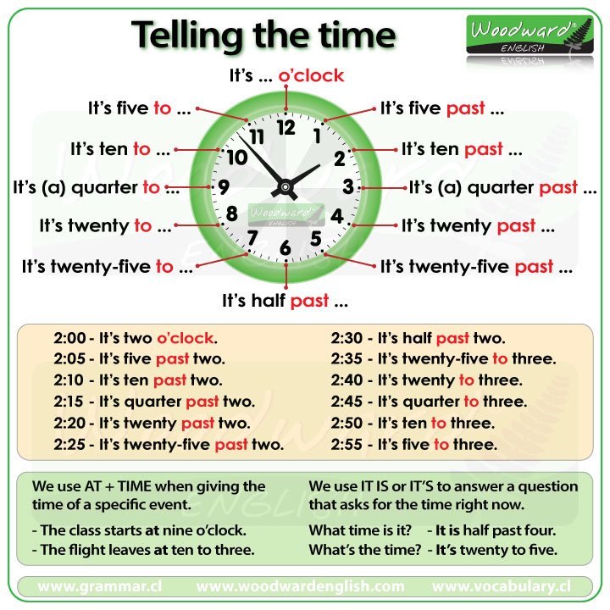
There are two common ways of telling the time.
1) Say the hour first and then the minutes. (Hour + Minutes)
- 6:25 - It's six twenty-five
- 8:05 - It's eight O-five (the O is said like the letter O)
- 9:11 - It's nine eleven
- 2:34 - It's two thirty-four
- 10: 27- It’s ten twenty-seven
2) Say the minutes first and then the hour. (Minutes + PAST / TO + Hour)
For minutes 1-30 we use PAST after the minutes.
For minutes 31-59 we use TO after the minutes.
- 2:35 - It's twenty-five to three
- 11:20 - It's twenty past eleven
- 4:18 - It's eighteen past four
- 8:51 - It's nine to nine
- 2:59 - It's one to three
When it is 15 minutes past the hour we normally say: (a) quarter past
- 7:15 - It's (a) quarter past seven
- 10:15 – It’s (a) quarter past ten.
When it is 15 minutes before the hour we normally say: a quarter to
- 12:45 - It's (a) quarter to one
- 10:45 – It’s (a) quarter to eleven.
When it is 30 minutes past the hour we normally say: half past (jaf)
- 3:30 - It's half past three (but we can also say three-thirty)
- 11:30- It’s half past eleven.

O'clock
We use o'clock when there are NO minutes.
- 10:00 - It's ten o'clock
- 5:00 - It's five o'clock
- 1:00 - It's one o'clock
- 10: 20 – ten twenty sharp
Sometimes it is written as 9 o'clock (the number + o'clock)

12:00
For 12:00 there are four expressions in English.
- twelve o'clock (12:00)
- midday = noon (12:00 pm)
- midnight (12:00 am)

AM vs. PM
We don't normally use the 24-hour clock in English.
We use a.m. (am) for the morning and p.m. (pm) for the afternoon and night.
3am = Three o'clock in the morning.
3pm = Three o'clock in the afternoon.

Asking for the Time
The common question forms we use to ask for the time right now are:
- What time is it? It’s (a) quarter to eleven.
- What is the time? It’s twelve to eleven.
A more polite way to ask for the time, especially from a stranger is:
- Could you tell me the time please? It’s ten to eleven.
15 minutes (a) quarter
30 minutes half
12:00 pm noon
1200 am midnight
12:00 twelve o’clock
8:10 It’s ten past eight..
8:05 It’s eight oh-five// It’s five past eight.
8:06
11:30 It’s half past eleven.
11:45 It’s (a) quarter to twelve.
11:15 It’s (a) quarter past eleven.
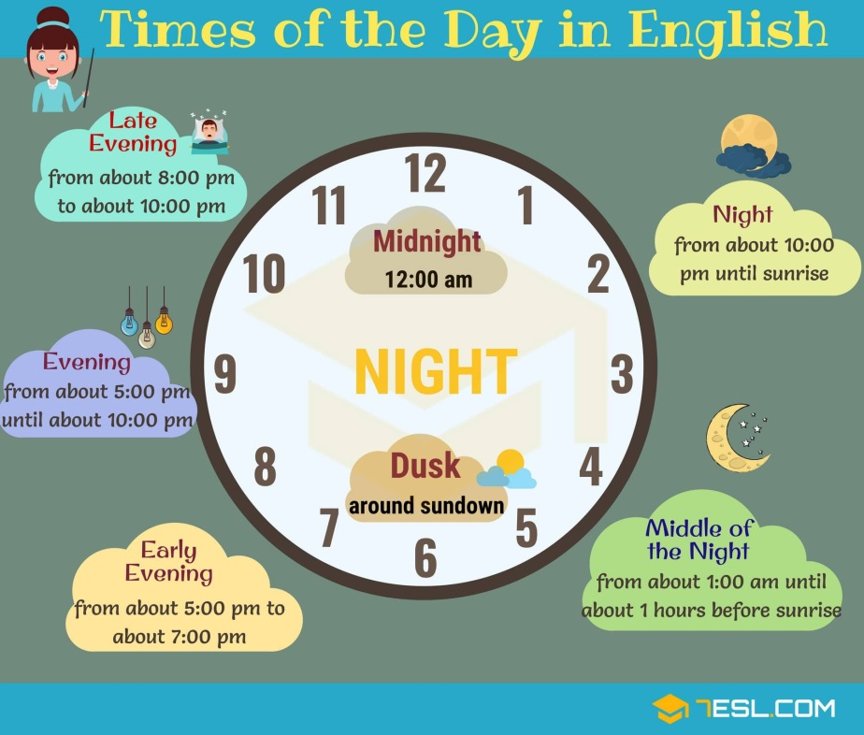
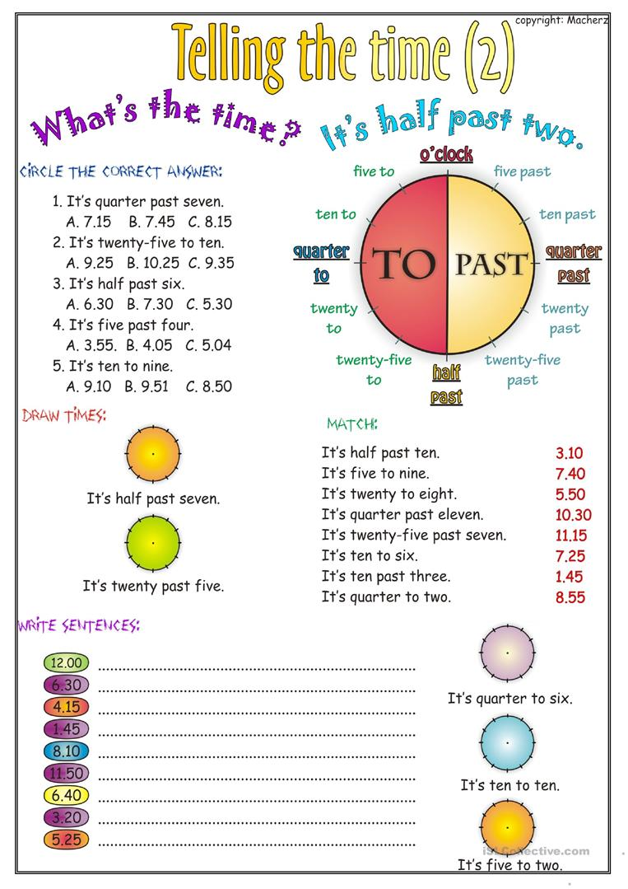

SIMPLE PRESENT
USE: *To talk about habits or routines.
*To talk about facts (something that is always true)
*To talk about permanent situations.
3rd (she,he,it) person rules (affirmative sentences):
1. most verbs take “s”
I work ……… she/he/ it works
I run ……….. he/she/it runs
Read …….. reads
Dance …… dances
Eat ………. Eats
Panchito eats beans every day.
2. verbs ending in z, ss, ch, sh, x, and o add “es”
They kiss ……….. she/he/ it kisses
Watch ……………. He/she/it watches
Fix …………………. Fixes
Miss ……………… misses
Buzz ……………… buzzes
3. verbs ending in consonant + y drop the y and add “ies”
I Fly ………….. she/he/it flies
Cry …………. Cries
Study ……… studies
**** I play ………. She/he/it plays
Irregular forms
Have ………… has I have…… she/he/it has…
Be ……………. Is …………. She/he/it is
Auxiliary do/don’t I, you, we, they
Does/doesn’t she, he, it
(+) I work very hard from Monday to Saturday.
(-) I don’t work very hard from Monday to Saturday.
(+) Pancracia sleeps late every day.
(-) Pancracia doesn´t sleep late every day.
Yes/ no questions
Auxiliary (do/does) + subject + verb + complement ?
Do you work very hard from Monday to Friday?
Yes, I do// no, I don’t
Does she sleep late every day?
Yes, she does// No, she doesn’t.
Information Questions
Information word (Wh- words)
What information
When date
What time time
Where place
Why reason
Which choices/ options
Who people
How often frequency
How + adjective details How beautiful is Pancracia?
How old age
How far distance
How much/many quantity
1. wh + auxiliary + subject + verb + complement ? object questions
2. wh + verb + complement ? subject questions
Q: When do you work very hard?
A: From Monday to Saturday.
Panchito works with Anacleta twice a week. Because he needs money to buy a new bike.
Q: How often does Panchito work with Anacleta?
A: twice a week.
Q: Who does Panchito work with? (object question)
A: with Anacleta
Q: Who works with Anacleta? (subject question)
A: Panchito
Q: Why does Panchito work with Anacleta?
A: To buy a new bike.
Q:Why does Panchito work?
A: Because he needs money.
