UNIT 2
OBJECTIVE
To make a movie review.
To review past tenses.
PAST TENSES REVIEW
Simple Past
Use: To talk about finished actions in the past (specific time in the past)
To talk about the sequence of the main events in a story.
To talk about someone’s life when they are dead.
Auxiliary: did/ didn’t
I did my homework last weekend.// I went to the supermarket yesterday.
I didn’t do my homework last weekend.// I didn’t go to the supermarket ….
Q: When did you do homework? Q: When did you go to the super?
A: last weekend A: Yesterday
Q:What did you do last weekend?
A: My homework
Q: Who did homework last weekend?
A: I
Panchito went to the supermarket yesterday.
Q: Who went to the supermarket yesterday?
A: Panchito.

PAST CONTINUOUS
Structure : was/were + v-ing
Use: To describe a background events which were in progress around the time of the main event.
1. an interrupted action
I was cooking dinner when she arrived.
When she arrived, I was cooking.
I was watching tv when somebody called me.
While I was watching tv, somebody called me.
While I was cooking, she arrived.
When my sister came to my room , I was doing homework.
I was doing homework when my sister came to my room.
It started to rain while I was running.
While I was eating, somebody texted me.
Somebody texted me while I was eating.
While I was studying , somebody called me.
I was playing with my children when someone knocked the door.
While I was playing video games, my mom gave me a snack.
2. precise time in the past.
At 4 o’clock, I was eating dinner.
What were you doing at 1pm?
I was working. // I was taking a nap
What were you doing yesterday noon?
I was watching a movie.

3. parallel actions (2 actions that were both continuing at the same time)
I was writing a report while I was listening to music.
While I was taking the English class , she was writing in her notebook.
While I was cooking, my mom was talking.
While I was working, I was listening to music.

PAST PERFECT
Structure: had + past participle
Use: To talk about what happened earlier before the main event.
I had walked 2 km by lunch time.
He had gone out when I arrived to the office.
1. save documents
2. computer crash.
She had already saved the documents before the computer crashed.
1. start cooking
2. they arrive
She had started cooking when they arrived.
I hadn’t done my homework when the teacher assigned another one.
1. don’t sleep (past perfect)
2. be tired (simple past)
I was tired because I hadn’t slept well.
I had finished breakfast before my Mom came to visit me.
They had already eaten when their friends came over.
I was angry because I hadn’t eaten yet.
I had cooked lunch before going out to work.

1. clean my house
2. my mom arrives
I hadn’t cleaned my house when my mom arrived.

Past perfect continuous
Structure: had + been + v-ing
Use: To describe and action that was in progress before or up to the main event in the past. (don’t use stative verbs)
Had you been waiting long before the taxi arrived?
Panchito had been swimming for 2 hours when Pancracia rescued him.
I had been riding the motorcycle all morning when the rain started.

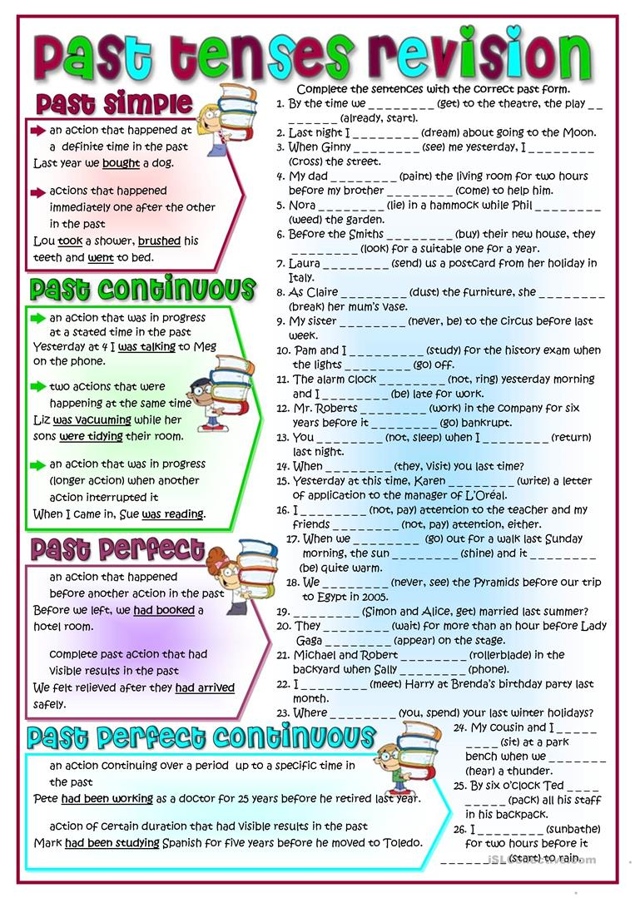
PASSIVE VOICE
Use: To focus on the action. When we don’t want to identify the agent.
(It’s not important or not known..)
Structure: be + past participle + (by + agent)
1.A few well-chosen words convey a great deal of meaning. (active )
A great deal of meaning is conveyed by a few well-chosen words. (passive)
2. Spielberg directs movies. (active)
Movies are directed by Spielberg. (passive)
3. The Beatles wrote “A Hard day’s night”. (active)
A Hard day’s night was written by The Beatles. (passive)

BE + PP
Am/is/are + pp simple present
Houses are built by Panchito. Panchito builds houses.
Am/is/are + being + pp present continuous.
Houses are being built by Panchito. Panchito is building houses.
Have/has + been + pp present perfect
Houses have been built by Panchito. Panchito has built houses.
Was/were + pp simple past
Houses were built by Panchito. Panchito built houses.
Was/were + being + pp past cont.
Houses were being built by Panchito. Panchito was building houses.
Will + be + pp future
House will be built by Panchito. Panchito will build houses.
Am/is/are + going to + be + pp
Houses are going to be built by Panchito. Panchito is going to build houses.
Must/can/ could/should/ may/ might + be + pp modals
