UNIT 2
Objectives
To talk about what we have at home.
To describe our neighborhood.
Grammar:
THERE IS (A/AN) SINGULAR
THERE ARE PLURAL
THERE IS A BED BUT THERE ISN’T A TV IN MY BEDROOM. (SINGULAR NOUN)
(+) THERE ARE FOUR BOOKS. (PLURAL NOUN)
(+) THERE ARE SOME BOOKS.
(-) THERE AREN’T ANY ENGLISH BOOKS IN MY BEDROOM.
(?) IS THERE A BED IN YOUR BEDROOM? (SINGULAR NOUN)
YES, THERE IS. // NO, THERE ISN’T.
(?) ARE THERE ANY BOOKS IN YOUR BEDROOM? (PLURAL NOUN)
YES, THERE ARE.// NO, THERE AREN’T.
NOTE: A/AN SINGULAR NOUNS
A book (word beginning with a consonant sound)
An apple (word starting with a vowel sound)
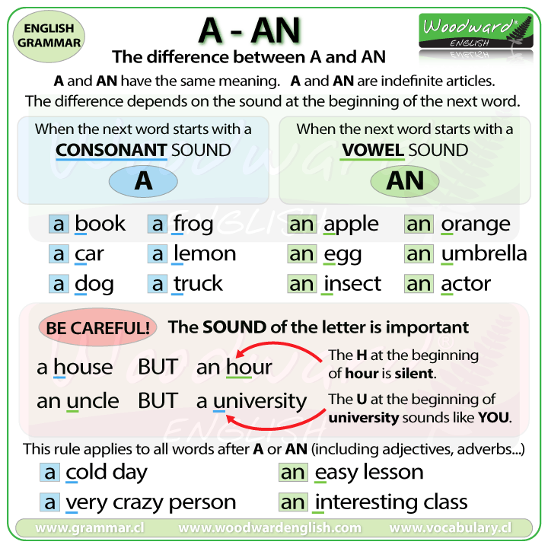
SOME PLURAL NOUNS// POSITIVE SENTENCES, (QUESTIONS)
ANY PLURAL NOUNS// NEGATIVE SENTENCES, QUESTIONS

Positive Sentences
We use there is for singular and there are for plural.
- There is one table in the classroom.
- There are three chairs in the classroom.
- There is a spider in the bath.
- There are some people at the bus stop.
We also use There is with uncountable nouns:
- There is milk in the fridge.
- There is some sugar on the table.
- There is ice cream on your shirt.

Contractions
The contraction of there is there's.
- There's a good song on the radio.
- There's only one chocolate left in the box.
You cannot contract there are.
- There are some cats on the roof.
- There are only five weeks until my birthday.

Negative Form
The negative is formed by putting not after is or are:
- There is not a horse in the field.
- There are not eight children in the school.
- There is not a tree in the garden.
- There are not any elephants in the zoo.
We almost always use contractions when speaking.
The Negative contractions are:
- There's not = There isn't
- There are not = There aren't

There aren't with ANY
When we want to indicate that a zero quantity of something exists we use there aren't any.
- There aren't any people at the party.
- There aren't any trees in my street.
We also use this structure with uncountable nouns:
- There isn't any water in the swimming pool.
- There isn't any sugar in my coffee.

Questions
To form a question we place is / are in front of there.
Again we use any with plural questions or those which use uncountable nouns.
We also use there is / are in short answers.
- Is there a dog in the supermarket? - No, there isn't.
- Are there any dogs in the park? - Yes, there are.
- Is there a security guard in the shop? - Yes, there is.
- Are there any polar bears in Antarctica? - No, there aren't.
- Is there any ice-cream in the freezer? - Yes, there is.
How Many with Are There
If we want to find out the number of objects that exist we use How many in the following form:
How many + plural noun + are there (+ complement).
- How many dogs are there in the park?
- How many students are there in your class?
- How many countries are there in South America?
- How many Star Wars films are there?

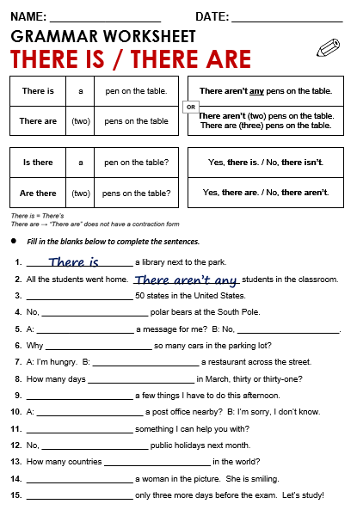
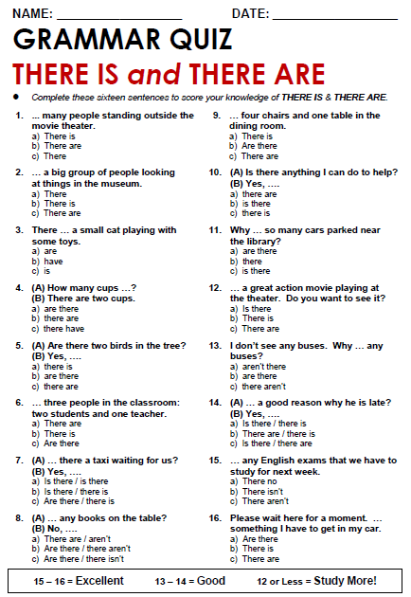

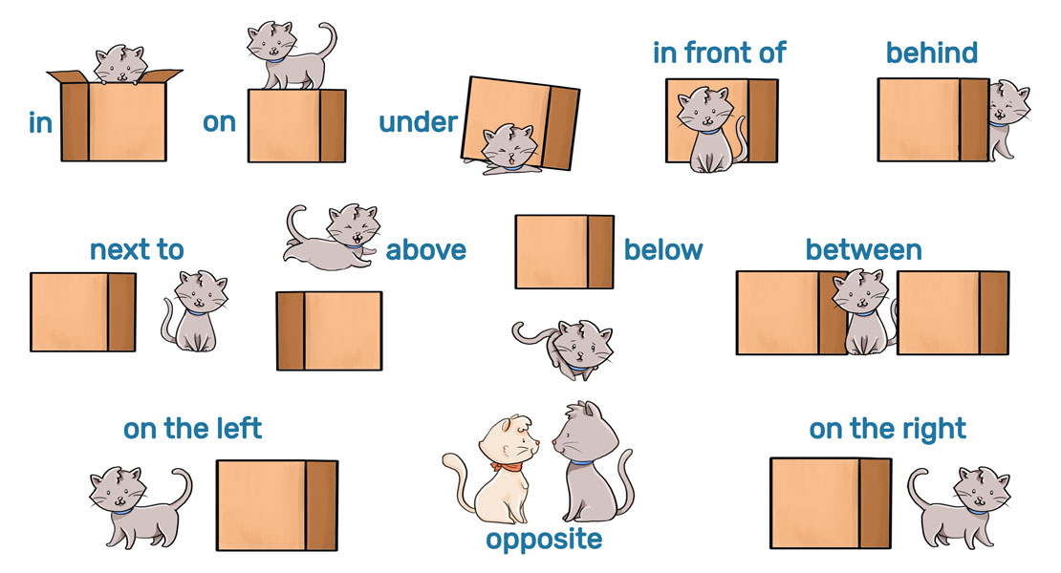

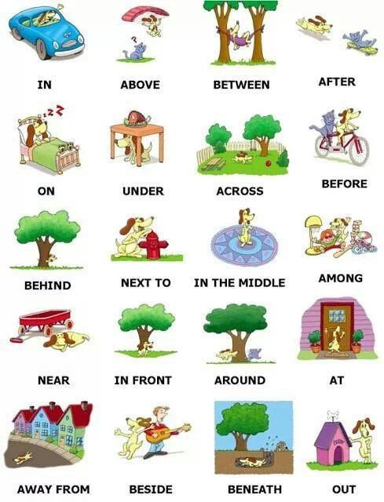

PLURAL NOUNS
- To most nouns add “s”
Car ……………. Cars
Pencil ………... pencils
Pen ……………. Pens
Book ………….. books
- Ending in s, ch, sh, x, z, add “es”
Bus …………… buses
Watch ……… watches
Box ………….. boxes
Quiz ………… quizzes
Dish ………… dishes
- Ending in f or fe change f/fe to “ves”
Wolf ……….. wolves
Wife ……….. wives
Knife ………. Knives
Leaf ……….. leaves
Exceptions : roof …. Roofs, cliff …. Cliffs
- Ending in vowel + y add “s”
Day …………. Days
Key …………. Keys
Boy ………… boys
Donkey ….. donkeys
- Ending in consonant + y remove y add “ies”
City ………. Cities
Country … countries
Story …….. stories
Party …….. parties
- Ending in vowel + o add “s”
Zoo …….. zoos
Radio …… radios
Video …… videos
Kangaroo… kangaroos
- Ending in consonant + o add “es”
Tomato ……… tomatoes
Potato……….. potatoes
Hero ………… heroes
- Irregular nouns
Man …….. men
Woman…… women
Child ………. Children
Foot ……….. feet
Tooth……… teeth
Person…….. people
Mouse ……. Mice
- No change
Sheep …….. sheep
Fish ………… fish
Series ……... series
Deer ……….. deer
Species ……. species

