UNIT 12
OBJECTIVES
TO TALK ABOUT NATURE

Second conditional (present unreal)
Use: to talk about an improbable or hypothetical situation and its consequence.
Structure: simple past , would/could/may/might + base form
If clause main clause (result)

Ex. If I were/was rich, I would travel around the world.
If I were on vacation, I would be relaxed.
If I were in Roatan, I would go to the beach.
I could speak French if I lived in France.
If I won the lotto, I would buy a huge house.
I would buy a huge house if I won the lotto.
What would you do if you were a butterfly?

Second Conditional Form

Make the second conditional
1) If I _______ (be) you, I ___________________ (get) a new job.
2) If he _______younger, he __________ (travel) more.
3) If we _________ (not/be) friends, I __________ (be) angry with you.
4) If I ______ (have) enough money, I ______________ (buy) a big house.
5) If she __________ (not/be) always so late, she ____________ (be) promoted.
6) If we _______(win) the lottery, we______________ (travel) the world.
7) If you ________ (have) a better job, we ______________ (be) able to buy a new car.
8) If I __________ (speak) perfect English, I ______________ (have) a good job.
9) If we _____________ (live) in Mexico, I _____________ (speak) Spanish.
10) If she_________ (pass) the exam, she_______________ (be) able to enter university.
10) She _________ (be) happier if she _____________(have) more friends.
11) We ________ (buy) a house if we _______________ (decide) to stay here.
12) They ________(have) more money if they ________(not/buy) so many clothes.
13) We ________________ (come) to dinner if we _________ (have) time.
14) She __________(call) him if she __________- (have) his number.

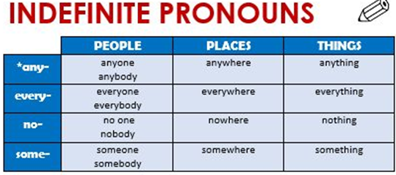
Indefinite pronouns are used to talk about places, people or things without saying who, where or what they are. They are followed by singular verbs.
