UNIT 11- BOOK 4
Objective
To report news

GRAMMAR: REPORTED SPEECH
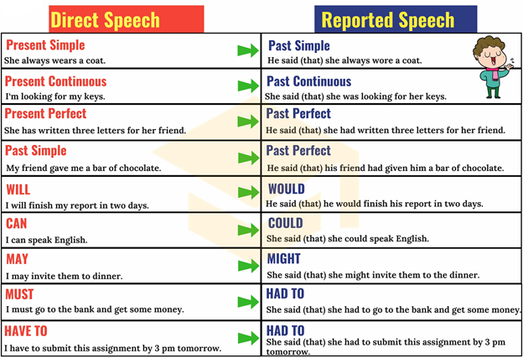
Should should
REPORTED SPEECH BACKSHIFT
IN REPORTED SPEECH, WE USE BACKSHIFT SOMETIMES, BUT NOT ALWAYS.
- IF A SITUATION IS STILL TRUE, BACKSHIFT IS NOT USED
- FOR GENERAL TRUTHS, BACKSHIFT IS OPTIONAL ( THE EXPERSTS SAID…… THE SCIENTISTS REPORTED….
- SOMETIMES BACKSHIFT IS OPTIONAL BECAUSE IT DEPENDS ON WHAT THE SPEAKER WANTS TO SAY. PANCHITO SAID (THAT) HE LIVES IN A BIG HOUSE. (STILL TRUE)
PANCHITO SAID HE LIVED IN A BIG HOUSE (STILL TRUE BUT THE SPEAKER IS MORE INTERESTED IN THE FACT THAT HE’S REPORTING SOMETHING SAID EARLIER)
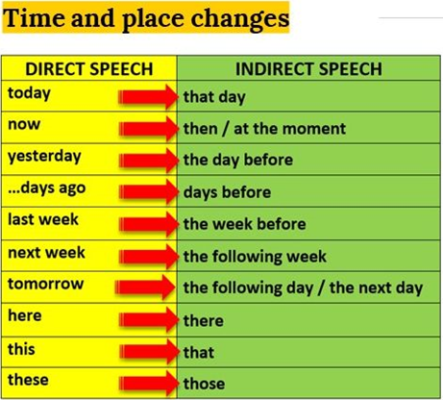

“I’m very tired” She said (that) she was very tired.
“They were happy yesterday ” He said (that) they had been happy the day before.
“ He is writing a report” She said (that) he was writing a report.
“Karol has eaten too mucho” She told me (that) Karol had eaten too much.
“I will wash your car on Sunday” He told me (that) he would wash my car on Sunday.
“They can help you” She told me that they could help me.
REPORTING QUESTIONS
Yes/No questions
Direct speech Reported speech
Do you want some more cake? She asked him if he wanted some more cake.
Are you coming to the cinema He asked if/whether she was going to the cinema
with me? with him.
Wh – questions
Where did he go on holiday? She asked me where he had gone on holiday.
How often do you play soccer? He asked him how often he played soccer.
How old is she? They asked me how old she was.
Why can you do it? He asked me why I could do it.
What did you do? He asked me what I had done.

Imperatives
Don’t come late! My daddy told me not to come late.
Clean your room! Her mom told her to clean her room.

REPORTING VERBS
PATTERNS
- SAY + that + clause (sentence)
SHE SAID THAT HER BOYFRIEND HAD LEFT HER.

- ASK, TELL, REMIND, INVITE+ OBJECT + (NOT) + INFINITIVE
SHE TOLD ME NOT TO WRITE THE LETTER.

- PROMISE, OFFER + (NOT) INFINITIVE
SHE OFFERED TO CLEAN THE ROOM.

- PROMISE + THAT + CLAUSE (SENTENCE)
SHE PROMISED THAT SHE WOULDN’T DO IT AGAIN.

TO REPORT TOUGHTS:
- REALIZE, THINK, KNOW + THAT + SUBJECT + VERB
SHE KNEW THAT SHE HAD LEFT HER WALLET AT HOME.

- WONDER + IF/WHETHER
SHE WONDERED IF HER SON HAD DONE HIS HOMEWORK.

