UNIT 10
OBJECTIVES
TO TALK ABOUT A COMMON OBJECT.
TO TALK ABOUT LOGOS.

GRAMMAR: PASSIVE VOICE
STRUCTURE: SUBJECT + BE+ PAST PARTICIPLE (by + agent)
USE: * when we don’t know who did the action.
- When we don’t want to say who did the action.
- When is obvious who did the action.
- When it’s not important who did the action.
(simple present)Panchito builds houses. (active voice)
(simple present)Houses are built by Panchito. (passive voice)
(simple past) Panchito built houses. (A. V)
(simple past) Houses were built by panchito.
Panchito is building houses.
Houses are being built by Panchito.
Panchito has built houses.
Houses have been built by Panchito.
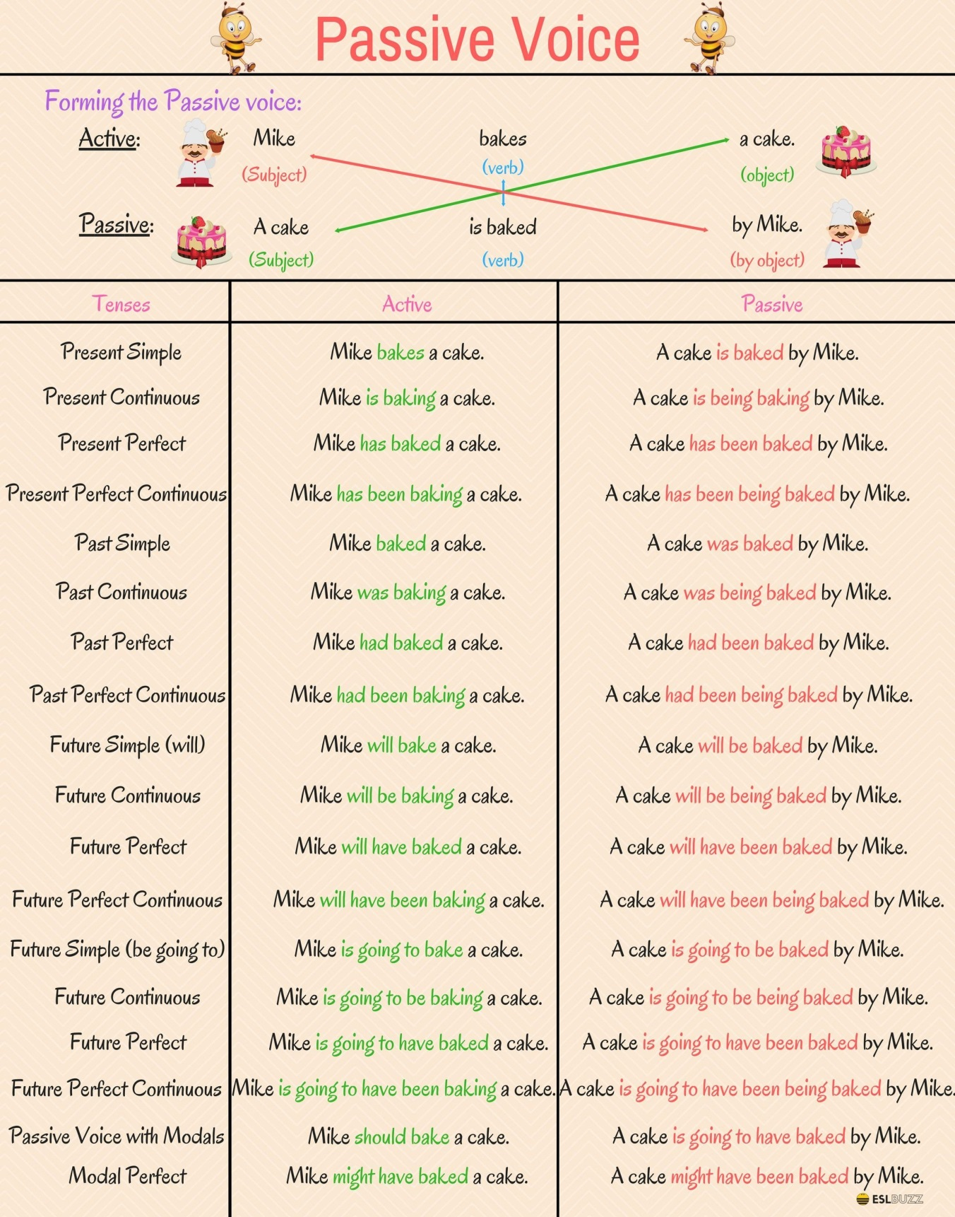

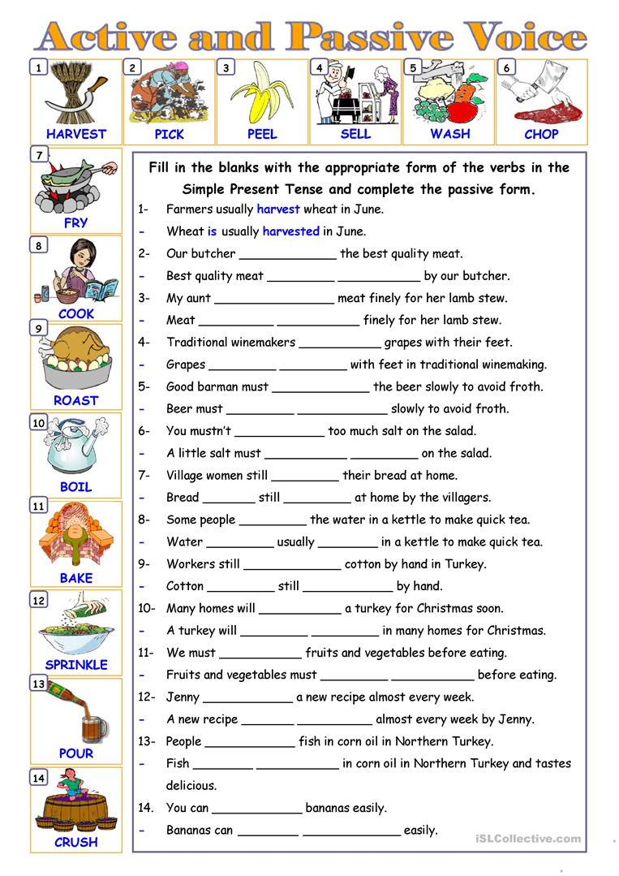
USED TO + base form (accustomed)
Use: to talk about a situation that existed in the past but does not exist now.
Axiliary: did/didn’t
(+) I used to get up early for work.
(-) I didn’t use to get up early for work.
(?) Did you use to get up early for work?
Yes, I did// no, I didn’t

(+) We used to go out more.
(-) We didn’t use to go out often.
(?) Did you use to go out more?
Yes, I did.
Panchito used to eat meat when he was a child.
