Unit 1/book 3
Objectives
You have to read a book (50pgs)
- To introduce yourself
- To talk about your favorite person.
- To discuss about health
- To talk about evaluation.

Evaluation
Written tests 50% ( 5 bonus (myelt) When? Every other Saturday.
Oral 50% (class participation/ speech about the book/ oral presentations)

Passing grade 80%

Grammar: SIMPLE PRESENT
Use:
- Routine /habits
I always take a shower in the morning.
I usually get up at 7 am.
I do exercise every day.
- For fact
The president of the United States lives in the White House.
Lions eat meat.
- Schedules
I take English clases at 8 am.
- Permanent situations/states.
Panchito lives in El Chichicaste.
Adverbs of frequency.
Always (100%) I always take a shower in the morning.
Usually
Normally/generally
Often/frequently
Sometimes
Occasionally
Seldom 20% (not very often)
Rarelly/ hardly ever
Almost never
Never
1. subject + be + adverb of frequency
Panchito is always happy. Panchito always is happy. (incorrect)
Pancracia and Anacleta are usually at the Mall.
Aria is sometimes in the park.
The President is always a bad president.
We are usually on time.
Panchito is seldom bored on weekends.
Be + adverb of frequency + place (adjective, event)
They are usually in that restaurant.
Panchito is rarely in the class.
2. subject + adverb of frequency + verb
Sara usually goes to the park.
Sara usually watches tv at night.
Sara doesn’t usually watch tv at night.
Jarvin usually goes running with his friends.
Jarvin doesn’t usually go running with his friends.
Mercy sometimes practices swimming in the pool.
I sometimes read a book.
I never read a book.
My nephew doesn’t usually play video games.
Expressions of frequency
Sentence + expression of frequency.
- Once a week , a month, a day, a year
They go on vacation once a year.
I have an English class once a week.
- Twice a day, a month, a week, a year..
I wash the dishes twice a day.
I drink coffee twice a day.
- Every morning ,
- All the time
- Once in awhile (occasionally)
- From time to time (sometimes)
I visit my mother in law from time to time.
- Once in a lifetime
An opportunity like this comes along once in a life time.
- Once in a blue moon (hardly ever /almost never)
Auxiliary: do / don’t I, you, they, we
Does/doesn’t he, she, it.
3rd person rule (she, he, it) (positive sentences)
I, you, they, we go she, he, it goes
Watch ------ watches
Fix ----------- fixes
Clean ------- cleans
Work ------- works
Study ------ studies
Try --------- tries
Fry --------- fries
Play ------- plays
(+) Panchito plays the guitar very well.
(-) Panchito doesn’t play the guitar very well.
(?) Does Panchito play the guitar very well?
Yes, he does.
(wh) Q/= What does Panchito play?
A/ the guitar
Q/ How well does Panchito play the guitar?
A/ very well.
Q/ Who plays the guitar very well?
A/ Panchito

PRESENT CONTINUOUS
SUBJECT + BE + V-ING
I am working at the moment.
Use: *
- Action happening now (right now)
You’re listening to me right now.
- Temporary situations .
I’m living in San Pedro Sula for a few weeks.
- Temporary habits
Panchito is eating a lot these days.
- Annoying habits
She is always complaining about cleaning her room.
- Definite future plans
I’m meeting my father tomorrow morning.
(+) I’m working late tomorrow.
(-) I’m not working late tomorrow.
(?) Are you working late tomorrow? Yes, I am // no, I’m not.
What are you doing right now?
I’m listening to the class.
I’m writing in my notebook.
We’re taking an English class at the moment.
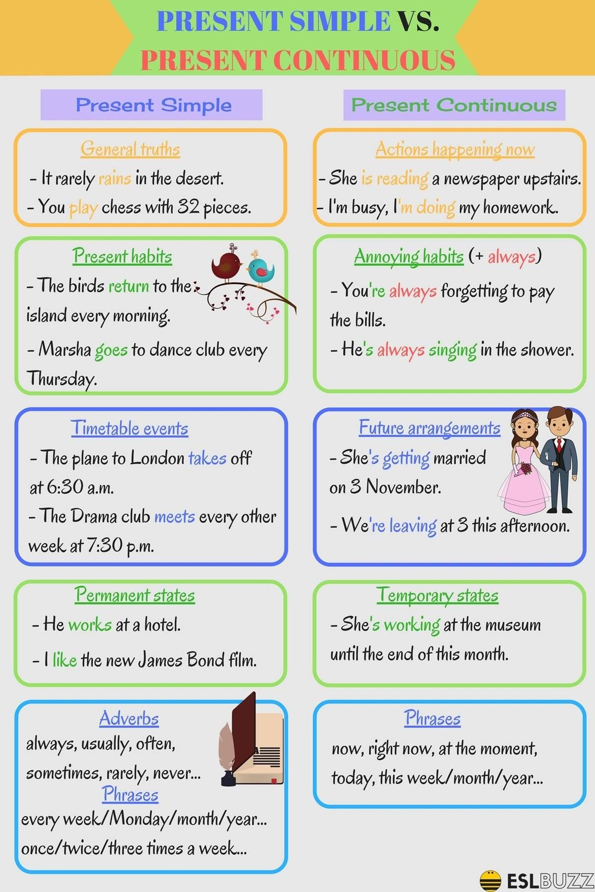
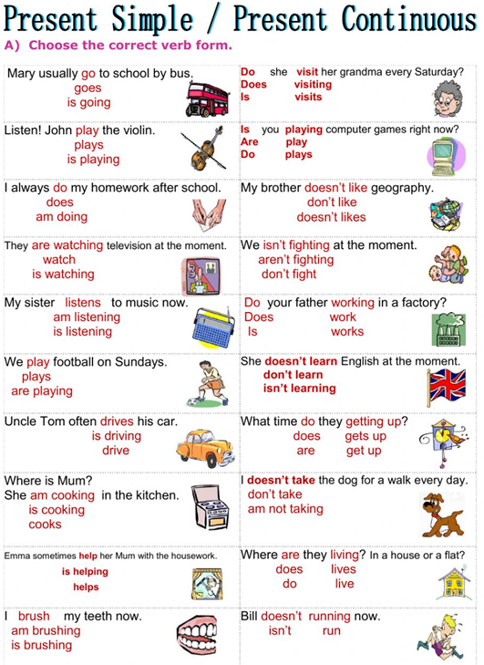
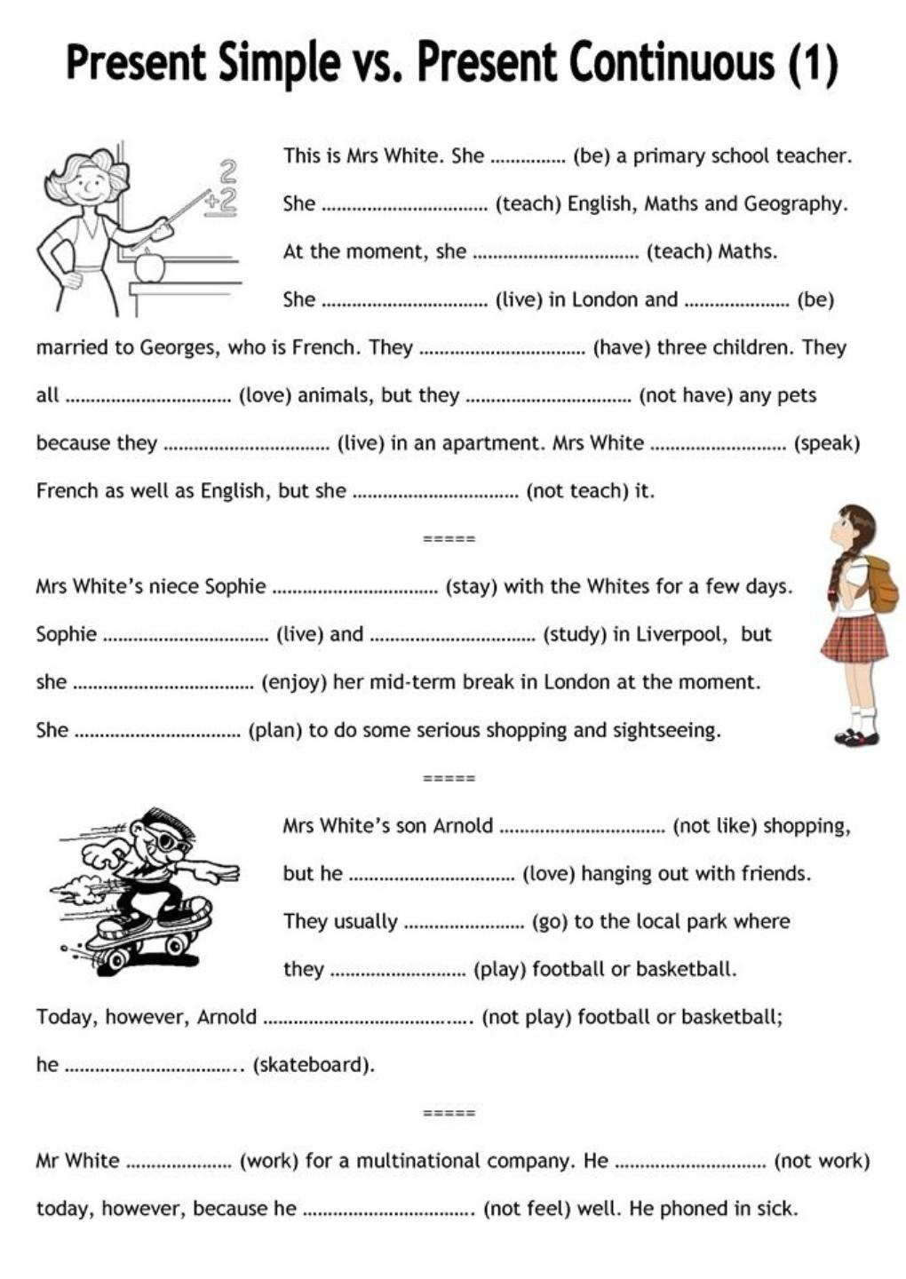

1 Complete each sentence. Use the words in brackets. Use present simple or present continuous.
a) Richard (always, get up) __________________________ before 7.00.
b) Hurry up! The bus (wait) ___________________________ for us!
c) Where (we, go) ___________________________ ? This is the wrong road!
d) My friends (not believe) _________________________ my story.
e) Please be quiet! I (read) _____________________ a very interesting book.
f) (like, Susan) _____________________________________ horror films?

2 Choose the most suitable word or phrase for each space.
1) ‘Someone ..... for you outside.’ ‘Who is it?’
A) waits B) is waiting C) waiting

2) ‘What ..... of this book?’ ‘I think it’s fantastic!’
A) do you think B) is you think C) you do think

3) ..... in ghosts?
A) Are you believe B) Are you believing C) Do you believe

4) Kate is busy. She ..... for a test.
A) is study B) is studying C) is studies

5) ..... a great time at the moment!
A) We are have B) We’re have C) We’re having

6) Tina usually ..... at 7.00.
A) get up B) is getting up C) gets up

3 Correct each sentence or question.
a) I doesn’t likes this film. _________________________________
b) What do you wants? ____________________________________
c) Jim walk sometimes to school. ____________________________
d) When the lesson begins? _________________________________
e) I don’t gets up early on Saturdays. __________________________
f) Tina not like computer games. _____________________________
g) Figen watchs television every night. ________________________

4 Put one word in each space. Contractions are one word.
a) What ............ ...... you usually eat for lunch?
b) George and Terry .................. speak Portuguese. They speak English.
c) It’s 9.30 and the children .................. sitting at their desks.
d) Ken .................. like tea. In fact, he hates it.
e) When it rains, .................. you take an umbrella?
f) What .................. it say on the board? I can’t see from here.

5 Choose the most suitable word or phrase for each space.
a) What time . .... to bed?
A) usually do you go B) do usually you go C) do you usually go
b) Every day, Frank ..... to work.
A) goes B) is going C) go
c) Stop it! ..... it!
A) I’m not liking B) I don’t like C) I not like
d) What ..... ? Is it an orange?
A) you are eating B) are you eating C) do you eat
e) Yumiko feels ill, so she ..... basketball.
A) doesn’t play B) isn’t play C) isn’t playing
f) Pay attention, Philip! ..... ?
A) Do you listen B) Is it listening C) Are you listening
g) Excuse me. ..... to Manchester?
A) This road goes B) Does this road go C) Is this road go

6 Change each sentence. Use the words in brackets.
a) Jo goes to school by bus. (usually) .... ............... ......... ..... ............ ...... ..........
b) I’m working hard. (not) ..................................................................
c) Sara likes sport. (not) ..................................................................
d) I get up at 6.30. (always) ..................................................................
e) We speak German. (not) ..................................................................
f) Pierre goes to the beach. (often) ..................................................................
g) George drinks beer. (never) ..................................................................
h) We’re having a good time. (not) ..................................................................

7 Present simple or present continuous? Change the verb if it is wrong.
a) Are you having a motorbike?
............ ........ ........... ... ........................ ..................................................................
b) I’m staying in a hotel near the sea.
............................................................................................................................
c) I’d like to buy this coat. How much is it costing?
............................................................................................................................
d) What you doing?
............................................................................................................................
e) I’m usually getting up at 6.00.
............................................................................................................................
f) This book is difficult. I’m not understanding it.
............................................................................................................................
g) I watch a lot of TV every night.
............................................................................................................................
h) Excuse me. Are you knowing the way to the museum?
............................................................................................................................

