THERE IS / THERE ARE NAME:___________________________

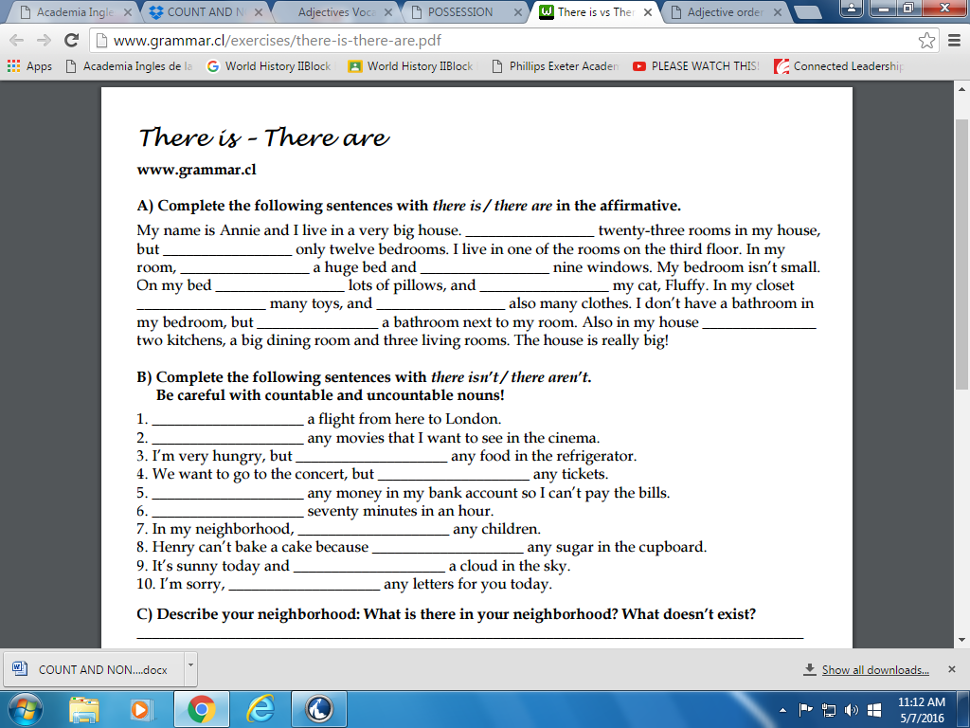
Complete the following sentences using THERE IS, THERE ARE, IS THERE, ARE THERE

- ________________________no milk in the fridge.
- ________________________ many rooms in your house?
- ________________________ a lot of snow in the mountains.
- ________________________any mistakes in this text?
- ________________________ one question left.
- ________________________no snails in my garden.
- ________________________nobody in.
- ________________________nothing to do?
- ________________________ seven days in a week?
- ________________________a lot of tea in the kitchen.

