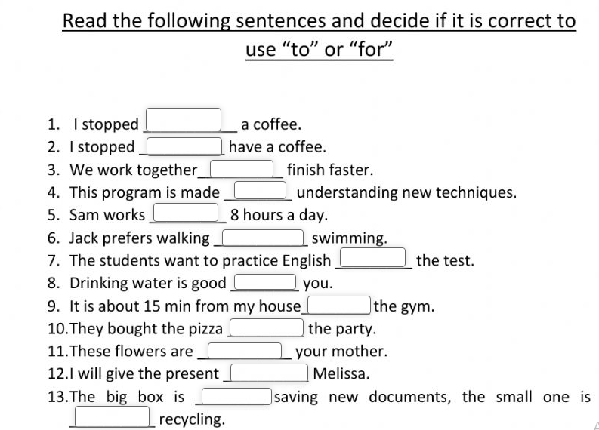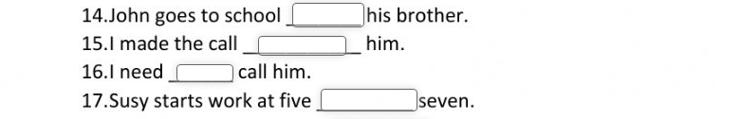
So that
Complete the sentence with an original idea and (so that).
- I went to the movies, ____________________________________________________.
- Marvin did the HMWK, __________________________________________________.
- My sister washed all her clothes, ___________________________________________.
- Andrea called her boyfriend, _____________________________________________.
- David attended the class, _______________________________________________.
- The students took extra classes, ___________________________________________.
- I spoke Spanish to the students, ___________________________________________.
- Cameron Díaz took her favorite dress to the dry-cleaning, ______________________.

