Unit 6
Objectives
To talk about last vacations.
To talk about the past lives of people.

Grammar: Simple Past Tense
Use: to talk about finished actions in the past (specific time in the past)
To talk about someone’s life when they’re dead.
Time expressions: yesterday, last week, ago, the day before yesterday.
Verb to be was/ were
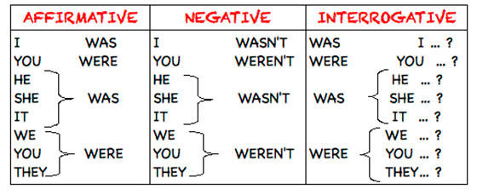
(+) I was happy last weekend.
(-)
(?)
(wh)

(+) She was a nurse when she was young.
(-)
(?)
(wh)
(+) You were at school yesterday afternoon.
(-)
(?)
(wh)

Irregular and regular Verbs
Auxiliary: did -- didn’t
REGULAR VERBS
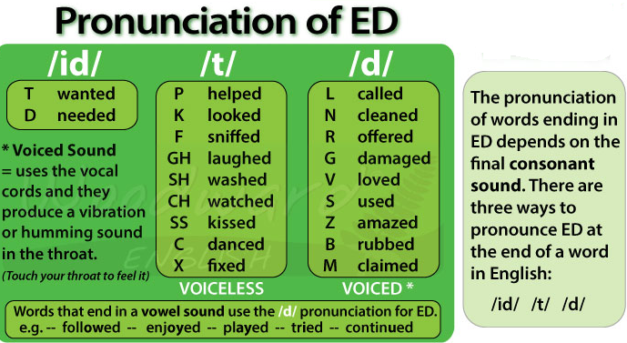
(+) I played my guitar loudly yesterday.
(-)
(?)
(wh)
(+) She kissed me on the cheek.
(-)
(?)
(wh)
(+) Angela watched TV all night.
(-)
(?)
(wh)
(+) John wanted to go to the museum.
(-)
(?)
(wh)
Irregular verbs
(+) We slept well last night.
(-)
(?)
(wh)
(+) I went to work yesterday.
(-)
(?)
(wh)
(+) She had to come to school last Saturday.
(-)
(?)
(wh)

Simple past
Tell the story – fill in the simple past tense
On Friday, the children ___________ (talk) about a day out together in the country. The next morning, they __________ (go) to the country with their two dogs and ___________ (play) together. Ben and Dave _________ (have) some kites. Sometime later the dogs ____________ (be) not there. So they ___________ (call) them and ___________ (look) for them in the forest. After half an hour the children ___________ (find) them and ____________ (take) them back. Charlie ____________ (be) very happy to see them again. At lunch time Nick _____________ (go) to the bikes and ____________ (fetch) the basket with some meat sandwiches. Then they ___________ (play) football. Nick and Dave ____________ (win). In the evening they _____________ (ride) home.

Past Tense Negation
Put the following sentences into the negation.
Example: We had fish for dinner. We didn't have fish for dinner.
1. We saw our friends after school.
We ____________ our friends after school.
2. I talked to her this morning.
I _____________ to her this morning.
3. She did the washing while we were at work.
She _____________ the washing while we were at work.
4. My sister was at home when Aunt Susan arrived.
My sister ____________ at home when Aunt Susan arrived.
5. Barbara fed the animals in the morning.
Barbara ___________ the animals in the morning.
6. The lessons were very interesting.
The lessons ____________ very interesting.
7. The meeting began at eight o'clock in the morning.
The meeting ___________ at eight o'clock in the morning.
8. We agreed to what she said.
We _____________ to what she said.
9. She showed me her new mountain bike.
She ______________ me her new mountain bike.
10. They were at home yesterday afternoon.
They _____________ at home yesterday afternoon.
11. We met him at the station last Friday.
We _______________ him at the station last Friday.
12. We played football at the weekend.
We ______________ football at the weekend.
13. His mother went to work by car yesterday.
His mother ______________ to work by car yesterday.
14. He wasn't angry with me because I told him the truth.
He was angry with me because I ____________ him the truth.
15. We were happy because Ron invited us to his party.
We were angry because Ron ___________ us to his party.

Simple Past
Fill in the correct simple past forms.
The students of class 8B ______________ (do) a project last week. First the pupils _____________ (choose) what they wanted to do. Then they ___________ (get) information from books and brochures, and they ___________ (talk) to a lot of people. They ____________ (find) some interesting photos in the library. Their teacher _____________ (help) them when they ___________ (ask) her. Then they __________ (make) a poster and a video and ___________ (tell) the other groups about their project.
Fill in the correct simple past forms.
arrange / bring / choose / decide / find / get / go / say / start
Last month Jenny, Nick and Ben _____________ to do a project together. They____________ Cornwall. First Jenny __________ to a travel agency and __________some brochures. Nick and Ben ____________ some interesting books in the library. Then they __________ work. A week later they __________ all their material to school and __________ it on a poster. ‘Your presentation is interesting’, __________ Miss Hunt.

