SPECULATION EXERCISES
NAME:________________________________________________ DATE:__________________________

Exercise 1 – Complete the blanks with must, can’t, or might:
1. Look at that guy's enormous muscles. He ________________ work out a lot.
2. Michelle ________________ want to participate in the festival - it seems like the type of thing she'd be interested in. Why don’t you ask her?
3. She goes camping every weekend. She ________________ really love the outdoors.
4. He worked hard on his report, then accidentally deleted the file from his computer. He ________________ be upset.
5. You ________________ be right - but I'm going to check to make sure.
6. We're not sure if this painting is an original. It ________________ be worth thousands of dollars.
7. I ________________ not be able to go to the football game. It depends on whether
I can get the afternoon off from work.
8. He's working full-time and studying for his Ph.D. That ________________ be easy.
9. You just ate a huge dinner! You ________________ be hungry again already!
10. Wow! Look at that diamond necklace. It ________________ cost a fortune.

Exercise 2 – Now complete the blanks with must, should, shouldn’t, or couldn’t:
1. I'm so thankful for your help with this project. I ___________________ have done it without you!
2. The repairs I made ___________________ have fixed the problem, but they didn't - so I'll have to take another look.
3. It ___________________ have rained a lot last night - there are puddles everywhere.
4. I ___________________ have watched that horror movie; it gave me nightmares.
5. We ___________________ have known about this; nobody told us anything about it.
6. If you’ve been trying to lose weight, then you really ___________________ have eaten all that ice cream.
7. He ___________________ have finished a 500-page book in a single day!
8. She never showed up. She ___________________ have forgotten about our appointment.
9. He broke two of the plates while washing the dishes. He ___________________ have been more careful.
10. They ate every bite of their dinner - they ___________________ have enjoyed the food.
Exercise 3 – Put the Letter of the situation (box) inside the possibility (circle) that matches the situation.
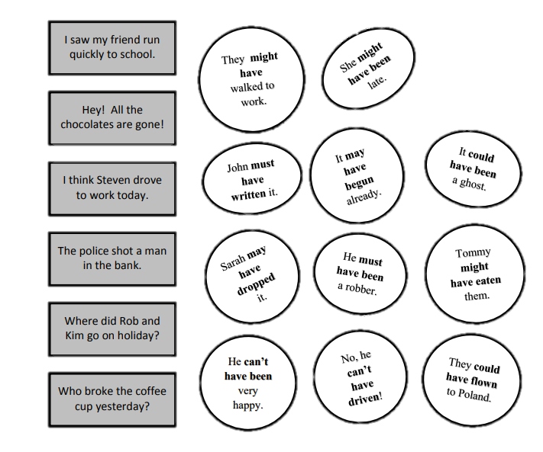
A

B

C

D

E

F

