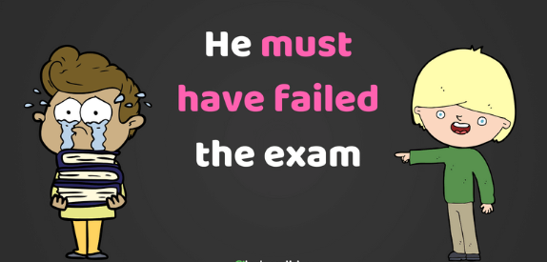
EXERCISE
Create a SPECULATION IN PAST just like the example. Remember you can use: MUST, COULD, MAY, MIGHT.
