SIMPLE PRESENT NAME:___________________________
DATE:___________________________
- Complete the sentences using the correct form of simple present.

1. Uncle Joe _________ (wear) glasses.
2. Ducks _________ (love) water.
3. The sun _________ (rise) in the east.
4. The children _________ (not go) to school by bus.
5. Juanma _________ (enjoy) singing.
6. Jesus _________ (not lend) me his bike.
7. Monkeys _________ (like) bananas.
8. Pepi _________ (not collect) stamps.
9. The earth _________ (go) around the sun.
10. It often _________ (snow) in winter.
11. We _________ (wash) our hands.
12. We _________ (eat) three meals a day.
13. _________ he _________ (type) very fast?
14. Lucía _________ (work) at the court.
15. Everyone _________ (make) mistakes.
16. Winter _________ (not come) after spring.
17. _________ you _________ (like) my new bike?
18. _________ she _________ (walk) to school?
19. Pedro _________ (speak) English very well.
20. My dog _________ (bark) very loudly.
21. _________ Sara _________ (read) in bed?
22. _________ babies _________ (sleep) during the day?
23. Eva _________ (try) not to disturb.
24. Eagles _________ (fly) high in the sky.
25. My sister _________ (cook) all our meals.

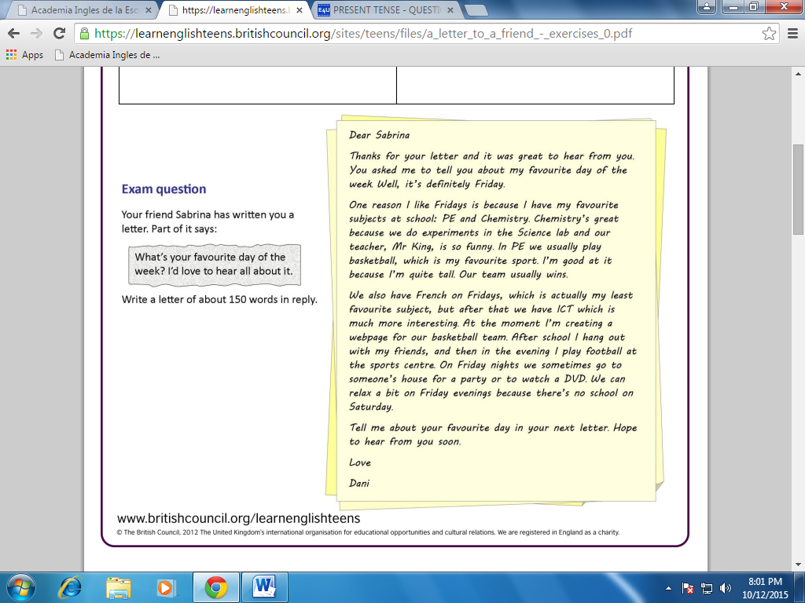
- Read each question and match with its corresponding answer.
- Read then circle True or False
26. Dani is a high school student. True False
27. Dani thinks Friday is the best day of the week.
True False
28. Dani likes French. True False
29. On Friday Dani has ICT class before her French class.
True False
30. Mr.King is the PE teacher. True False
31. Dani goes to the sport centre to play basketball.
True False

