SIMPLE PRESENT
NAME:_________________________________________________ DATE:_________________________

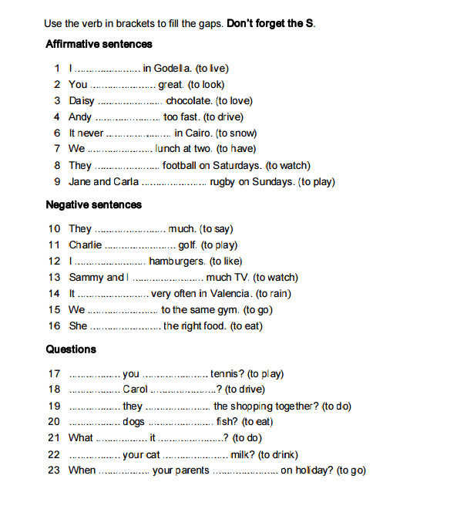

READING COMPREHENSION
Read about Tim’s Day and answer the questions.
Tim works for a company in Sacramento, California. He's a customer service representative. He gets up at six o'clock each workday. He drives to work and begins his job at eight o'clock. He speaks to people on the telephone to help them with their banking problems. People telephone the bank to ask questions about their accounts. He doesn't give information about accounts until people answer a few questions. Tim asks callers their birth date, the last four digits of their social security number and their address. If a person gives incorrect information, Tim asks him to call back with the correct information. Tim is polite and friendly with everyone. He has lunch in a park next to his office. He returns home at five o'clock in the evening. After work, he goes to the gym to work out. He has dinner at seven o'clock. Tim likes watching TV after dinner. He goes to bed at eleven o'clock at night.
1.Where does Tim work?
- In Europe
- In the USA
- In Asia
2.When does he get up?
- He gets up at seven o'clock in the morning.
- He gets up at six o'clock in the morning.
- He gets up at six o'clock in the afternoon.
3.How does he get to work?
- He walks to work.
- He drives to work.
- He takes the bus to work.
4.What does he do during the day?
- He helps customers in a bank.
- He helps customers on the telephone.
- He helps customers outside.
5.What does he do to check information?
- He asks people some questions.

- He tells them to call later.
- He asks to see documents.
6.Which question does he NOT ask?
- What is your birth date?
- What is your job?
- What is your address?
7.What does he do if the information is incorrect?
- He gives banking account information.
- He asks the callers to call back with correct information.
- He asks to speak to the parents.
8.What is Tim like on the job?
- He is unfriendly and helpful.
- He is funny and helpful.
- He is polite and friendly.
9.Where does he eat lunch?
- At work
- In a park near work
- At home
10.What does he do in the evening?
- He works out at the gym and watches TV.
- He works out at the gym and reads a book.
- He watches TV and plays ping pong.

