SHOULD OR SHOULDN’T.
- Complete the sentences with should or shouldn’t and an appropriate verb.

1)If it´s rainy you ____________________ an umbrella.

2)Tom _____________________ so many lollipops. It´s bad for his teeth.

3) a) ________________I drink hot tea if I have a sore throat?
b) Yes, you ______________.

4) They have a test tomorrow. They __________________ to the cinema . They ______________________ at home and study!

5) Children __________________ lots of vegetables but they __________________ lots of sweets.

6) I have a party tonight. What___________I ____________? A dress or a pair of trousers?

7) The doctor said: "You _______________ healthy food. You ________________ fast food. You _____________________ so much
TV. You _____________________ in the park 1 hour a day. You ______________ fruit juice and water. You __________________ wine or beer.

II. Look at the pictures . Make sentences giving advice to these people . Use should.
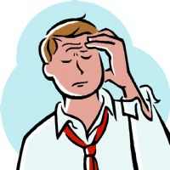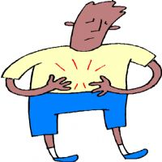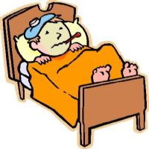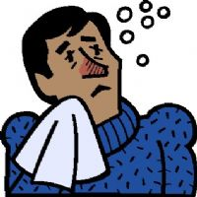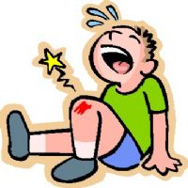
1. 2. 3. 4. 5.

1. He has a headache so ____________________________________________ .
2. He has a stomachache so ___________________________________________.
3. He has a cold so __________________________________________________.
4. He has a flu so __________________________________________________.
5. He has a bruise so ________________________________________________.

