REPORT SPEECH
USE: TO SAY WHAT SOMEONE ELSE SAID.
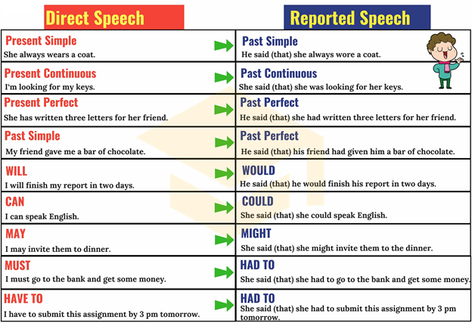
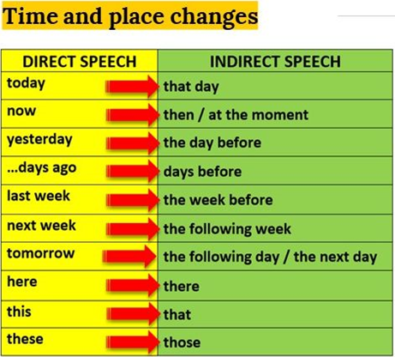
REPORTING QUESTIONS
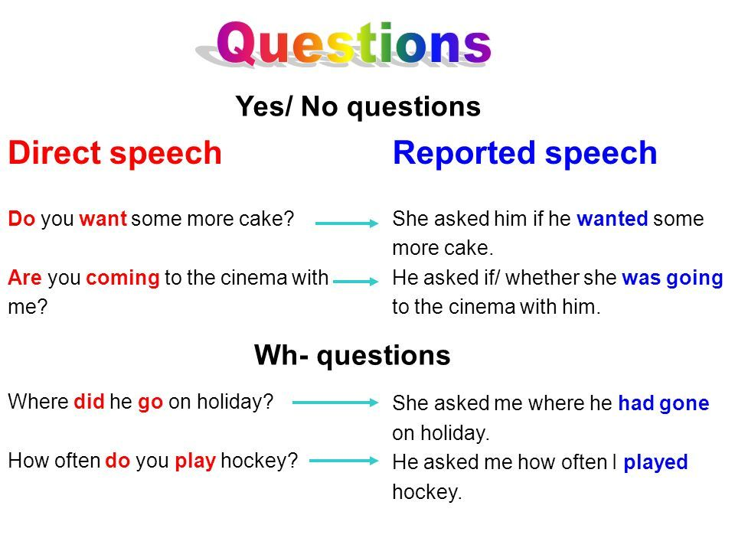
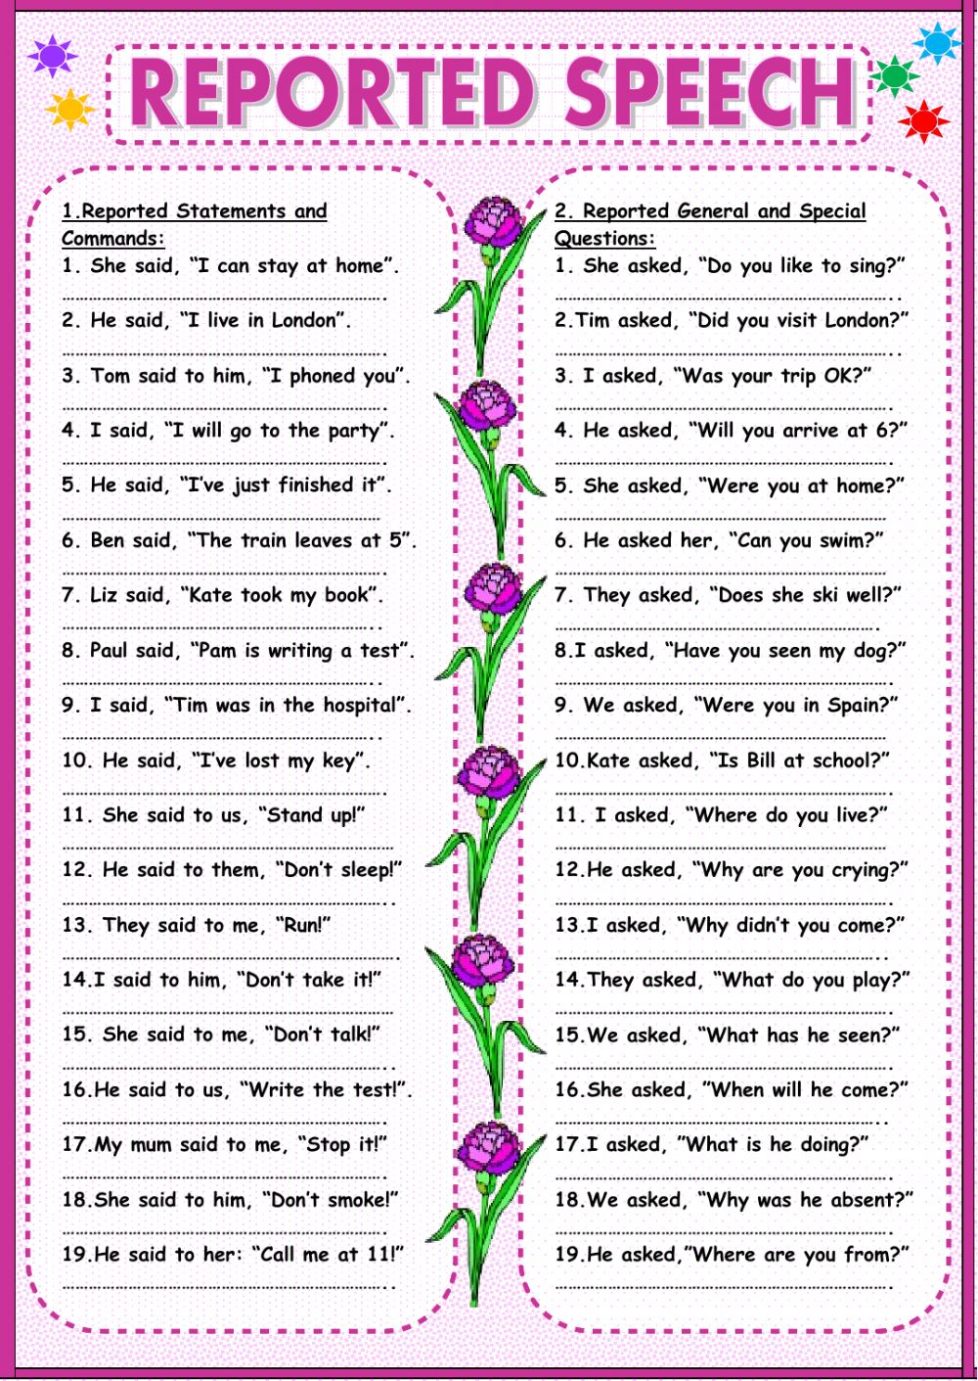
REPORTING VERBS
PATTERNS
- SAY -------
SHE SAID THAT HIS BOYFRIEND HAD LEFT HER.

- ASK, TELL, REMIND, INVITE+ OBJECT + (NOT) + INFINITIVE
SHE TOLD ME NOT TO WRITE THE LETTER.

- PROMISE, OFFER + (NOT) INFINITIVE
SHE OFFERED TO CLEAN THE ROOM.

- PROMISE + THAT + CLAUSE
SHE PROMISED THAT SHE WOULDN’T DO IT AGAIN.

TO REPORT TOUGHTS:
- REALIZE, THINK, KNOW + THAT + SUBJECT + VERB
SHE KNEW THAT SHE HAD LEFT HER WALLET AT HOME.

- WONDER + IF/WHETHER
SHE WONDERED IF HER SON HAD DONE HIS HOMEWORK.

