RELATIVE CLAUSES

USE: TO GIVE MORE INFORMATION ABOUT A NOUN IN THE MAIN CLAUSE OF THE SENTENCE.

Relative Pronouns
relative pronoun | use | example
Who/that | subject or object pronoun for people | I told you about the woman who lives next door.  The six friends, that had gone to school together, went to the beach.
Which/that | subject or object pronoun for animals and things | Do you see the cat which is lying on the roof?  I don’t like the table that stands in the kitchen.
which | referring to a whole sentence | He couldn’t read which surprised me.
whose | possession for people animals and things | Do you know the boy whose mother is a nurse?
whom | object pronoun for people, especially in non-defining relative clauses | I was invited by the professor whom I met at the conference.
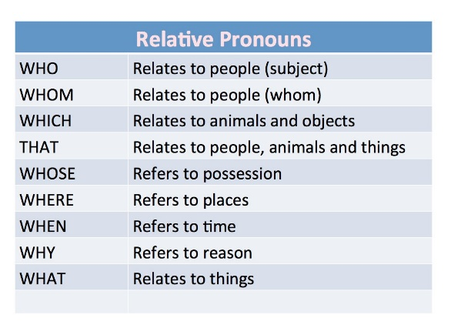

Subject Pronoun or Object Pronoun?
Who, which, that are used for subject and object pronouns. You can, however, distinguish them as follows:
If the relative pronoun is followed by a verb, the relative pronoun is a subject pronoun. Subject pronouns must always be used.
The apple which is lying on the table
If the relative pronoun is not followed by a verb (but by a noun or pronoun), the relative pronoun is an object pronoun. Object pronouns can be dropped in defining relative clauses.
The apple (which) George put on the table…

Defining Relative Clauses
Defining relative clauses give extra information which is essential ( the meaning of the main clause is unclear without it). Defining relative clauses are not put in commas.
A seaman is someone who works on a ship.
The boy (who/whom) we met yesterday is very nice.

Non-Defining Relative Clauses
Non-defining relative clauses give extra information but it is not essential ( the meaning is clear without it). Non-defining relative clauses are put in commas.
Do you know that girl, who is talking to Panchito?
Note: In non-defining relative clauses, who/which may not be replaced with that.
Jim, who/whom we met yesterday, is very nice.

How to Shorten Relative Clauses?
Relative clauses with who, which, that as subject pronoun can be replaced with a participle. This makes the sentence shorter and easier to understand.
IF THE VERB IN THE RELATIVE CLAUSE IS IN THE ACTIVE WE USE THE PRESENT PARTICIPLE (V-ING)
The girl who sits next to Peter is my neighbor’s daughter.
The girl sitting next to Peter is my neighbor’s daughter.
Who is the girl who is sitting next to your brother?
Who is the girl sitting next to your brother?
A girl who works at a pub has won a lottery.
A girl working at a pub has won a lottery.
The lady who lives next door throws numerous parties.
The lady living next door throws numerous parties.
IF THE VERB IN THE RELATIVE CLAUSE IS IN THE PASSIVE (be + past participle) , WE USE THE PAST PARTICIPLE
Yesterday I read a book which was written by Hemingway.
Yesterday I read a book written by Hemingway.
Most people who were invited to the party didn’t turn up.
Most people invited to the party didn’t turn up.

Relative Clauses

Forming relative clauses
Combine the sentences using a relative clause. Use relative pronouns only where necessary.

A holiday in Scotland
- We spent our holiday in Scotland last year. Scotland is in the north of Great Britain.
Last year we spent our holiday in Scotland which is in the north of Great Britain.
- People live in Scotland. They are called Scots.
The people who live in Scotland are called Scots.
- We first went to Edinburgh. Edinburgh is the capital of Scotland.
We first went to Edinburgh which is the capital of Scotland.
- Arthur Conan Doyle was born in Edinburgh. He wrote the Sherlock Holmes stories.
Arthur Conan Doyle who wrote the Sherlock Holmes stories was born in Edinburgh.
- Then we visited a lake. It is in the Highlands.
The lake which we visited is in the Highlands.
- Loch Ness is 37 km long. People know it for its friendly monster.
Loch Ness ,which is known for its friendly monster, is 37 km long.
- There we met an old man. He told us that he had seen Nessie.
An old man who we met told us that he had seen Nessie.
- We then travelled to a mountain. The mountain is near the town of Fort William.
We then ______________________________________________
- The mountain is the highest mountain in Great Britain. It is called Ben Nevis.
The mountain __________________________________________
I sent you a postcard. It was written on the summit of Ben Nevis.
The postcard____________________________________________

What´s the name of the book. You want me to read.
What’s the name of the book that/which you want me to read.
That’s the boy. His mother works in the hospital.
That’s the boy whose mother works in a hospital.

