UNIT 10

RELATIVE CLAUSES

USE: TO GIVE MORE INFORMATION ABOUT A NOUN IN THE MAIN CLAUSE OF THE SENTENCE.

Relative Pronouns
relative pronoun | use | example
Who/that | subject or object pronoun for people | I told you about the woman who lives next door.  The six friends, that had gone to school together, went to the beach.
Which/that | subject or object pronoun for animals and things | Do you see the cat which is lying on the roof?  I don’t like the table that stands in the kitchen.
which | referring to a whole sentence | He couldn’t read which surprised me.
whose | possession for people animals and things | Do you know the boy whose mother is a nurse?
whom | object pronoun for people, especially in non-defining relative clauses | I was invited by the professor whom I met at the conference.
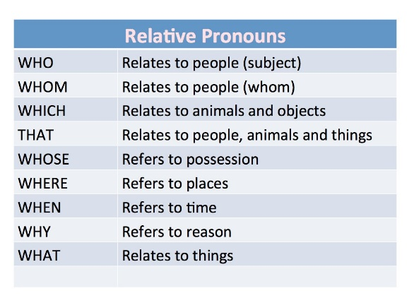

Subject Pronoun or Object Pronoun?
Who, which, that are used for subject and object pronouns. You can, however, distinguish them as follows:
If the relative pronoun is followed by a verb, the relative pronoun is a subject pronoun. Subject pronouns must always be used.
The apple which is lying on the table
If the relative pronoun is not followed by a verb (but by a noun or pronoun), the relative pronoun is an object pronoun. Object pronouns can be dropped in defining relative clauses.
The apple (which) George put on the table…

Defining Relative Clauses
Defining relative clauses give extra information which is essential ( the meaning of the main clause is unclear without it). Defining relative clauses are not put in commas.
A seaman is someone who works on a ship.
The boy (who/whom) we met yesterday is very nice.

Non-Defining Relative Clauses
Non-defining relative clauses give extra information but it is not essential ( the meaning is clear without it). Non-defining relative clauses are put in commas.
Do you know that girl, who is talking to Panchito?
Note: In non-defining relative clauses, who/which may not be replaced with that.
Jim, who/whom we met yesterday, is very nice.

How to Shorten Relative Clauses?
Relative clauses with who, which, that as subject pronoun can be replaced with a participle. This makes the sentence shorter and easier to understand.
IF THE VERB IN THE RELATIVE CLAUSE IS IN THE ACTIVE WE USE THE PRESENT PARTICIPLE (V-ING)
The girl who sits next to Peter is my neighbor’s daughter.
The girl sitting next to Peter is my neighbor’s daughter.
Who is the girl who is sitting next to your brother?
Who is the girl sitting next to your brother?
A girl who works at a pub has won a lottery.
A girl working at a pub has won a lottery.
The lady who lives next door throws numerous parties.
The lady living next door throws numerous parties.
IF THE VERB IN THE RELATIVE CLAUSE IS IN THE PASSIVE (be + past participle) , WE USE THE PAST PARTICIPLE
Yesterday I read a book which was written by Hemingway.
Yesterday I read a book written by Hemingway.
Most people who were invited to the party didn’t turn up.
Most people invited to the party didn’t turn up.

Choose the correct relative pronoun.
- The woman __________is sitting at the desk is Mr. Winter's secretary.
- I cannot remember the reason __________ he wanted us to leave.
- Jane, _____________ mother is a physician, is very good at biology.
- She didn’t see the snake _____________ was lying on the ground.
- Do you know the shop __________ Andrew picked me up?

Combine the sentences with relative clauses. (Decide whether to use commas or not.)
- A monk is a man. The man has devoted his life to God.
A monk ____________________________________________
- I have one black cat. His name is Blacky.
I have __________________________________________
- A herbivore is an animal. The animal feeds upon vegetation.
A herbivore _______________________________________
- Carol plays the piano brilliantly. She is only 9 years old.
Carol ____________________________________________
- Sydney is the largest Australian city. It is not the capital of Australia.
Sydney __________________________________________

Combine the sentences with relative clauses.
- We ordered a book. It was very expensive.
_______________________________________________
- You are sitting on a bench. The paint on the bench is still wet.
_______________________________________________
- The photographer could not develop the pictures. I had taken them in Australia.
_______________________________________________
- One of the bins smells awful. You haven’t emptied the bin for 3 weeks.
_______________________________________________
- They are singing a song. I don’t know the song.
________________________________________________

Combine the sentences with relative clauses

The city seems to be abandoned. It is usually crowded with people.
________________________________________________
- You made an offer. We cannot accept it.
We ____________________________________________
- A midwife is a woman. She assists other women in childbirth.
A woman ________________________________________
- Three youngsters were arrested by the police. They had committed criminal offences.
The police ________________________________________
- The World Wide Web has become an essential part of our lives. It was invented by Tim Berners-Lee.
Tim Berners-Lee ______________________________________

