READING COMPREHENSION
COMPARATIVE
NAME:________________________________________________ DATE:__________________________

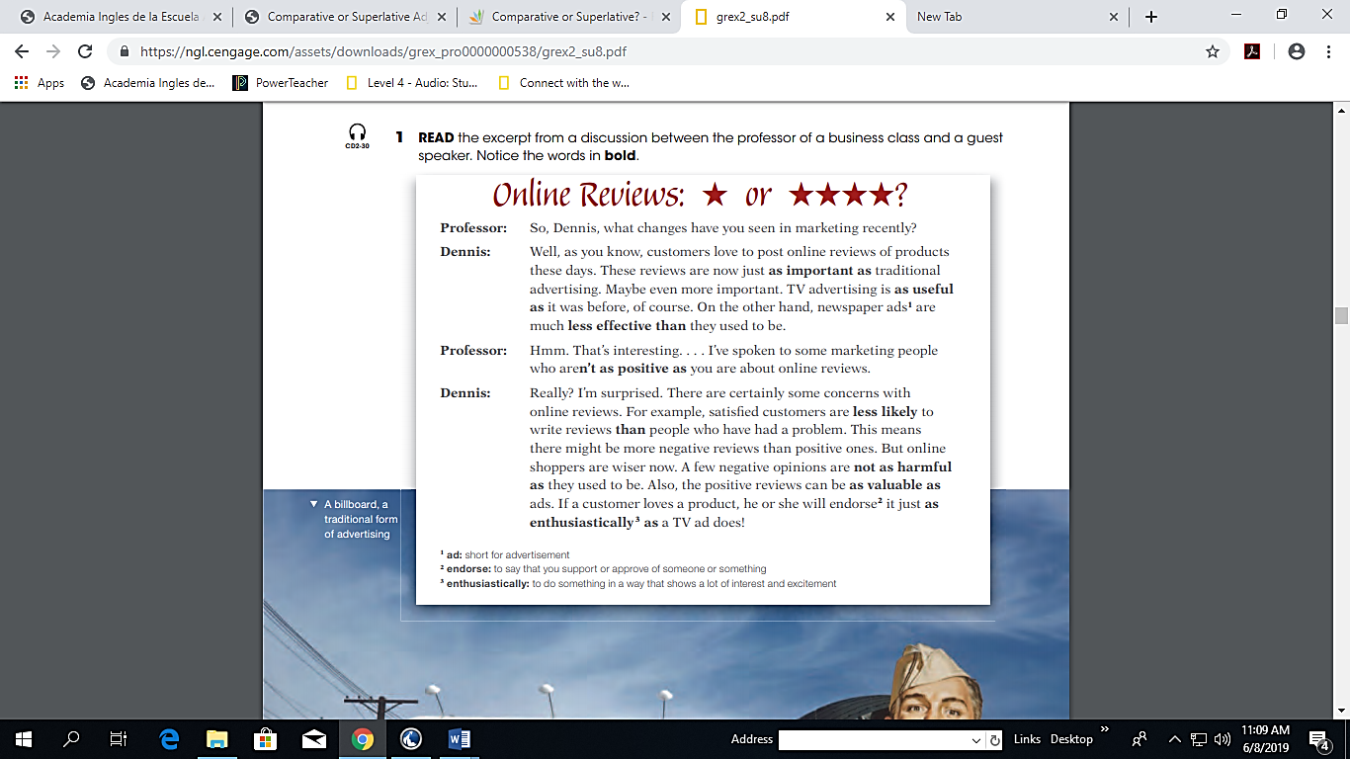

- CHECK. Read each statement. Circle T for true or F for false.
1. Dennis thinks that online reviews are not very important in marketing. T F
2. Newspaper ads used to be more effective. T F
3. Some marketing people have a negative opinion of online reviews. T F
4. Customers with problems are more likely to write online reviews. T F
5. Online shoppers won’t buy a product if they see a negative review. T F
6. Positive online reviews aren’t very valuable. T F

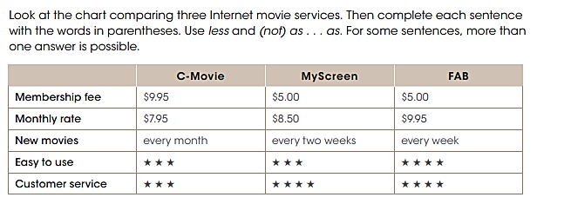
1. FAB’s membership fee is ______________________________(be / cheap) MyScreen’s.
2. Becoming a member of MyScreen ______________________________ (be / expensive) joining C-Movie.
3. C-Movie’s monthly rate ______________________________ (be / high) the others’.
4. C-Movie______________________________ (add new movies / frequently) FAB.
5. Using FAB ______________________________ (be / difficult) using the others.
6. On C-Movie, you can ______________________________ (find movies / easily) on MyScreen. They are both pretty easy to use.
7. MyScreen’s customer service ______________________________ (be / good) FAB’s.
8. C-Movie’s customer service ______________________________ (be / helpful) the other two services.

