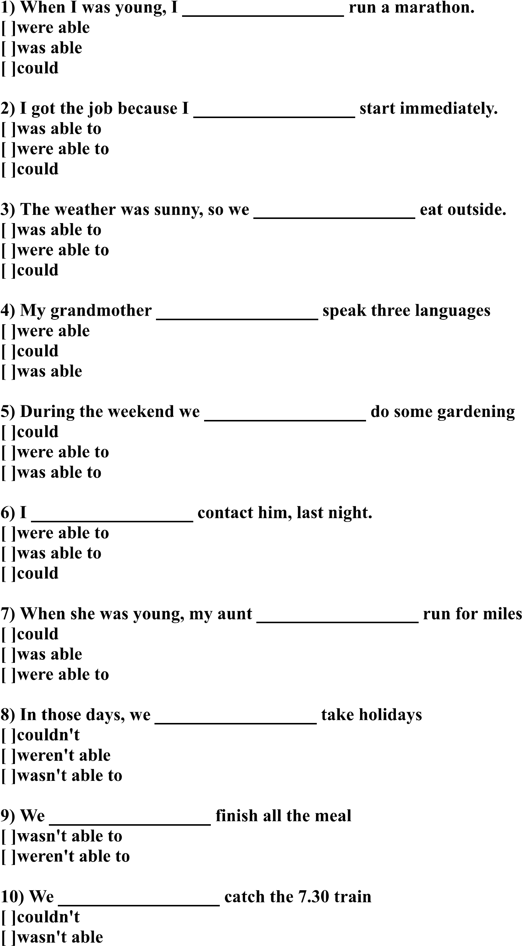
AST ENGLISH ACADEMY
LEVEL 8 QUIZ 2
NAME: _______________________________________

