THE AMERICAN SCHOOL.
ENGLISH COURSES.
LEVEL 6th.

STUDENT’S NAME: ______________________________________________GRADE:______________%
TEACHER’S NAME: KENY HERNANDEZ FUENTES.

- Change the sentences to REPORTED SPEECH. (Positive and Negative sentences.)

1. Mr. Brown:" I watch TV all the time."
Mr. Brown _____________________________________________________________________________.
2. Kiara:" I eat in Fridays sometimes."
Andrea _______________________________________________________________________________.
3. Bob:" We went to a party last weekend."
Bob _________________________________________________________________________________.
4. The farmer:" I have planted the flowers recently."
The farmer ____________________________________________________________________________.
5. Will & Tim:" My mother is very happy about the present."
Will and Tim __________________________________________________________________________.
6. Mr. and Mrs. Jones: We are cooking with our sons."
They _________________________________________________________________________________.
7. Roger Federer:" We played a lot of tennis last year."
Roger Federer __________________________________________________________________________.
8. My mother:" I saw you at the mall yesterday."
My mother ____________________________________________________________________________.
9. The Clarks:" We are going to Cancun next summer."
The Clarks____________________________________________________________________________.
10. Helen:" I do my HMWK every night."
Helen _______________________________________________________________________________.
II.Create your own sentences using the REPORTED SPEECH.

11. We said____________________________________________________________________________
12. Oscar told _________________________________________________________________________
13. Fiorella asked _______________________________________________________________________
14. The students said ____________________________________________________________________
15. The teacher told _____________________________________________________________________
16. Melissa told ________________________________________________________________________

- Reported speech COMMANDS. Complete the sentences.

17. MRS. Callejas: "Clean my window!"
Mrs. Callejas asked us ____________________________________________________________________
18. YOUR MOTHER: "Buy some bread in Salman’s."
Your mother asked me __________________________________________________________________
19. My sister: "Don’t say that."
She told us ___________________________________________________________________________
20. We: "Make your bed!"
We asked Mary __________________________________________________________________________
21. La Chupitos: "Don't drink there!"
She told you ____________________________________________________________________________
22. GEORGE: "Feed the cat!"
GEORGE asked his girlfriend _____________________________________________________________
23. MR. Rivera: "Go to the supermarket!"
Mr. Rivera told me ______________________________________________________________________
24. Zully: "Stay with me!"
She asked her boyfriend __________________________________________________________________
25. I: "Speak English in class!"
I asked the students _____________________________________________________________________

- Complete the sentences with these words.

Blog Twitter broadband text Flicker
Youtube SkypeTM WiFi ebook blogger

26. Read the latest bestsellers on your new _________________________________.
27. Upload all your photos on __________________________________.
28. Tell your friends where you are by sending a ________________________________.
29. Follow celebrity tweets on __________________________________.
30. Connect to the Internet wireless with ________________________________.
31. Make sure your Internet connection is fast by using ___________________________________
32. Call or chat to friends online with __________________________________.
33. Write a daily online diary- write your own ______________________________________.
34. Upload and watch videos on _________________________________.
35. My best friend is a famous ________________________. She writes about food around the world.

- Choose the newspaper section for each headline.
35. Company Profits Rise by 10%
a. business section b. weekend edition

36. Motagua Wins National League.
a. politics and society b. sports pages

37. Mount Kilauea erupts tons of lava in Hawaii.
a. business section b. national news

38. Should The President Be Spending Less Money?
a. weekend edition b. comment and analysis

39. Prince Harry marries Meghan Markle this weekend.
a. entertainment b. front page

40. US Has A New President
a. entertainment b. front page

VI. Complete the blog with words from Exercises 4 and 5. (41-51).

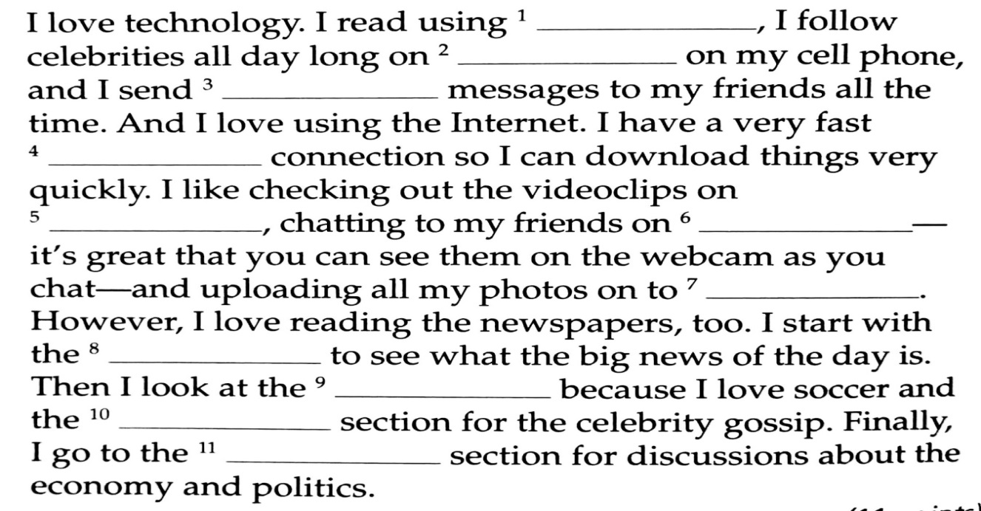

- Put the words in order and write the sentences.
52. to / I / speak / Could / please / Peter. / ?
______________________________________________________________________________________
53. like / him / as / to / I’d / possible / soon / as / speak / to
______________________________________________________________________________________
54. him / Can / leave / I / message / a / for / ?
______________________________________________________________________________________

- Label the pictures with the correct vocabulary.

55. _____________________ 56. __________________ 57. ____________________


58. ______________________ 59.___________________ 60.___________________

