PRESENT PERFECT
NAME:_________________________________________________ DATE:________________________
- Complete these sixteen sentences to score your knowledge of PRESENT PERFECT grammar.
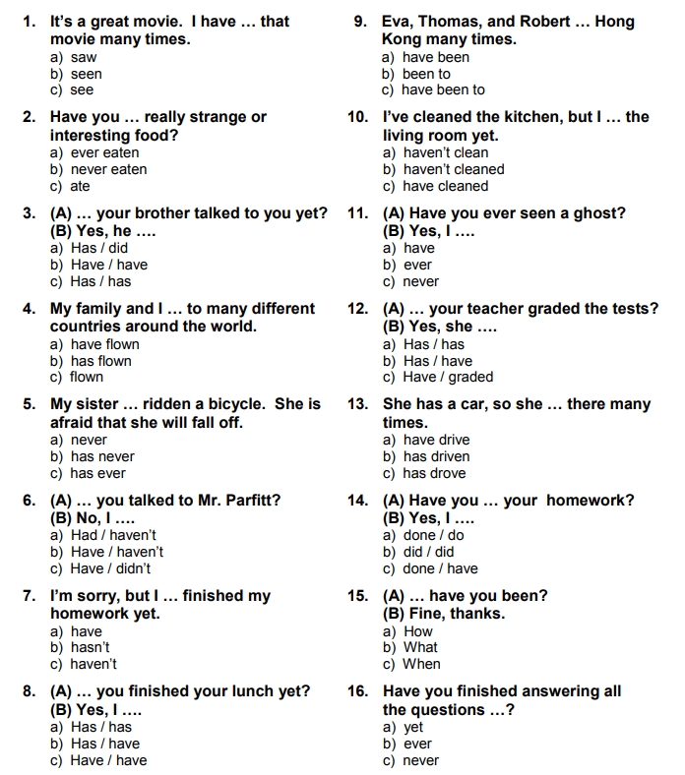

- Choose the correct time expression used with the present perfect tense.
- They have lived in that house (since / for) ten years.
- She has (just / yet) gone to the bank.
- Franklin hasn't arrived in Boston (yet / already)
- We have worked at this company (since / for) 2008.
- Jason hasn't telephoned me (since / for) two weeks.
- How (long / much) have you known Susan?
- They've (already / yet) studied the past simple tense.
- Our mothers have (just / yet) left for the station.
- The President has traveled to more than twenty countries (since / for) he was elected.
- Thomas hasn't had time to read the book (just / yet).
- Alice has told me she's (yet / already) been to that park.
- My daughter's (just / since) finished her homework.
- Have they (already / yet) spoken to Mr. Peters?
- I've (just / for) interviewed the best candidate for the job.
- Our coach hasn't chosen the starting team (already / yet).
- Bob and Tim have (already / yet) decided where they are going on vacation.
- Have you purchased the new computer (just / yet)?
- Sam has wanted to go to Japan (for / since) he was a little child.
- Jason hasn't worked here (since / for) very long.
- Our boss has (just / yet) hired a new engineer.

